Pathophysiology of the kidneys

 The kidneys are paired organs, 11-14 cm in length in adults, 5-6 cm in width and 3-4 cm in depth. The kidneys lie retroperitoneally on either side of the vertebral columns at the level of T₁₂ to L₃. Renal parenchyma comprises and outer cortex and inner medulla. Arterial blood is supplied to kidneys via the renal arteries which branch off from abdominal aorta and venous blood is conveyed to the inferior vena cava via the renal veins.
Multiple functions of the kidneys are executed by specialized structures - nephrons – the main morpho-functional unit of the kidney. The most important homeostatic processes taking place in the nephron are glomerular filtration, tubular reabsorption, tubular secretion, urine elimination through the urinary pathways and internal secretion of biologic active substances.
The main functions of the kidneys are to maintain the constant parameters of internal environment of the body, particularly water and electrolyte homeostasis (concentration of Na⁺, K⁺, Ca⁺⁺, Mg, Cl⁻ ions and phosphates), osmotic pressure, hemocirculatory homeostasis, acid-base balance (concentration of the hydrogen ions). Kidneys play a vital role in the metabolism of proteins, carbohydrates, lipids, secrete into the blood such substances as renin, kinins, erythropoietin, prostaglandins and 1,25 – (OH)₂D₃ vitamin. By elimination of urine, kidneys maintain optimal concentration of the intermediate and final products of the metabolism, maintaining thus homeostasis.

Dysfunction of glomerular filtration
Glomerular filtration is a process of liquid filtration from the glomerular capillaries through the kidney filter into the cavity of Bowman’s capsule. Liquid that is filtrated by the glomerulus into the Bowman capsule is called glomerular ultrafiltrate.
An essential feature of renal function is that a large volume of blood, approximately 25% of cardiac output (1300 ml) per minute passes through two millions of glomeruli.
The permeability selectivity of the renal filter depends, on properties of the filtrated substances: on molecular mass, electric charge and spatial configuration of molecules, on their hydrosolubility, plasma viscosity, gradient of hydrostatic and colloid osmotic pressure and gradient of the substances concentration on both sides of the renal filter. Substances with a molecular mass less than 20 kDa are filtrated as easy as water, while proteins the size of albumins (67 kDa) are retained in the blood. It might be considered that glomerular membrane is virtually impermeable to plasmatic proteins, but it is highly permeable to the micromolecular substances that are dissolved in plasma. Glomerular filtrate has almost the same composition as liquid that is filtrated into the interstitium from the arterial part of the capillary. It contains no blood cells and almost no proteins (0.03% of proteins), contains organic and anorganicmicromolecular substances. The ultrafiltrate of the blood plasma in the cavity of Bowman’s capsule is called primary urine.
Glomerular filtration is a physical process conditioned by the interaction of following forces: intra-glomerular hydrostatic pressure, colloid-osmotic pressure of the blood plasma in the capillaries of the renal glomeruli and intra- capsular pressure.
The force that results from dynamic interaction of these three forces determines the efficient filtration pressure (EFP) that is calculated by the formula:
EFP = HP – (COP + ICP), where:
HP – hydrostatic pressure in the capillaries of the glomerulus (about 70% from systemic arterial pressure – 70 – 60 mm Hg; COP – colloid-osmotic pressure of blood proteins in the capillaries of the glomerulus – about 25 mmHg; ICP – intra-capsular pressure conditioned by intra-renal pressure created by inextensible fibrous capsule of the organ and by ultrafiltrate pressure (about 10 mmHg.) An efficient filtration pressure, calculated by means of this formula, varies within the limits of 30 – 40 mm Hg.

Glomerulus filtration could be subjected to qualitative and quantitative changes. Qualitative changes are represented by significant deviations of substance concentration filtrated into the primary urine or appearance of some substances that are usually not filtrated. Quantitative changes represent increased or decreased filtration rate and consequently changed volume of the renal filtrate. Renal and extrarenal factors may influence the glomerulus filtration. In turn, extrarenal factors may be both, pre-renal and post-renal.
Increased glomerular filtration
Possible reasons of increased glomerular filtration are:
- Dilatation of afferent arteriole, this leading to increased intracapillary hydrostatic glomerular pressure and efficient filtration pressure – the facts that increase volume of renal filtrate (during the increment stage of fever);
- Constriction of efferent arteriole concomitantly with normal tone and patency of afferent arteriole, this leading to increased intracapillary hydrostatic pressure (administration of small doses of adrenaline, during initial stage of hypertonic disease);
- Increased systemic blood pressure above 200 mm Hg – this exceeding the level of renal pressure auto-regulation at the level of glomerular capillaries causing a proportional growth of the glomerular filtrate volume and volume of urinary output);
- Absolute hypoproteinemia (starvation, liver failure, massive proteinuria) or relative hypoproteinemia (overhydration, resorption of edemas) with decreased colloidal osmotic blood pressure leading to increased efficient filtration pressure.
Final consequences of increased glomerular filtration rate could be (in function of degree of canalicular reabsorbtion) polyuria which in its turn can lead to dehydratation and electrolytic dyshomeostasis (hyponatremia or false hypernatremia due to hemoconcentration, hypokalemia, hypophosphatemia etc…).

Decreased glomerular filtration
In health, GFR remains constant owing to intrarenal regulatory mechanisms. In disease, GFR will fall and the ability to eliminate waste material and to regulate the volume and composition of the body fluid will decline. This will be manifest as a rise in the plasma urea or creatinine and reduction of GFR.
• Pre-renal factors that decrease glomerular filtration are:
1) Systemic arterial hypotension - drop of blood pressure lower than 70 mm Hg (shock of different genesis, cardiovascular insufficiency, dehydratation, hemorrhages, etc) – is accompanied by decreased efficient filtration pressure, decreased renal blood flow and decreased glomerular filtration. It should to be reminded that in the pathogenesis of anuria in shock, the ischemic damage of kidney is also relevant. In decompensated heart failure, venous return is decreased, that leading to interstitial edema with increased intra-renal pressure, all these leading consequently to decreased efficient filtration pressure.
2) Obstruction, compression or obliteration of renal arteries (thrombosis, embolism, and atherosclerosis) with decreased renal blood flow, decreased intra-glomerular hydrostatic pressure and decreased efficient filtration pressure.
3) Hypertonus of the sympathetic system, hypersecretion of catecholamine by adrenal medulla or excitation of sympathetic renal system as well as renin hypersecretion – all these factors leading to narrowing of the afferent arterioles, decreasing intracapillary pressure and efficient filtration pressure.
4) Decreased lumen of afferent arterioles (hypertonic disease, atherosclerosis) lowers the glomerular blood flow, reduce intra-capillary pressure and consequently lower the efficient filtration pressure.
5) Increased colloid-osmotic pressure of the blood (dehydration, administration of proteins) decreases glomerular filtration by lowering the efficient filtration pressure.

• Intra-renal factors that decrease glomerular filtration are the following:
1) decreased mass of functional nephrons concomitantly with reduced filtration surface (inflammatory processes, necrosis, nephrectomy, hydronephrosis);
2) intra-glomerular causes that decrease glomerular blood flow (capillary endothelial and mesangial cells proliferation leading to decreased renal vessels patency);
3) glomeruli sclerosis and their exclusion from the process of filtration;
4) thickening of the basement membrane as result of precipitation on immune complexes, thus presenting an impediment for filtration ( in systemic collagenosis, vasculitis).

• Postrenal factors – are factors that impede the outflow of urine from urinary pathways:
1) nephrolithiasis;
2) obstruction or constriction of ureters and urethra;
3) prostate hypertrophy
A long lasting impediment on the way of urine flow lead to increased pressure at the level of Bowman’s capsule, concomitantly with a considerable decrease of glomerular filtration till its total cessation.
Final consequences of decreased renal filtration are oliguria (critical oliguria, incompatible with life, is decreased urine output less than 400 ml per 24 hours), general dyshomeostasis (hyper-hydratation, hypernatremia, hyperkaliemia, acidosis, uremia).

Intra-renal pathological processes which alter glomerular filtration
Glomerular disease (glomerulopathy)
Glomeruli may be injured by a variety of factors and in the course of several systemic diseases. Systemic immunological diseases such as systemic lupus erythematosus (SLE), vascular disorders such as hypertension, metabolic diseases such as diabetes mellitus, and some hereditary conditions such as Fabry disease often affect the glomerulus.
Glomerular disorders generally fall in one of categories: nephritic syndrome, nephrotic syndrome, rapidly progressive glomerulonephritis, isolated urinary abnormalities (glomerular hematuria and/or subnephrotic proteinuria), chronic glomerulonephritis.
Glomerulonephritis represents local or diffuse inflammation of renal glomeruli, is the second leading cause of kidneys failure.
Etiology. There are many causes of glomerular disease. These can be a primary condition when glomerulus involvement is the only disease present or a secondary condition in which glomerular abnormalities result from another disorders, such as diabetes or SLE. Factors that cause glomerulonephritis can be immunologic, non-immunologic and hereditary (Alport syndrome). Mostly of etiological factors are of biologic origin (bacteria – streptococci, enterococci, pneumococcus, meningococcus, Salmonella, Treponemapallidum, Yersinia enterocolitica, hepatitis B or C virus, AIDS infection, measles virus, chickenpox, infectious mumps, viruses Epstein-Barr, ECHO-Coxsackie, rickettsia, parasites – malaria, toxoplasmosis, trichinosis). Glomerulonephritis may develop in diabetes mellitus, amyloidosis, collagenosis (SLE and rheumatoid arthritis), vasculitis, in tumoral diseases, after administration of some drugs (antibiotics, anticonvulsants), postvaccinal complications, circulatory dysfunctions (constrictive pericarditis), thrombosis of renal veins.
Pathogenesis. Glomerular injuries can develop by more mechanisms: immune (most frequent), non-immune (metabolic, hemodynamic, toxic, infectious and inflammatory).
Immune injuries are results of different allergic reactions: cytolytic–cytotoxic allergic reactions of the II type (deposition in the glomeruli of auto-antibodies against some glomerular antigens - antibodies against the basal membrane of glomerulus); allergic reactions of III-rd type (damage produced by circulating immune complexes or immune complexes formed in situ in the glomeruli); cell allergic reactions IV-th type, which involve sensitized lymphocytes.
From general manifestations of chronic glomerulonephritis should be mentioned the following (Fig.1):
• Arterial hypertension is a result of many factors that lead to the kidney ischemia – as result of vascular damage (arteriolosclerosis, proliferation and thickening of the endothelium, obstruction of the capillaries with leucocytes, immune complexes, micro-aggregates and thrombi). Nephron ischemia triggers synthesis of renin that induces the formation of angiotensin – fact that causes the development of arterial hypertension, later with increased release of aldosterone that will retain ions of sodium an osmotically water. Among other pathogenetic mechanisms of renal hypertension should be mentioned the loss by the kidney of the ability to inactivate vasopresive substances as well as deficient synthesis of vasodilator substances with local effects (prostaglandin E₂).
• Proteinuria and hematuria result from increased glomerular membrane permeability. Proteinuria might cause protein deficiency, loss of transferrin and development of anemia, while urinary loss of immunoglobulins and complements lead to secondary immunodeficiency with increased risk for infection.
• Leucocyturia is the result of leukocyte migration from the vessels into the Bowman capsule.
• Presence of dipsticks reflects the presence in the urine of cylindrical structures formed in kidney tubules from erythrocytes, leukocytes, proteins, lipids, salts widely filtrated during inflammatory processes.
• Oliguria results from decreased glomerular filtration rate (GFR) as result of reduced number of functionally active glomeruli and increased number of damaged nephrons.
• Anemia is explained by decreased erythropoietin secretion by the damaged kidney, as well as lack of iron and proteins caused by anorexia, vomiting, and suppression of erythropoiesis under the influence of toxins, intensification of hemolysis (toxic, infectious).
• Salt-water retention (lead to edema, ascites, pleuritis) is explained by the influence of onco-osmotic factors – hypersecretion of aldosterone caused by renal hypoperfusion with sodium retention as well as proteinuria that lead to hypoproteinemia which decrease the colloid-osmotic pressure of the plasma. To all these can be added as well increased capillary permeability, increased tissue hydrophilic properties, excretory acidosis, cardiac venous hyperemia and others.
• Hypoproteinemia (hypogammaglobulinemia, hypo-alfa-1-globulinemia) relative hyper-alfa-2-globulinemia and hyper-alfaβ-globulinemia are mainly conditioned by proteinuria. To factors that aggravate these above mentioned metabolic disorders should be added as well protein malabsorbtion and inability of the liver to compensate the hypo-proteinemia by intensified protein synthesis.

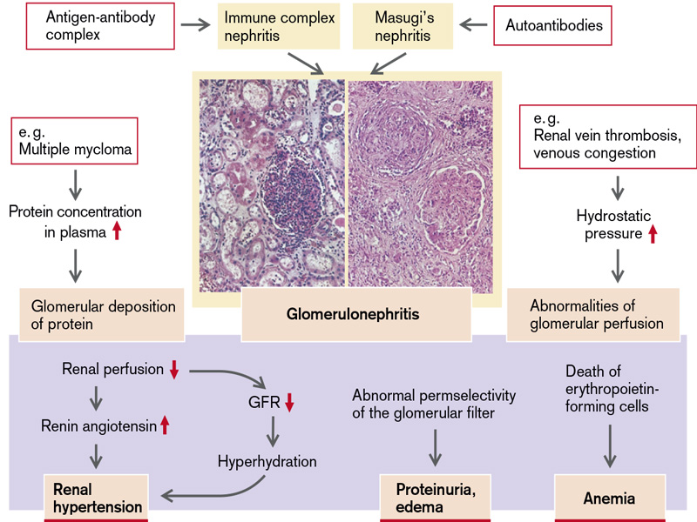
Fig.1 Causes and manifestations of glomerular disease
(From S. Silbernagl and F. Lang; Color Atlas of Pathophysiology)

Qualitative changes of glomerular filtrate
Qualitative changes of the glomerular filtrate are represented by changes in its chemical composition.
• Glomerular proteinuria
Proteins in the primary urine have a plasmatic origin and the origin is related to increased permeability of the renal filter developed as result of alterative processes, presence of inflammatory or degenerative diseases (glomerular nephropathies), nephron hypoxia (cardiovascular insufficiency, kidney compression or twisted renal vascular pedicle). Selective proteinurias are conditioned by minor glomerular damages when albumins represent 85% from total proteinuria, while the rest are represented by globulins with low molecular mass (alfa1 - globulins, transferrin). Severe glomerular injuries induce massive non-selective proteinurias with presence of transferrin, IgG, IgM and beta lipoproteins in the urine.
According to type of manifestation, glomerular proteinurias can be transitory (intermittent) and permanent. Transitory glomerular proteinurias are induced by renal hemodynamic changes: by one hand there is decreased kidney blood flow and volume of glomerular filtrate concomitantly with increased glomerular basement membrane permeability and decreased tubular reabsorption of proteins as result of reduced peritubular blood flow by other hand. This is the pathogenic mechanism that explains development of orthostatic proteinuria (postural proteinuria),lordotic proteinuria, cold proteinuria, proteinuria in stasis.

• Hematuria
In physiological conditions, with urine there are lost about 2000 erythrocytes per minute (up to 12500 RBC /ml of urine). When this number is exceeded, there is a pathological state called hematuria. Hematuria can be visible (macroscopic hematuria), or can be detected only on dipstick test (microscopic hematuria). Hematuria may be caused by multiple general disorders (acute and chronic infectious diseases, collagenosis, liver failure and avitaminosis), kidney diseases (acute and chronic nephritis, nephrolithiasis, nephocalcinosis, oxalosis, tuberculosis, hydronephrosis, renal infarction, lumbar traumas), diseases of urinary pathways (urolithiasis, malignant and benign tumors, polyps of urinary bladder, vesico-uretethral malformations and so on). True positive test can be found during menstruation or strenuous exercise
Hematuria of glomerular origin is accompanied by hemic dipsticks. The pathophysiological mechanism of glomerular hematuria is represented by diapedesis of erythrocytes through the renal filter which has increased permeability. Dipstick test for hematuria can be also positive in case of hemoglobinuria which is characteristic for intravascular hemolysis as well as for myoglobinuria which occurs in rhabdomyolysis.
• Glomerular leucocyturia.
The presence of 10 or more leucocytes per cubic millimeter in fresh mid-stream urine samples is abnormal. Leucocyturia is a general signs of kidney disorders, as well as disorders of urinary pathways. Usually it is met more frequent in infectious diseases of urinary pathways and less in degenerative renal disorders or in glomerulonephritis. Leucocyturia accompanied by hematuria and positive dipstick test usually has glomerular origin. It is explained by increased leucocytes diapedesis through filtrating membrane in case of glomerulonephritis with exudative component. Leucocyturia when there are more than 100 leucocytes in visual field is called pyuria.
- Glomerular lipiduria. Lipiduria represents presence of different lipid fraction in the urine. Lipiduria develops as result of general metabolic dysfunctions in nephrotic syndrome as well as in lipid dystrophies of tubular epithelium.
- Bacteriuria – presence of bacteria in the urine and is highly suggestive for urinary infection.

Dysfunctions of canalicular reabsorbtion
Reabsorption ability of different tubular segments of the kidneys is not equivalent.
Epithelium of proximal tubules. Cells of the proximal tubules (till the loop of Henley) supplies 65% of total reabsorbtion of glomerular filtrate. Epithelial cells of the proximal tubule are characterized by a very intense metabolism, contain a considerable number of mitochondria that assure intense processes of active transport. Apical part of membrane of these cells is supplied with microvilli and transport proteins which perform transportation of substances absorbed from the tubular lumen into interstitium (glucose and amino acid) as well as antiport of substances secreted from blood into the renal tubules (hydrogen ions).
Thin segment of the loop of Henley. Epithelium of the loop of Henley is rich in cells with brush border margins, but they contain only few mitochondria, being a sign of low metabolic activity. The descending part of thin segment of loop of Henley is highly permeable to water but it possesses just a gentle permeability to urea, sodium and other ions. The ascending part of thin segment of the loop of Henley is even less permeable to water than the descending part.
Thick segment of the loop of Henley. Epithelial cells of the thick segment of the loop of Henley are similar with cells of proximal tubules. These are adapted to an active process of transport of sodium and chloride from tubular lumen into interstitium but are impermeable to water and urea.
Distal tubule is divided into dilution segment and terminal part. In the dilution segment a high amount of ions is easily reabsorbed, but the tubule remains impermeable to water and urea. This is why, this segment performs dilution of tubular liquid, in a similar way as do the thick segment of the loop of Henley. The epithelium of the terminal part of the distal tubule and collective tubes are impermeable for urea, in this way the whole amount of urea flows into the collective tube to be excreted with terminal urine. Both segments considerably absorb sodium with the support of aldosterone. The terminal part of the distal tubule and cortical collective tube contain some special epithelial cells called intercalate cells, that secrete hydrogen ions, by an active mechanisms against the gradient of concentration, thus performing the control of the acid–base balance of body liquids. Terminal part of the distal tubule and the collective tube is permeable to water only in the presence of antidiuretic hormone being totally impermeable in its absence, a fact that represents an efficient control mechanism of the urine dilution and maintenance of water homeostasis.

Each substance has its own specific mechanisms of reabsorbtion (Fig.2).
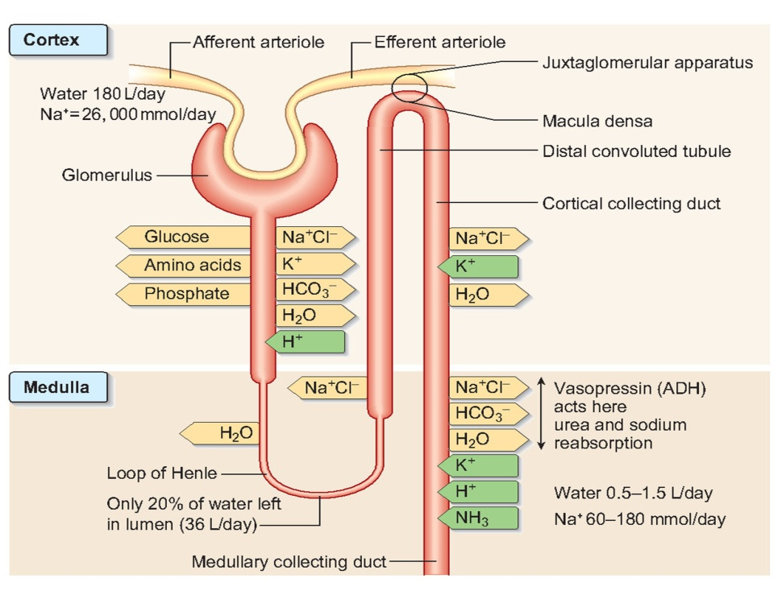
Fig.2 Reabsorbtion and secretion in the kidneys
(From C. Porth and G. Matfin; Pathophysiology. Concepts of altered health states).

• Reabsorbtion of water and electrolytes
Water and sodium are subjected to a process of active reabsorbtion on the level of proximal renal tubes. Reabsorption of sodium on the level of proximal channel, also called compulsory reabsorption, is an active process that occurs with energy consumption and is coupled with a passive process of water reabsorbtion. On the level of loop of Henley 6% of the water of the filtrate is reabsorbed, 9% in the distal tube and on the level of collective tube – 4%. Water reabsorbtion on the level of distal convoluted tubes happens in the presence antidiuretic hormone (vasopressin) (Fig.2). Vasopressin acts on specific V₂ receptors localized on cytoplasmatic membrane of epithelial cells, activates intracellular adenylate-cyclase and synthesis of AMPc that stimulates intra-membrane structure orientation with their reorientation into luminal membrane and inclusion into the membrane composition of the proteinic channels that totally permit the water to pass.
Disorders of water reabsorbtion at the level of the proximal renal tubes could be a result of increased amount of un-reabsorbed osmotic substances that induce osmotic diuresis (diabetes mellitus, administration of osmotic diuretics like urea and manitol or administration of furosemid that inhibit the reabsorbtion of sodium ions). Decreased water reabsorbtion in the distal and collector tubes is conditioned by lack of antidiuretic hormone, dystrophy of tubular epithelium and insensitiveness to this hormone (diabetes insipidus). Taking into consideration that collective tubes pass through the medullary layer of the kidney, interstitial pathology like renal amyloidosis and renal sclerosis lead to disorders of water reabsorbtion.

Sodium reabsorbtion
Entrance of sodium into the cells of proximal convoluted tubes is coupled with glucose and amino-acids transport (co-transport) (Fig.2).
In the distal tubes, sodium reabsorbtion is regulated by aldosterone. The main stimulant of aldosterone secretion is decreased correlation of sodium and potassium in the plasma. Aldosterone acidulates the urine and alkalifies the plasma. The regulation of the sodium secretion is important for both, osmotic and acid-base homeostasis taking into account that this ion represents 90% from total amount of extracellular cations.
Potassium, which is reabsorbed on the apical pole of the proximal tubule’s epithelial cells, together with sodium and water, ultimately is secreted in the ascending part of the loop of Henley and in distal tubes together with H⁺ ions in exchange to sodium ions. K⁺ secretion in the distal renal tubes and collective tubes increases directly with increased its intracellular concentration, as well as under the influence of aldosterone, which at the same time slows down sodium secretion. When extracellular concentration of K⁺ increases, these ions diffuse into epithelial cells of distal and collective renal tubes. A passive secretion of K⁺ is also conditioned by electronegativity of urinary channels as result of sodium reabsorbtion.
Disorders of sodium reabsorption are caused by lack of aldosterone or its blockage by inhibitors (aldactone). A considerable amount of sodium ions is lost in tubular atrophy or injury, leading to dehydration due to osmotic diuresis. Disorders of sodium and bicarbonates reabsorbtion are attested in disorders of ammonio- and acido-genesis at the level of tubular epithelium, leading to acidosis. In these cases, kidneys inability to reabsorb ions of sodium is manifested by osmotic, hydric and acid-base dyshomeostasis.
Anorganic phosphate is reabsorbed at the level of proximal tubes in proportion of 80% - 90%, that of calcium in proportion of 96%, the rest being eliminated with final urine. Active trans-tubular transport of phosphate is inhibited by parathormone that at the same time contributes to the reabsorbtion of calcium, and by corticosteroids (inhibit as well calcium reabsorbtion). Vitamin D (calcitriol) stimulates reabsorbtion of phosphates. It worth mentioning that, reabsorbtion of calcium is influenced by calciemia (when Ca concentration in the blood is lower than 8 mg/dL the reabsorbtion is stimulated, when blood Ca concentration is higher than 10 mg% – reabsorbtion is inhibited).
Renal reabsorbtion of bicarbonate. The plasma HCO₃– is normally maintained at approximately 25 mmol/L. In individuals with normal glomerular filtration rate (120 ml/min) about 4500 mmol of bicarbonate if filtered each day. If this filtered bicarbonate were not reabsorbed, the plasma HCO₃⁻ would fall, along with blood pH. Thus, maintenance of normal plasma bicarbonate requires that all of the bicarbonate in the glomerular filtrate be reabsorbed. The proximal convoluted tubule reclaims 85-90% of filtered bicarbonate; in contrast the distal tube reclaims very little. This difference is caused by the greater quantity of luminal carbonic anhydrase in the proximal tubule than in the distal nephron (Fig.3). As result of this quantitative difference, bicarbonate that escapes reabsorbtion at the level of proximal tubule is excreted in the urine. Proximal tubular bicarbonate reabsorbtion is catalysed by the Na⁺/K⁺ ATP-ase pump located in the basolateral membrane of tubular cells. By exchanging peritubular potassium with intracellular sodium ions, the pump keeps the intracellular Na⁺ ions low, allowing these ions to enter the cell by moving down the sodium concentration gradient from the tubule lumen to the cell interior. H⁺ ions are transported in the opposite direction, thereby maintaining elecroneutrality. Before bicarbonate enters the proximal convoluted tubule it combines with these secreted H⁺ ions forming carbonic acid. In the presence of luminal carbonic anhydrase carbonic acid rapidly dissociate into CO₂ and H₂O, which can then rapidly enter into proximal tubular cell. In the cell CO₂ is hydrated by cytosolic carbonic anhydrase forming bicarbonate, which is then transported down an electrical gradient from the cell interior across the membrane into the peritubular fluid and finally into the blood. In this process each H⁺ ions which is secreted into the proximal tubule lumen is reabsorbed and can be resecreted; so there is no net loss of H⁺ and no gain of bicarbonate ions.
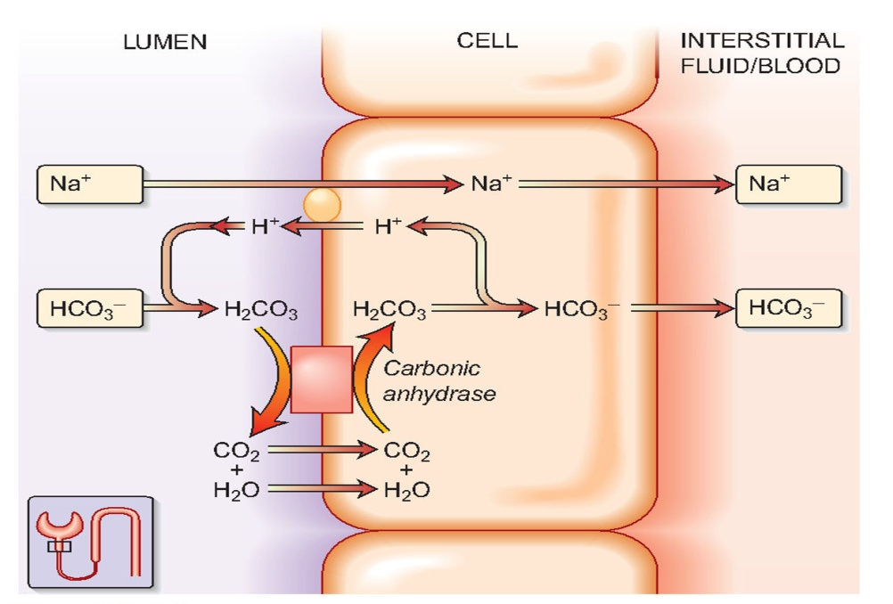
Fig.3 Renal reabsorption of bicarbonate
(From C. Porth and G. Matfin; Pathophysiology. Concepts of altered health states).

Reabsorbtion of organic substances
The glomerular filtrate contains five groups of substances with different nutritional value for the organism: carbohydrates (glucose), proteins, amino acids, ions of aceto-acetate and vitamins. All these substances are totally reabsorbed by an active transport in proximal tubes.
Reabsorbtion of proteins
Through renal filter during 24 h pass about 30 g of proteins. If they don’t come back into the blood it would be a considerable loss for the body. Because sizes of protein macromolecules are too large for being transported by usual mechanisms, these are transported through the membrane of proximal tubes by pinocytosis.
Tubular proteinurias are explained by decreased channel reabsorbtion of proteins filtrated through the glomerular filter as result of inflammation, dystrophy (amyloidosis, sclerosis) or desquamation of tubular epithelium, disorders of lymphatic circulation in the kidneys.
Tubular reabsorbtion of glucose
When the concentration of glucose in the blood is normal (about 100 mg/dl) it is totally reabsorbed at the level of the first third of proximal renal tubes so that glucose in final urine is lacking. Until its concentration does not exceed 170-180 mg/dL, glucose is totally reabsorbed; the quantity that exceeds this glucose threshold can’t be more reabsorbed and will be present in final urine – glucosuria. Exceeding kidney glucose threshold represent mechanisms of glucosuria in physiological hyperglycemia and partially in diabetes mellitus. Glucosuria leads to osmotic diuresis, decreases the volume of extracellular liquid.
Decreased glucose reabsorbtion may be also explained by hereditary deficiency in ferments responsible for it reabsorbtion (hexokinase). Glucosuria developed in intoxications (urea, Pb, Hg) may be explained by direct toxic effect on the transporting system of the renal tubes. In this way, renal diabetes encountered in poisoning with potassium cyanide is a result of toxic effect on the renal hexokinase.
Reabsorbtion of amino acids.
Tubular reabsorbtion of amino acids is performed by active mechanisms, specific for every group of amino acids with a specific affinity to the transporter. Mechanisms of amino acids reabsorbtion function by means of diffusion independently of gradient of concentration. Every amino acid has a specific tubular point when its reabsorbtion is equal to its diffusion. Increased amino acids elimination with the secondary urine is called aminoaciduria. Aminoaciduria develops in enzyme defects that ensure glucose transport at the level of proximal tubes and may be observed in renal diseases with tubular disorders. Excessive excretion of amino acids may be found during intense catabolic processes in burns, in liver diseases.
Defects of the enzymatic systems of the epithelium of proximal renal tubes are present in Fanconi syndrome, that is manifested through disorders of amino acids, glucose, phosphates reabsorbtion and development of acidosis. The loss of phosphates leads to development of rickets that is resistant to vitamin D (phosphate diabetes).

Pathological processes that disturb tubular reabsorbtion
Renal phosphate diabetes (vitamin D resistant rickets, hypophosphatemic rickets) is a syndrome that can be both, congenital and acquired. The illness is manifested by hyperphosphaturia and hypophosphatemia, rickets (in children) and osteomalacia (in adult) because phosphate deficit lead to bone demineralization, hypocalciuria and increased activity of alkaline phosphatase in the blood. As pathogenetic mechanism of vitamin D resistant rickets are supposed to be a defect of enzymatic system of tubular transport of phosphates at the level of proximal convoluted tube. It is considered that, there are also calcium and phosphate absorbtion disorders on the level of the intestine because of a secondary hyperparathyroidism.
Increased renal reabsorbtion of phosphate can develop in deficiency of parathormone (hypoparathyroidism) or in dysfunction of parathyroid glands (pseudo-hypoparathyroidism). This leads to hyperphosphatemia.
Toni-Debre-Fanconi syndrome is a congenital or acquired (poisoning by heavy metals) complex tubulopathy. The mechanism of functional changes is represented by blockage of enzymatic systems at the level of proximal convoluted tubes or presence of some disorders with secondary enzymatic deficiency. Lack of ferments on the level of transporting systems does not allow generation of energy in the Krebs cycle, necessary for the transporting processes. Loss of phosphates (phosphaturia), glucose (glucosuria) and aminoacids (aminoaciduria), proximal tubular acidosis lay on the basis of clinical symptoms: polyuria, constipation, vitamin D resistant rickets (in children) or osteomalacia (in adult).
Dysfunction of the tubular secretion
Renal secretion of H⁺ ions. H⁺ secreted into the proximal tubule are almost completely reabsorbed with bicarbonate; so, proximal tubular hydrogen ions secretion do not contribute significantly to H⁺ elimination from the body. The excretion of daily acid load requires secretion of H⁺ ions at the level of distal nephron segments (Fig.4). The excretion of H⁺ occurs primarily in the collecting tubules, which has two types of cells:
- The principal cells – aldosteron sensitive Na⁺ absorbtion site. These cells reabsorbed Na⁺ ions and water and excrete K⁺ under the influence of aldosteron.
- α intercalated cells – these cells posses the proton pump for the active secretion of H⁺ ions in the exchange for reabsorbtion of K⁺ ions.
Aldosteron increase secretion of H⁺ ions. Aldosteron has several facilitating effects on H⁺ ions secretion. Aldosteron opens sodium channels in the luminal membrane on the principal cells and increases activity of Na⁺/K⁺ ATP-ase. The subsequent movement of cationic sodium ions into the principal cells creates a negative charge within the tubular lumen. K⁺ ions from principal cells and H⁺ ions from intercalated cells move out from the cell into tubular lumen. Aldosteron also stimulates directly the H⁺ATP-ase at the level of intercalated cells enhancing even more H⁺ secretion.
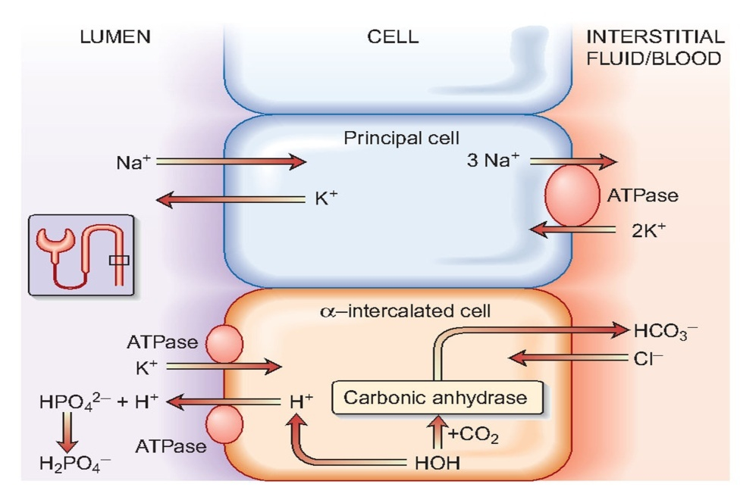
Fig.4 Renal excretion of H⁺ ions
(From C. Porth and G. Matfin; Pathophysiology. Concepts of altered health states).

Ammonium (NH₄⁺). All ammonia used to buffer urinary H⁺ ions in collecting tubule is synthesized in proximal convoluted tube. Glutamine is the primary source of NH₄⁺. It undergoes deamination catalysed by glutaminase, resulting in α-ketoglutaric acid and ammonia (NH₃) (Fig.5). Once formed, ammonia can diffuse into proximal tubular lumen and becomes acidified forming ammonium (NH₄⁺). Ammonium flows along tubular lumen and at the level of thick ascending part of loop of Henle it diffuse into medullary interstitium. Here, NH₄⁺ dissociates to NH₃, leading to a high ammonia concentration in the renal interstitium. Next, NH₃ diffuses down its concentration gradient into the lumen of collecting tubule. Here its reacts with H⁺ ions secreted by collecting tubular cells to form again ammonia (NH₄⁺). Because ammonia is lipid-insoluble it is trapped into tubular lumen and excreted in the urine as ammonium chloride. α-ketoglutaric acid at the level of proximal convoluted tubule is breaks down to bicarbonate which is secreted into the peritubular fluid at an Na⁺/HCO₃⁻ cotransporter.

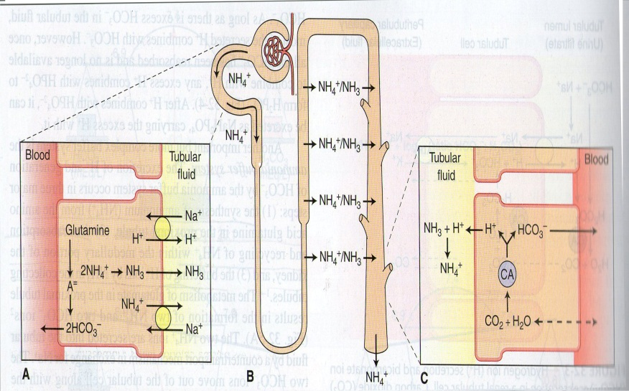
Fig.5 The ammonia buffer system in the kidneys
(A) Glutamine is metabolized in the proximal tubule to produce two NH₄⁺ and two bicarbonate ions (HCO₃⁻). The two NH₄⁺ are secreted into the tubular fluid and the two HCO₃⁻, which represent the new HCO₃⁻ are returned to the circulation. (B) A significant portion of secreted NH₄⁺ is reabsorbed in the medullary interstitium, where it exist as both NH₄⁺ and NH₃.. (C) The NH₃ diffuses into the tubular fluid of the collecting tubule, where it interacts with secrete H⁺ to form NH₄⁺, which is eliminated in the urine. For each NH₄⁺ excreted in the urine, another HCO₃⁻ is returned to the circulation. (CA – carbonic anhydrase). (From C. Porth and G. Matfin; Pathophysiology. Concepts of altered health states).

Renal tubular acidosis
Renal tubular acidosis refers to a group of tubular defects in reabsorption of bicarbonate ions (HCO₃⁻) or excretion of hydrogen ions (H⁺) that result in metabolic acidosis and its subsequent complication, including metabolic bone disease, kidneys stones and growth failure in children. There are two main types of renal tubular acidosis: proximal tubular disorders that affect tubular bicarbonate reabsorption and distal tubular defects that affect the secretion of fixed metabolic acids. A third type of renal tubular acidosis results from aldosterone insufficiency or resistance to its action that lead to impaired absorbtion of Na⁺ ions with reduced elimination of H⁻ ions and K⁺ ions. Renal acidosis also occurs in kidney failure.
Disorders of urine dilution and concentration
Normally, in function of necessities, the kidneys can eliminate hypotonic urine (osmolarity less than 100 mOsm/L) or hypertonic urine (osmolarity more than 1200 mOsm/L). Urine dilution and concentration represent two processes with the help of which there is performed either retention of electrolytes (urine dilution) or retention of water (urine concentration). Retention of electrolytes in the process of urine dilution is accompanied by elimination of excess of water with a small amount of electrolytes. Water reabsorbtion with urine concentration is accompanied by elimination of urine with excessive electrolytes and small amount of water.
Osmolarity of the final urine varies – a normal kidney eliminates urine with a density of 1005 - 1035 mOsm/L that is called normosthenuria.
Hyposthenuria (water diuresis) - is a dysfunction of the urine concentration mechanism characterized by elimination of urine with an osmolarity less than the osmolarity of the plasma. It could be met in hyperhydration of the body (hypervolemia), diabetes insipidus (lack of ADH), during the compensated stage of chronic renal failure. It is accompanied by polyuria. Hyposthenuric polyuria can be the result of injuries at the level of distal convoluted tubes with their inability to concentrate hypotonic urine which come from the ascending thick segment of the loop of Henle.
Isosthenuria - is a dysfunction of the urine dilution and concentration mechanism characterized by elimination of urine with osmolarity equal to that of deproteinated plasma. This dysfunction develops in diffuse injuries of renal epithelium at the level of collecting tubes as well as at the level of Henle loop. In this situation there is no normal passage of sodium ions into renal interstitium and dilution of urine at the level of thick segment of the loop of Henle. In isosthenuria maintenance of interstitiumhyperosmolarity is impossible.
Hypersthenuria is characterized by elimination of urine with an osmolarity higher than 1035 mOsm/L and is characteristic for dehydration, diabetes mellitus. This dysfunction is usually accompanied by oliguria.

Renal edemas. Renal edemas are divided into nephritic and nephrotic. Main link in development of nephrotic edema is impaired tubular reabsorption of proteins from primary urine, especial albumin, and excessive loss of proteins with urine (proteinuria), which leads decreased level of albumins in the blood (hypoproteinemia, hypoalbuminemia) with decreased oncotic pressure. Proteinuria in nephrotic syndrome is related with selective increase in glomerular membrane permeability and excessive filtration of proteins through the renal filter, as well as disorders in their reabsorption at the level of renal tubules. Urine protein loss can reach up to 30-50 g/24 h (in normal conditions does not exceed 50 mg). So, the main pathogenic mechanism of nephrotic edema is related to reduced oncotic pressure in the blood. Hypoproteinemia increases fluid leakage from vessels into interstitium leading to development of hypovolemia. Resultant hypovolemia will reduce the cardiac output leading to redistribution of circulation with renal hypoperfusion and activation of renin-angiotensin-aldosterone system with retention of sodium and water. By this pathway there will be involvement of second pathogenetic mechanism in renal edemas – plasma hyperosmolarity, which will stimulate ADH secretion. This will increase water reabsorption at the level of the kidney.
Nephritic renal edema develops in case of acute diffuse glomerulonephritis that favor retention of water and salts in the body. These are mainly due to excessive secretion of aldosterone in the result of renal ischemia (at the level of the renal cortex), that contributes to activation of renin-angiotensin-aldosterone system. Hypernatremia activates ADH secretion, which contributes to increased reabsorption of water in distal collecting tubules. In patients with glomerulonephritis there were found increased activity of plasmatic kallikrein that increases vascular permeability. So, in pathogenesis of nephritic renal edema are involved the hyperosmotic and membranogenic mechanisms of edema. The characteristic features of nephritic edema are:
- increased protein level in edematous fluid;
- increased hydrophilic properties of connective tissue due to aldosterone, ADH, active biologic substances, kinin and prostaglandins action.

Disorders of urine evacuation
Disorders of urine voiding can be induced by pathological processes which lead to obstruction or compression of the urinary pathways. The most frequent causes are: calculi, prostate adenoma, tumors in the urinary pathways.
Urolythiasis is a disorders characterized by presence of calculi at the level of urinary pathways.
Etiological factors for renal calculi as well as calculi at the level of urinary pathways conventionally can be classified into two groups:
- Exogenous factors :
- Intake of water with high concentration of Ca ions;
- Intake of food with vitamin deficiency (especially deficiency of vitamin A);
- Infectious factors: infection at the level of urine pathways, digestive tract, genital organs etc…
- Endogenous cases:
- Metabolic disturbances
- Endocrine disorders (thyroid and parathyroid dysfunction).
Main conditions for development of nephrolithiasis and urolithiasis are:
- Decreased urinary level of substances which maintain the urinary salts in dissolved state (urea, creatinin, xantin, citrates) and inhibitors of salt cristalization (anorganic pyrophosphate);
- Increased urinary level of agents which trigger the process of salt cristalization (mucoproteins, salts of pyruvic acid, collagen, elastin);
- Changed urinary pH: at a pH of 5,0 predominantly sedimentate the salts of uric acid, at pH 7,0 – precipitate salts of ammonia and Ca phosphate;
- Increased concentration of salts in the urine;
- Disturbances in the process of urine voiding - urostasis
Pathogeny of nephron-urolithiasis. According to crystallization theory, the process of calculi development is initiated by salt crystallization with subsequent involvement of organic components (fibrin and collagen). According to colloidal theory primarily there is development of organic matrix on which later occur salt crystallization.
Onset of renal lithiasis is in the context of infections at the level of the urinary apparatus or associates to infections which develop primarily, sometimes being difficult to determine the cause-effect interrelations. Definition of infectious calculi means calculi formed from magnesium phosphate, ammonium phosphate and carbonic apatite in the development of which a decisive role have infections at the level of the urinary system.
A compulsory factor for development of infectious calculi is the rapid breakdown of urea to ammonia and carbon dioxidwe under the action of bacterial urease. Only in the presence of this enzyme alkaline reserves of the urine, ammonia concentration, bicarbonate and carbon become sufficient to trigger crystallization of phosphates and carbonic apatite. Urease is secreted just by some bacteria, this is why their multiplication in the urine represent the main pathogenetic loop in calculi development.
Hypercalciuria can be the consequence of long-lasting immobilization, high amount of vitamin D, tubule-renal acidosis, primary hyperparathyroidism etc… Primary hypercalciuria is directly related to exaggerated absorbtion of calcium at intestinal level, which induce moderate increase of calcium level in the extracellular spaces, decreased production of parathormone leading to blockage of calcium reabsorbtionfrom renal tubes. Renal hypercalciuria represents a defect in calcium tubular reabsorbtion, inherited or acquired, determined by inability of the kidneys to retain calcium ions, these being excessively lost with urine.
Consequences of nephrolithiasis are hydronephrosis, nephrosclerosis, pyelonephritis, renal abscesses.

Disorders of endocrine function of the kidneys
Endocrine function of the kidneys is realized by juxtaglomerular apparatus which release renin, vasodilatator factor – meduline, erythropoietin and kininogenes.
Renin represents a proteolytic enzyme synthetized by granular juxtaglomerular cells. Release of renin in the bloodstream is triggered by stimuli originating at different levels of juxtaglomerular apparatus. The final result is conversion of inactive angiotensinogen in active angiotensin. Control of renin release at the level of juxtaglomerular apparatus is performed by more factors:
- Renalbloodflow;
- Changes in the plasmatic and urine level of sodium ions;
- Changes in the total blood volume;
- Changes in the activity of the vegetative system.
Role of renin-angiotensin system. There was demonstrated that active angiotensin has vasoconstrictor effect as well as increases release of aldosterone. By vasconstrictive effects, release of aldosterone, renin angiotensin system leads to increased peripheral vascular resistance as well as to increased volume of circulatory blood, all these leading to arterial hypertension.
Erythropoietin. In the result of renal hypoxia the kidneys release in the bloodstream a factor which stimulates erythrocytopoiesis – erythropoietin. Stimulation of erythrocytopoiesis by erythropoietin leads to increased volume of the blood due to increased number of red blood cells.
Renal vasodilator factor. In the medullary zone of the kidneys were described interstitial cells which release “antihypertensive renomedullary lipid”.
Prostaglandins.At the level of the kidneys were put into evidence more types of prostaglandins (PGE₂, PGF_{1-alpha}, PGA₂, PGF₂-alpha). At the level of urinary tubes prostaglandins lead to decreased sodium reabsorbtion and enhanced losses of these with urine.
Kinin-formator enzymes. Kininogenes (kalicreinogene) released in the bloodstream act on plasma globuline (kininogen) with formation of a biological active substances – bradykinin. In the bloodstream plasma kinines manifest multiple effects, trough these vasodilation and increased permeability of capillaries.

Manifestations of renal disorders in the organs of the mouth
In case of pathologic processes in the kidneys there are microcirculatory disturbances, general intoxication (uremia) which have negative effects on mouth mucosa decreasing its barrier function by reducing resistance to action of environmental factors. Chronic kidney disorders are accompanied by inflammation at the level of paradentium in the result of aggressive anti-inflammatory therapy and immune deficiency in the body. At the level of masticatory muscle there can be found typical metabolic changes. In patient with chronic kidney disesases is present a week inflammatory process in the paradont concomitantly with retraction of gums and hyperesthesia of hard bone tissues.
In case of chronic kidney disease in the saliva can be detected increased activity of lactadehydrogenase (LDH) and alkaline phosphatase, without changes in activity of these enzymes in the blood. Increased activity of fraction LDH₁ and LDH₂ in the saliva represents a marker of enhanced anaerobic glycolytic processes. Increased activity of alkaline phosphatase is induced by migration of neutrophils in the mouth.
In children, nephrogenic osteodystrophy are characterized by identical changes at the level of osteo-cartilaginous tissue which are characteristic for rickets. In adults there is characteristicosteomalacia induced by disorders in the metabolism of vitamin D.

•

