PATHOPHYSIOLOGY OF CARDIOVASCULAR SYSTEM
ARTERIAL HYPERTENSION
HEART ARRHYTHMIAS
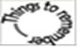 The structure and function of blood vessels
The general architecture and cellular composition of blood vessels are the same throughout the cardiovascular system. However, certain features of the vasculature vary with and reflect distinct functional requirements at different locations. To withstand the pulsatile flow and higher blood pressures in arteries, arterial walls are generally thicker than the walls of veins. Arterial wall thickness gradually diminishes as the vessels become smaller, but the ratio of wall thickness to lumen diameter becomes greater.
The basic constituents of the walls of blood vessels are endothelial cells and smooth muscle cells, and extracellular matrix (ECM), including elastin, collagen, and glycosoaminoglycans. The three concentric layers - intima, media, and adventitia - are most clearly defined in the larger vessels, particularly arteries. In normal arteries, the intima consists of a single layer of endothelial cells with minimal underlying subendothelial connective tissue. It is separated from the media by a dense elastic membrane called the internal elastic lamina. The smooth muscle cell layers of the media near the vessel lumen receive oxygen and nutrients by direct diffusion from the vessel lumen, facilitated by holes in the internal elastic membrane. However, diffusion from the lumen is inadequate for the outer portions of the media in large and medium-sized vessels, therefore these areas are nourished by small arterioles arising from outside the vessel (called vasa vasorum, literally “vessels of the vessels”) coursing into the outer one half to two thirds of the media. The outer limit of the media of most arteries is a well-defined external elastic lamina. External to the media is the adventitia, consisting of connective tissue with nerve fibers and the vasa vasorum.Based on their size and structural features, arteries are divided into three types: (1) large or elastic arteries, including the aorta, its large branches (particularly the innominate, subclavian, common carotid, and iliac), and pulmonary arteries; (2) medium-sized or muscular arteries, comprising other branches of the aorta (e.g., coronary and renal arteries); and (3) small arteries (less than approximately 2 mm in diameter) and arterioles (20 to 100 μm in diameter), within the substance of tissues and organs
The relative amount and configuration of the basic constituents differ along the arterial system owing to local adaptations to mechanical or metabolic needs. These structural variations, from location to location, are principally in the media and in the ECM. In the elastic arteries the media is rich in elastic fibers. This allows vessels such as the aorta to expand during systole and recoil during diastole, thus propelling blood through the peripheral vascular system. With aging, the aorta loses elasticity, and large vessels expand less readily, particularly when blood pressure is increased. Thus, the arteries of older individuals often become progressively tortuous and dilated (ectatic). In muscular arteries the media is composed predominantly of circularly or spirally arranged smooth muscle cells. In the muscular arteries and arterioles (see below), regional blood flow and blood pressure are regulated by changes in lumen size through smooth muscle cell contraction (vasoconstriction) or relaxation (vasodilation), controlled in part by the autonomic nervous system and in part by local metabolic factors and cellular interactions. Since the resistance of a tube to fluid flow is inversely proportional to the fourth power of the diameter (i.e., halving the diameter increases resistance 16-fold), small changes in the lumen size of small arteries caused by structural change or vasoconstriction can have a profound effect. Thus, arterioles are the principal points of physiologic resistance to blood flow.
Capillaries, approximately the diameter of a red blood cell (7 to 8 μm), have an endothelial cell lining but no media. Collectively, capillaries have a very large total cross-sectional area; within the capillaries, the flow rate slows dramatically. With thin walls only and slow flow, capillaries are ideally suited to the rapid exchange of diffusible substances between blood and tissues. As normal tissue function depends on an adequate supply of oxygen through blood vessels, and since diffusion of oxygen in solid tissues is inefficient over distances of greater than approximately 100 μm, the capillary network of most tissues is very rich. Metabolically highly active tissues, such as the myocardium, have the highest density of capillaries.
Blood from capillary beds flows initially into the postcapillary venules and then sequentially through collecting venules and small, medium, and large veins. In many types of inflammation, vascular leakage and leukocyte exudation occur preferentially in postcapillary venules.
Relative to arteries, veins have larger diameters, larger lumens, and thinner and less well organized walls. Thus, because of their poor support, veins are predisposed to irregular dilation, compression, and easy penetration by tumors and inflammatory processes. The venous system collectively has a large capacity; approximately two thirds of all the blood is in veins. Reverse flow is prevented by venous valves in the extremities, where blood flows against gravity.
Lymphatics are thin-walled, endothelium-lined channels that serve as a drainage system for returning interstitial tissue fluid and inflammatory cells to the blood. Lymphatics constitute an important pathway for disease dissemination through transport of bacteria and tumor cells to distant sites.
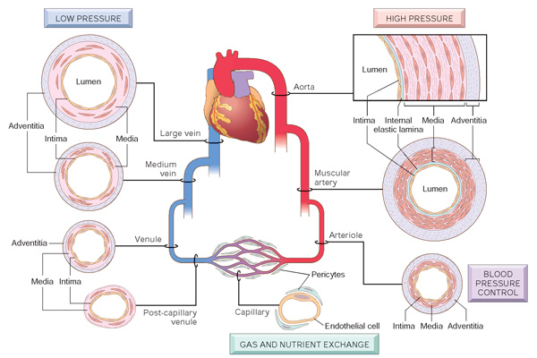
Regional specializations of the vasculature. Although the basic organization of the vasculature is constant, the thickness and composition of the various layers differ according to hemodynamic forces and tissue requirements. (From Robbins-Cotran; Pathological basis of disease)

The arterial blood pressure reflects the rhythmic ejection of blood from the left ventricle into the aorta. It rises during systole as the left ventricle contracts and falls as the heart relaxes during diastole, giving rise to a pressure pulse. The systolic blood pressure reflects the rhythmic ejection of blood into the aorta. As blood is ejected from the left ventricle into the aorta, it stretches the vessel wall and produces a rise in aortic pressure. The extent to which the systolic pressure rises or falls with each cardiac cycle is determined by the amount of blood ejected into the aorta with each heart beat (stroke volume), the velocity of ejection, and the elastic properties of the aorta. Systolic pressure increases when there is a rapid ejection of a large stroke volume or when the stroke volume is ejected into a rigid aorta. The diastolic blood pressure is maintained by the energy that has been stored in the elastic walls of the aorta during systole. The pulse pressure is the difference between the systolic and diastolic pressures. It reflects the pulsatile nature of arterial blood flow and is an important component of blood pressure. The mean arterial blood pressure represents the average blood pressure in the systemic circulation. Mean arterial pressure can be estimated by adding one third of the pulse pressure to the diastolic pressure (diastolic blood pressure + pulse pressure/3).
Regulation of normal blood pressure. Blood pressure is a function of cardiac output and peripheral vascular resistance, two hemodynamic variables that are influenced by multiple genetic, environmental, and demographic factors. The major factors that determine blood pressure variation within and between populations include age, gender, body mass index, and diet, particularly sodium intake. Cardiac output is highly dependent on blood volume, itself greatly influenced by the sodium homeostasis. Peripheral vascular resistance is determined mainly at the level of the arterioles and is affected by neural and hormonal factors. Normal vascular tone reflects the balance between humoral vasoconstricting influences (including angiotensin II, catecholamines, and endothelin) and vasodilators (including kinins, prostaglandins, and NO). Resistance vessels also exhibit autoregulation, whereby increased blood flow induces vasoconstriction to protect against tissue hyperperfusion. Other local factors such as pH and hypoxia, and the α- and β-adrenergic systems, which influence heart rate, cardiac contraction, and vascular tone, may also be important in regulating blood pressure. The integrated function of these systems ensures adequate perfusion of all tissues, despite regional differences in demand.
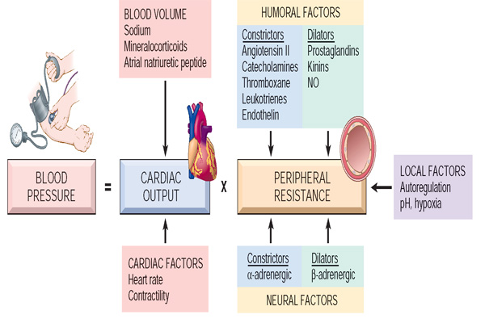
Factors which control the blood pressure (From Robbins-Cotran; Pathological basis of disease)
Short-term regulation of blood pressure. The mechanisms for short-term regulation of blood pressure, those occurring over minutes or hours, are intended to correct temporary imbalances in blood pressure, such as occur during physical exercise and changes in body position. These mechanisms also are responsible for maintenance of blood pressure at survival levels during life-threatening situations. The short-term regulation of blood pressure relies mainly on neural and hormonal mechanisms, the most rapid of which are the neural mechanisms.
Neural mechanisms. The neural control centers for the regulation of blood pressure is located in the reticular formation of the lower pons and medulla of the brain where integration and modulation of autonomic nervous system (ANS) responses occur. This area of the brain contains the vasomotor and cardiac control centers and is often collectively referred to as the cardiovascular center. The cardiovascular center transmits parasympathetic impulses to the heart through the vagus nerve and transmits sympathetic impulses to the heart and blood vessels through the spinal cord and peripheral sympathetic nerves. Vagal stimulation of the heart produces a slowing of heart rate, while sympathetic stimulation produces an increase in heart rate and cardiac contractility. Blood vessels are selectively innervated by the sympathetic nervous system. Increased sympathetic activity produces constriction of the small arteries and arterioles with a resultant increase in peripheral vascular resistance. The ANS control of blood pressure is mediated through intrinsic circulatory reflexes, extrinsic reflexes, and higher neural control centers. The intrinsic reflexes, including the baroreflex and chemoreceptor-mediated reflex, are located in the circulatory system and are essential for rapid and short-term regulation of blood pressure. The sensors for extrinsic reflexes are found outside the circulation. They include blood pressure responses associated with factors such as pain and cold. The neural pathways for these reactions are more diffuse, and their responses are less consistent than those of the intrinsic reflexes. Many of these responses are channeled through the hypothalamus, which plays an essential role in the control of sympathetic nervous system responses. Among higher-center responses are those caused by changes in mood and emotion.
The baroreceptors are pressure-sensitive receptors located in the walls of blood vessels and the heart. The carotid and aortic baroreceptors are located in strategic positions between the heart and the brain. They respond to changes in the stretch of the vessel wall by sending impulses to cardiovascular centers in the brain stem to effect appropriate changes in heart rate and vascular smooth muscle tone. For example, the fall in blood pressure that occurs on moving from the lying to the standing position produces a decrease in the stretch of the baroreceptors with a resultant increase in heart rate and sympathetically induced vasoconstriction that causes an increase in peripheral vascular resistance. The arterial chemoreceptors are sensitive to changes in the oxygen, carbon dioxide, and hydrogen ion content of the blood. They are located in the carotid bodies, which lie in the bifurcation of the two common carotids, and in the aortic bodies of the aorta . Because of their location, these chemoreceptors are always in close contact with the arterial blood. Although the main function of the chemoreceptors is to regulate ventilation, they also communicate with cardiovascular centers in the brain stem and can induce widespread vasoconstriction. Whenever the arterial pressure drops below a critical level, the chemoreceptors are stimulated because of diminished oxygen supply and a buildup of carbon dioxide and hydrogen ions. In persons with chronic lung disease, systemic and pulmonary hypertension may develop because of hypoxemia.
Humoral mechanisms. A number of hormones and humoral mechanisms contribute to blood pressure regulation, including the renin-angiotensin-aldosterone mechanism and vasopressin. Other humoral substances, such as epinephrine, a sympathetic neurotransmitter released from the adrenal gland, have the effect of directly stimulating an increase in heart rate, cardiac contractility, and vascular tone. The renin-angiotensin-aldosterone mechanism plays a central role in blood pressure regulation. Renin is an enzyme that is synthesized, stored, and released by the kidneys in response to an increase in sympathetic nervous system activity or a decrease in blood pressure, extracellular fluid volume, or extracellular sodium concentration. Most of the renin that is released leaves the kidney and enters the bloodstream, where it acts enzymatically to convert an inactive circulating plasma protein called angiotensinogen to angiotensin I. Angiotensin I travels to the small blood vessels of the lung, where it is converted to angiotensin II by the angiotensin-converting enzyme that is present in the endothelium of the lung vessels. Although angiotensin II has a half-life of several minutes, renin persists in the circulation for 30 minutes to 1 hour and continues to cause production of angiotensin II during this time. Angiotensin II functions in both the short-term and long-term regulation of blood pressure. It is a strong vasoconstrictor, particularly of arterioles and to a lesser extent of veins. The vasoconstrictor response produces an increase in peripheral vascular resistance (and blood pressure) and functions in the short-term regulation of blood pressure. A second major function of angiotensin II, stimulation of aldosterone secretion from the adrenal gland, contributes to the long-term regulation of blood pressure by increasing salt and water retention by the kidney. It also acts directly on the kidney to decrease the elimination of salt and water.
Vasopressin, also known as antidiuretic hormone (ADH), is released from the posterior pituitary gland in response to decreases in blood volume and blood pressure, an increase in the osmolality of body fluids, and other stimuli. Vasopressin has a direct vasoconstrictor effect on blood vessels, particularly those of the splanchnic circulation that supplies the abdominal viscera. However, long-term increases in vasopressin cannot maintain volume expansion or hypertension, and vasopressin does not enhance hypertension produced by sodium-retaining hormones or other vasoconstricting substances. It has been suggested that vasopressin plays a permissive role in hypertension through its fluid-retaining properties or as a neurotransmitter that serves to modify ANS function.
Long-term regulation of blood pressure. Long-term mechanisms control the daily, weekly, and monthly regulation of blood pressure. Although the neural and hormonal mechanisms involved in the short-term regulation of blood pressure act rapidly, they are unable to maintain their effectiveness over time. Instead, the long-term regulation of blood pressure is largely vested in the kidneys and their role in the regulation of extracellular fluid volume.
Renal mechanism. The role that the kidneys play in blood pressure regulation is emphasized by the fact that many hypertension medications produce their blood pressure– lowering effects by increasing salt and water elimination. According to the late Arthur Guyton, a noted physiologist, the extracellular fluid volume and the arterial blood pressure are regulated around an equilibrium point, which represents the normal pressure for a given individual. When the body contains an excess of extracellular fluid, the arterial pressure rises, and the rate at which water (pressure diuresis) and salt (pressure natriuresis) are excreted by the kidney is increased. Accordingly, there are two ways that arterial pressure can be increased using this model: one is by shifting the elimination of salt and water to a higher pressure level, and the second is by changing the extracellular fluid level at which diuresis and natriuresis occur. The function of the kidney in the long-term regulation of blood pressure can be influenced by a number of factors. For example, excess sympathetic nerve activity or the release of vasoconstrictor substances can alter the transmission of arterial pressure to the kidney. Similarly, changes in neural and humoral control of kidney function can shift the diuresis-natriuresis process to a higher fluid or pressure level, thereby initiating an increase in arterial pressure.
Extracellular fluid volume. There are several ways that extracellular fluid volume regulates blood pressure. One is through a direct effect on cardiac output, and another is indirect, resulting from autoregulation of blood flow and its effect on peripheral vascular resistance. Autoregulatory mechanisms function in distributing blood flow to the various tissues of the body according to their metabolic needs. When the blood flow to a specific tissue bed is excessive, local blood vessels constrict, and when the flow is deficient, the local vessels dilate. In situations of increased blood volume and cardiac output, all of the tissues of the body are exposed to the same increase in flow. This results in a generalized constriction of arterioles and an increase in the peripheral vascular resistance (and blood pressure).

According to the World Health Organization (VHO) normal values of systolic arterial pressure in aorta and large arteries vary between 110-130 mmHg, and diastolic pressure – between 65-85 mmHg. All varieties of disturbances of systemic arterial pressure are divided into two categories: arterial hypertension and arterial hypotension.
Systemic arterial hypertension (SAH)
Hypertension is one of the leading causes of the global burden of disease. Approximately 7.6 million deaths (13–15% of the total) and 92 million disability-adjusted life years worldwide were attributable to high blood pressure in 2001. Hypertension doubles the risk of cardiovascular diseases, including coronary heart disease, congestive heart failure, ischemic and hemorrhagic stroke, renal failure, and peripheral arterial disease. Hypertension is present in all populations except for a small number of individuals living in primitive, culturally isolated societies. In industrialized societies, blood pressure increases steadily during the first two decades of life. The likelihood of hypertension increases with age, and among individuals age 60, the prevalence is 65.4%.
Systemic arterial hypertension represents a permanent increase of systolic pressure higher than 140 and diastolic higher than 90 mmHg. The World Health Organization (WHO) has proposed the following values for all age groups.
Blood pressure classification | Systolic, mmHg | Diastolic, mmHg
Normal | <120 | <80
Prehypertension | 120 - 139 | 80 - 89
Stage 1hypertension | 140 - 159 | - - 99
Stage 2 hypertension | >160 | >100

The product of cardiac output and total peripheral resistance (TPR) determines blood pressure (Ohm’s law). Hypertension thus develops after an increase in cardiac output or TPR, or both. In the former case one speaks of hyperdynamic hypertension or cardiac output hypertension, with the increase in systolic pressure (SP) being much greater than that in diastolic pressure (DP). In resistance hypertension, SP and DP are either both increased by the same amount or (more frequently) DP more than SP. The latter is the case when the increased TPR delays ejection of the stroke volume. The increase of cardiac output in hyperdynamic hypertension is due to an increase in either heart rate or extracellular volume, leading to an increased venous return and thus an increased stroke volume (Frank–Starling mechanism). Similarly, an increase in sympathetic activity of central nervous system origin and/or raised responsiveness to catecholamines (caused by cortisol or thyroid hormone) can cause an increase in cardiac output (Fig.1)
Resistance hypertension is caused mainly by abnormally high peripheral vasoconstriction (arterioles) or some other narrowing of peripheral vessels, but may also be due to an increased blood viscosity (increased hematocrit). Vasoconstriction mainly results from increased sympathetic activity (of nervous or adrenal medullary origin), raised responsiveness to catecholamines, or an increased concentration of angiotensin II. Autoregulatory mechanisms also include vasoconstriction. If, for example, blood pressure is increased by a rise in cardiac output various organs (kidneys, gastrointestinal tract) “protect” themselves against this high pressure. This is responsible for the frequently present vasoconstrictor component in hyperdynamic hypertension that may then be transformed into resistance hypertension. Additionally, there will be hypertrophy of the vasoconstrictor musculature. Finally, hypertension will cause vascular damage that will increase TPR (fixation of the hypertension).
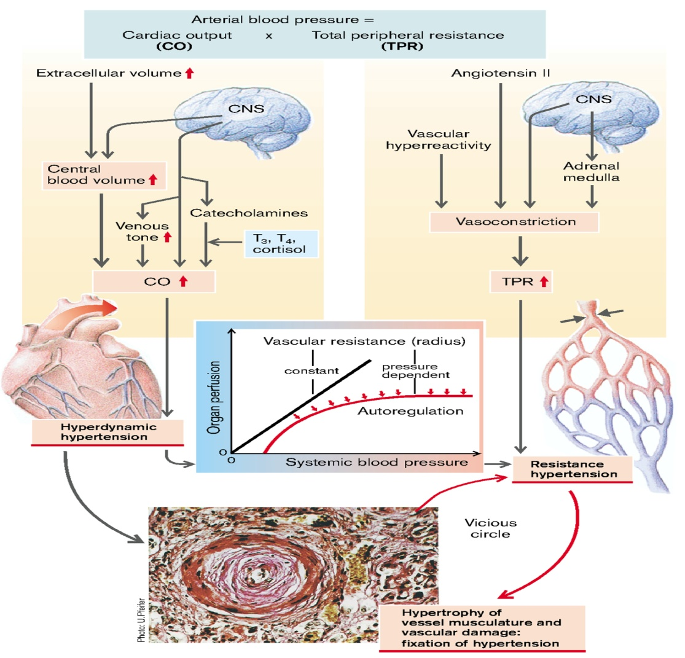
Fig.1 Principles of the development of hypertension
(From S. Silbernagl and F. Lang; Color Atlas of Pathophysiology)

A small number of patients (approximately 5%) have underlying renal or adrenal disease (such as primary aldosteronism, Cushing syndrome, pheochromocytoma), narrowing of the renal artery, usually by an atheromatous plaque (renovascular hypertension) or other identifiable cause (secondary hypertension). However, about 95% of hypertension is idiopathic (called essential hypertension) (Fig.2). This form of hypertension generally does not cause short-term problems. When controlled, it is compatible with long life and is asymptomatic, unless a myocardial infarction, cerebrovascular accident, or other complication supervenes.

Types and causes of hypertension (Systolic and diastolic)
(From Robbins-Cotran; Pathological basis of disease)
ESSENTIAL HYPERTENSION (90% to 95% of cases)
SECONDARY HYPERTENSION
Renal
Acute glomerulonephritis
Chronic renal disease
Polycystic disease
Renal artery stenosis
Renal vasculitis
Renin-producing tumors

Endocrine
Adrenocortical hyperfunction (Cushing syndrome, primary aldosteronism, congenital adrenal hyperplasia, licorice ingestion)
Exogenous hormones (glucocorticoids, estrogen [including pregnancy-induced and oral contraceptives], sympathomimetics and tyramine-containing foods, monoamine oxidase inhibitors)
Pheochromocytoma
Acromegaly
Hypothyroidism (myxedema)
Hyperthyroidism (thyrotoxicosis)
Pregnancy-induced

Cardiovascular
Coarctation of aorta
Polyarteritis nodosa
Increased intravascular volume
Increased cardiac output
Rigidity of the aorta

Neurologic
Psychogenic
Increased intracranial pressure
Sleep apnea
Acute stress, including surgery

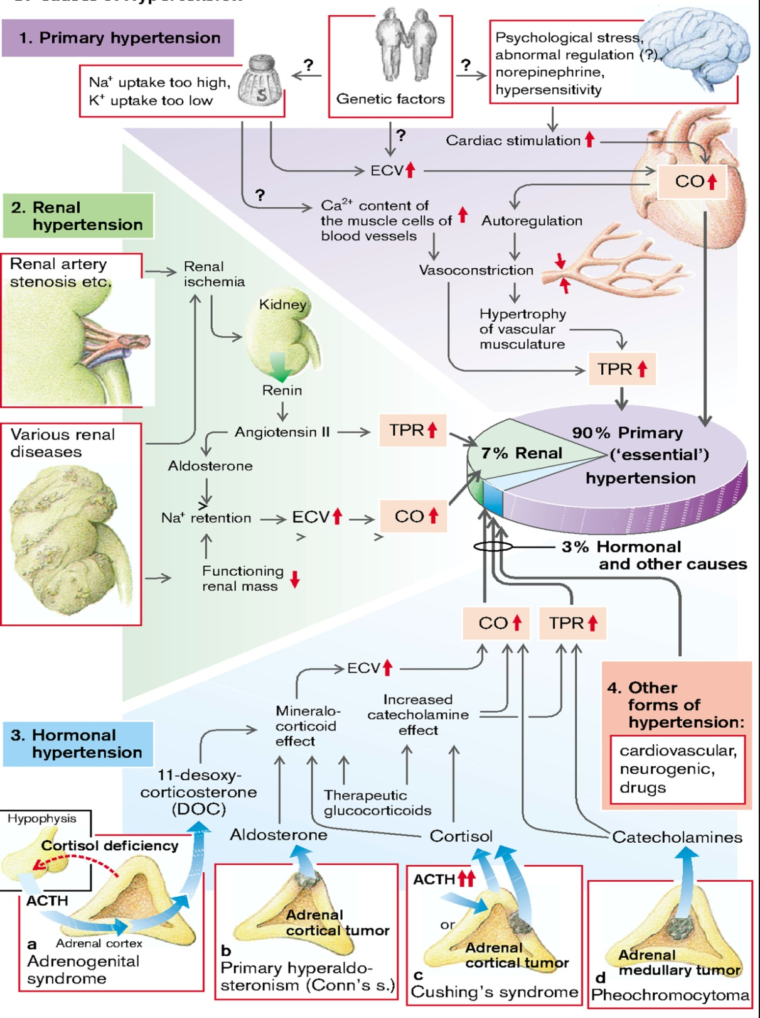
Fig. 2 Types of hypertension
(From S. Silbernagl and F. Lang; Color Atlas of Pathophysiology)

A small percentage, perhaps 5%, of hypertensive persons show a rapidly rising blood pressure that, if untreated, leads to death within a year or two. Called accelerated or malignant hypertension, this clinical syndrome is characterized by severe hypertension (systolic pressure over 200 mm Hg, diastolic pressure over 120 mm Hg), renal failure, and retinal hemorrhages and exudates, with or without papilledema. It may develop in previously normotensive persons but more often is superimposed on pre-existing benign hypertension, either essential or secondary

Essential arterial hypertension (primary hypertension)
Etiology. Despite of the high frequency (affects approximately 10% of general population), etiology of essential arterial hypertension is unknown. Possible causes may be:
- Chronic psychoemotional stress, repeated negative emotions;
- Genetic defects of receptors, cellular membranes and membrane ion pumps;
- Genetic defects of structures of vegetative nervous system, which participate in regulation of arterial pressure;

To the development of essential hypertension contribute following risk factors:
  - Body overweight (approximately 1/3 of population with obesity arterial hypertension is noticed);
  - Diabetes mellitus (30-40% of cases of diabetes mellitus collocate with arterial hypertension);
  - Excessive consumption of salts;
  - Psychoemotional stress situations in case of calamities (earthquakes, floods, fire);
  - Hypodynamia a (sedentary life);
  - Excessive consumption of alcohol, caffeine.

More women than men and more urbanites than country dwellers are affected by primary hypertension. In addition, chronic psychological stress, be it job-related (pilot, bus driver) or personality-based (“frustrated fighter” type), can induce hypertension. Especially in “salt-sensitive” people (1⁄3 of patients with primary hypertension; increased incidence when there is a family history) the high NaCl intake (10–15 g/d = 170–250 mmol/d) in the western industrialized countries might play an important role. While the organism is well protected against Na⁺ loss through an increase in aldosterone, those with an increased salt sensitivity are apparently relatively unprotected against a high NaCl intake. The actual connection between NaCl sensitivity and primary hypertension has not been fully elucidated, but the possibility is being considered that responsiveness to catecholamines is raised in people sensitive to NaCl. This results, for example, on psychological stress, in a greater than normal rise in blood pressure, on the one hand, due directly to the effect of increased cardiac stimulation and, on the other hand, indirectly as a result of increased renal absorption and thus retention of Na⁺ (rise in extracellular volume leads to hyperdynamic hypertension). Obesity and weight gain are strong, independent risk factors for hypertension. It has been estimated that 60% of hypertensives are >20% overweight. Centrally located body fat is a more important determinant of blood pressure elevation than is peripheral body fat. Low dietary intakes of calcium and potassium also may contribute to the risk of hypertension.
Pathogenesis of essential hypertension is very complicated and is studied insufficiently. There are several pathogenic mechanisms which are involved in the development primary hypertension: neurogenic mechanisms, hemodynamic factor, genetic component, humoral factor, hypertensive vascular reactivity and remodeling.
Genetic considerations in primary hypertension
Genetic factors play a definite role in determining blood pressure levels, as shown by studies comparing blood pressure in monozygotic and dizygotic twins, and other types of family studies, including comparisons of genetically related and adopted family members. Several strategies are being utilized in the search for specific hypertension-related genes. Animal models provide a powerful approach for evaluating genetic loci and genes associated with hypertension. Current evidence suggests that genes that encode components of the renin-angiotensin-aldosterone system, along with angiotensinogen and angiotensin-converting enzyme (ACE) polymorphisms, may be related to hypertension and to blood pressure sensitivity to dietary NaCl. Reduced renal sodium excretion in the presence of normal arterial pressure may be a key initiating event in essential hypertension and, indeed, a final common pathway for the pathogenesis of hypertension. Decreased sodium excretion may lead sequentially to an increase in fluid volume, increased cardiac output, and peripheral vasoconstriction, thereby elevating blood pressure. At the higher setting of blood pressure, enough additional sodium would be excreted by the kidneys to equal intake and prevent further fluid retention. Thus, an altered but steady state of sodium excretion would be achieved (“resetting of pressure natriuresis”), but at the expense of an increase in blood pressure.
Single-gene disorders cause severe but rare forms of hypertension through several mechanisms. These include:
- Gene defects affecting enzymes involved in aldosterone metabolism (aldosterone synthase, 11β-hydroxylase, 17α-hydroxylase). These lead to an increase in secretion of aldosterone, increased salt and water resorption, plasma volume expansion and, ultimately, hypertension.
- Mutations affecting proteins that influence sodium reabsorption. For example, the moderately severe form of salt-sensitive hypertension, called Liddle syndrome, is caused by mutations in an epithelial Na⁺ channel protein that lead to increased distal tubular reabsorption of sodium induced by aldosterone.
- The alpha-adducin gene is thought to be associated with increased renal tubular absorption of sodium, and variants of this gene may be associated with hypertension and salt sensitivity of blood pressure.
- Other genes possibly related to hypertension include genes encoding the angiotensin 1 receptor, aldosterone synthase, and the α-adrenoreceptors.
Environmental factors can modify the impact of genetic determinants. Stress, obesity, smoking, physical inactivity, and heavy consumption of salt have all been implicated as exogenous factors in hypertension. In the future, it is possible that DNA analysis will predict individual risk for hypertension and target organ damage and will identify responders to specific classes of antihypertensive agents.
Role of neurogenic factors in development of essential hypertension. The autonomic nervous system maintains cardiovascular homeostasis via pressure, volume and chemoreceptor signals. Adrenergic reflexes modulate blood pressure over the short term and adrenergic function, in concert with hormonal and volume-related factors, contributes to the long-term regulation of arterial pressure. The three endogenous catecholamines are norepinephrine, epinephrine, and dopamine. All three play important roles in tonic and phasic cardiovascular regulation. The activities of the adrenergic receptors are mediated by guanosine nucleotide-binding regulatory proteins (G proteins) and by intracellular concentrations of downstream second messengers. Norepinephrine and epinephrine are agonists for all adrenergic receptor subtypes, although with varying affinities. Based on their physiology and pharmacology, adrenergic receptors have been divided into two principal types: α and β. These types have been differentiated further into α₁, α₂, β₁, and β₂ receptors. Recent molecular cloning studies have identified several additional subtypes. α Receptors are occupied and activated more avidly by norepinephrine than by epinephrine, and the reverse is true for β receptors. α₁ Receptors are located on postsynaptic cells in smooth muscle and elicit vasoconstriction. α₂ Receptors are localized on presynaptic membranes of postganglionic nerve terminals that synthesize norepinephrine. When activated by catecholamines, α₂ receptors act as negative feedback controllers, inhibiting further norepinephrine release. In the kidney, activation of α₁-adrenergic receptors increases renal tubular reabsorption of sodium. Activation of myocardial β₁ receptors stimulates the rate and strength of cardiac contraction and consequently increases cardiac output. β₁ Receptor activation also stimulates renin release from the kidney.
Circulating catecholamine concentrations may affect the number of adrenoreceptors in various tissues. Down regulation of receptors may be a consequence of sustained high levels of catecholamines and provides an explanation for decreasing responsiveness, or tachyphylaxis, to catecholamines. Conversely, with chronic reduction of neurotransmitter substances, adrenoreceptors may increase in number or be upregulated, resulting in increased responsiveness to the neurotransmitter. Chronic administration of agents that block adrenergic receptors may result in upregulation, and withdrawal of those agents may produce a condition of temporary hypersensitivity to sympathetic stimuli.
Several reflexes modulate blood pressure on a minute-to-minute basis. One arterial baroreflex is mediated by stretch-sensitive sensory nerve endings in the carotid sinuses and the aortic arch. The rate of firing of these baroreceptors increases with arterial pressure, and the net effect is a decrease in sympathetic outflow, resulting in decreases in arterial pressure and heart rate. This is a primary mechanism for rapid buffering of acute fluctuations of arterial pressure that may occur during postural changes, behavioral or physiologic stress, and changes in blood volume. However, the activity of the baroreflex declines or adapts to sustained increases in arterial pressure such that the baroreceptors are reset to higher pressures. Patients with autonomic neuropathy and impaired baroreflex function may have extremely labile blood pressures with difficult-to-control episodic blood pressure spikes associated with tachycardia.
In both normal-weight and obese individuals, hypertension often is associated with increased sympathetic outflow. Sympathetic outflow is also increased in obesity-related hypertension and in hypertension associated with obstructive sleep apnea. Baroreceptor activation via electrical stimulation of carotid sinus afferent nerves has been shown to lower blood pressure in patients with "resistant" hypertension. Moreover, chronic or repeated vasoconstrictive influences could cause thickening and rigidity of the involved vessels (hypertensive vascular remodeling).
Drugs that block the sympathetic nervous system are potent antihypertensive agents, indicating that the sympathetic nervous system plays a permissive, although not necessarily a causative, role in the maintenance of increased arterial pressure.
Role of hemodynamic factors in development of essential hypertension. Cardiac output and peripheral resistance are the two hemodynamic determinants of arterial pressure. Cardiac output is determined by stroke volume and heart rate; stroke volume is related to myocardial contractility and to the size of the vascular compartment. Peripheral resistance is determined by functional and anatomic changes in small arteries (lumen diameter 100–400 m) and arterioles. Increase in cardiac output or/and peripheral resistence will lead to hypertension (hyperdynamic or resistence hypertension) (see above). Vascular volume is a primary determinant of arterial pressure over the long term. The initial elevation of blood pressure in response to vascular volume expansion may be related to an increase of cardiac output due to increased diastolic filling of the heart and activation of Frank-Starling law such increasing the stroke volume. Sodium is predominantly an extracellular ion and is a primary determinant of the extracellular fluid volume. When NaCl intake exceeds the capacity of the kidney to excrete sodium, vascular volume initially expands and cardiac output increases.
Role of humoral factors in development of essential hypertension. The renin-angiotensin-aldosterone system contributes to the regulation of arterial pressure primarily via the vasoconstrictor properties of angiotensin II and the sodium-retaining properties of aldosterone. Renin is an aspartyl protease that is synthesized as an enzymatically inactive precursor, prorenin. Most renin in the circulation is synthesized in the renal afferent renal arteriole. Prorenin may be secreted directly into the circulation or may be activated within secretory cells and released as active renin. Although human plasma contains two to five times more prorenin than renin, there is no evidence that prorenin contributes to the physiologic activity of this system. There are three primary stimuli for renin secretion: (1) decreased NaCl transport in the distal portion of the thick ascending limb of the loop of Henle that abuts the corresponding afferent arteriole (macula densa), (2) decreased pressure or stretch within the renal afferent arteriole (baroreceptor mechanism), and (3) sympathetic nervous system stimulation of renin-secreting cells via β₁ adrenoreceptors. Conversely, renin secretion is inhibited by increased NaCl transport in the thick ascending limb of the loop of Henle, by increased stretch within the renal afferent arteriole, and by β₁ receptor blockade. In addition, angiotensin II directly inhibits renin secretion due to angiotensin II type 1 receptors on juxtaglomerular cells, and renin secretion increases in response to pharmacologic blockade of either ACE or angiotensin II receptors.
Once released into the circulation, active renin cleaves a substrate, angiotensinogen, to form an inactive decapeptide, angiotensin I. A converting enzyme, located primarily but not exclusively in the pulmonary circulation, converts angiotensin I to the active octapeptide, angiotensin II, by releasing the C-terminal histidyl-leucine dipeptide. The same converting enzyme cleaves a number of other peptides, including and thereby inactivating the vasodilator bradykinin (Fig.3). Acting primarily through angiotensin II type 1 (AT₁) receptors on cell membranes, angiotensin II is a potent pressor substance, the primary tropic factor for the secretion of aldosterone by the adrenal zona glomerulosa, and a potent mitogen that stimulates vascular smooth muscle cell and myocyte growth. Independent of its hemodynamic effects, angiotensin II may play a role in the pathogenesis of atherosclerosis through a direct cellular action on the vessel wall. An angiotensin II type 2 (AT₂) receptor has been characterized. It is widely distributed in the kidney and has the opposite functional effects of the AT1 receptor. The AT₂ receptor induces vasodilation, sodium excretion, and inhibition of cell growth and matrix formation. Experimental evidence suggests that the AT₂ receptor improves vascular remodeling by stimulating smooth muscle cell apoptosis and contributes to the regulation of glomerular filtration rate. AT₁ receptor blockade induces an increase in AT₂ receptor activity.
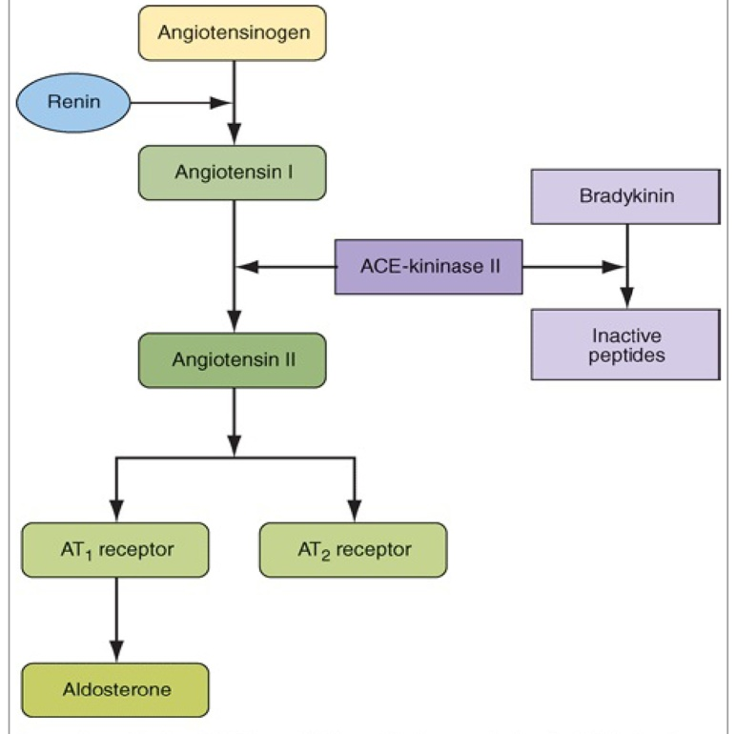
Fig. 3 Renin-angiotensin-aldosterone axis.
(From Harrison's Principles of Internal Medicine, 18th Edition)
Angiotensinogen, renin, and angiotensin II are also synthesized locally in many tissues, including the brain, pituitary, aorta, arteries, heart, adrenal glands, kidneys, adipocytes, leukocytes, ovaries, testes, uterus, spleen, and skin. Angiotensin II in tissues may be formed by the enzymatic activity of renin or by other proteases (tonin, chymase, and cathepsins). In addition to regulating local blood flow, tissue angiotensin II is a mitogen that stimulates growth and contributes to modeling and repair. Excess tissue angiotensin II may contribute to atherosclerosis, cardiac hypertrophy, and renal failure.
Angiotensin II is the primary tropic factor regulating the synthesis and secretion of aldosterone by the zona glomerulosa of the adrenal cortex. Aldosterone is a potent mineralocorticoid that increases sodium reabsorption by amiloride-sensitive epithelial sodium channels on the apical surface of the principal cells of the renal cortical collecting duct. Mineralocorticoid receptors also are expressed in the colon, salivary glands, and sweat glands. Aldosterone also has effects on non-epithelial targets. Aldosterone and/or mineralocorticoid receptor activation induces structural and functional alterations in the heart, kidney, and blood vessels, leading to myocardial fibrosis, nephrosclerosis, and vascular inflammation and remodeling, perhaps as a consequence of oxidative stress. These effects are amplified by a high salt intake and can contribute to development of hypertension.
Vascular hyperreactivity and remodeling in primary hypertension
Vascular radius and compliance of resistance arteries are also important determinants of arterial pressure. Resistance to flow varies inversely with the fourth power of the radius, and consequently, small decreases in lumen size significantly increase resistance. Vascular endothelium is a multifunctional tissue with a wealth of synthetic and metabolic properties; at baseline it has several constitutive activities critical for normal vessel homeostasis. Thus, endothelial cells maintain a non-thrombogenic blood-tissue interface, modulate vascular resistance, metabolize hormones, regulate inflammation, and affect the growth of other cell types, particularly smooth muscle cells. One of the vascular endothelial functions is to modulates vascular tone. The normal endothelium maintains a continuous release of nitric oxide, which is formed from L-arginine through the action of an enzyme called nitric oxide synthase. The production of nitric oxide can be stimulated by a variety of endothelial agonists, including acetylcholine, bradykinin, histamine, and thrombin. Shear stress on the endothelium resulting from an increase in blood flow or blood pressure also stimulates nitric oxide production and vessel relaxation. Nitric oxide also inhibits platelet aggregation and secretion of platelet contents, many of which cause vasoconstriction. In addition to nitric oxide, the endothelium also produces other vasodilating substances such as the prostaglandin prostacyclin, which produces vasodilation and inhibits platelet aggregation. The endothelium also produces a number of vasoconstrictor substances, including angiotensin II, vasoconstrictor prostaglandins, and a family of peptides called endothelins. There are at least three endothelins. Endothelin-1, made by human endothelial cells, is the most potent endogenous vasoconstrictor known. Receptors for endothelins also have been identified. Endothelium-dependent vasodilation is impaired in hypertensive patients due to low secretion of vasodilator local substances. By the contrary, endothelin production in patient with essential hypertension is increased.
The predominant cellular element of the vascular media is the smooth muscle cells. Smooth muscle cells have the capacity to proliferate when appropriately stimulated (also stimulation by hemodynamic factors like increased pressure); they can also synthesize ECM collagen, elastin, and proteoglycans and elaborate growth factors and cytokines. The migratory and proliferative activities of smooth muscle cells are regulated by growth promoters and inhibitors. Promoters include PDGF, as well as endothelin-1, thrombin, fibroblast growth factor (FGF), interferon-γ (IFN-γ), and interleukin-1(IL-1). Inhibitors include heparan sulfates, nitric oxide, and TGF-β. Other regulators include the renin-angiotensin system (angiotensin II), catecholamines, the estrogen receptor, and osteopontin, a component of the ECM.
In hypertensive patients, structural, mechanical, or functional changes may reduce the lumen diameter of small arteries and arterioles such worsening the evolution of hypertension. Hypertensive patients have stiffer arteries as a consequence of decreased vascular compliance due to structural changes in the vascular wall (hyperplasia and hypertrophy of the smooth muscle, hyperplasia of the intima). Hypertensive vascular remodeling refers to geometric alterations in the vessel wall without a change in vessel volume. Ion transport by vascular smooth muscle cells may contribute to hypertension-associated abnormalities of vascular tone (vascular hyperreactivity) and vascular growth (vascular remodeling), both of which are modulated by intracellular pH . Three ion transport mechanisms participate in the regulation of pH: (1) Na⁺-H⁺ exchange, (2) Na⁺-dependent HCO₃^{–-}Cl– exchange, and (3) cation-independent HCO₃–Cl– exchange. Activity of the Na⁺-H⁺ exchanger is increased in hypertension, and this may result in increased vascular tone by two mechanisms. First, increased sodium entry may lead to increased vascular tone by activating Na⁺-Ca²⁺ exchange and thereby increasing intracellular calcium. Second, increased pH enhances calcium sensitivity of the contractile apparatus, leading to an increase in contractility for a given intracellular calcium concentration. Additionally, increased Na⁺- H⁺ exchange may stimulate growth of vascular smooth muscle cells by enhancing sensitivity to growth factors (FGF, PDGF, TGF). The same effects has increased blood level of angiotensin II.
Vascular injury due to hemodynamic stress in hypertension stimulates smooth muscle cell growth and associated matrix synthesis that thickens the intima. Medial smooth muscle cells or smooth muscle precursor cells also migrate into the intima, proliferate, and synthesize ECM in much the same way that fibroblasts fill in a wound. It should be emphasized that the phenotype of neointimal smooth muscle cells is distinct from that of medial smooth muscle cells; neointimal smooth muscle cells do not contract like medial smooth muscle cells but have the capacity to divide. With persistent or recurrent insults, excessive thickening can cause narrowing or stenosis of small and medium-sized blood vessels. Hypertensive hypertrophic vascular remodeling (increased size and number of muscle cell and increased deposition of intercellular matrix, hyperplasia of the intima) results in decreased lumen size and hence contributes to increased peripheral resistance and such worsening hypertension (Fig.4).
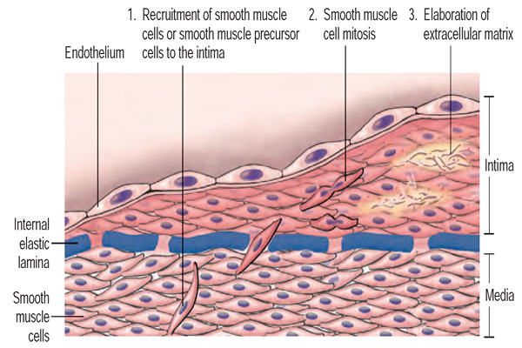
Fig.4 Hypertensive vascular remodeling
Schematic of intimal thickening, emphasizing smooth muscle cell migration and proliferation within the intima, with associated ECM synthesis. Intimal smooth muscle cells may derive from the underlying media or may be recruited from circulating precursors; they are shown in a different color from the medial cells to emphasize that they have a proliferative, synthetic, and noncontractile phenotype distinct from medial smooth muscle cells. (From Robbins-Cotran; Pathological basis of disease).

SECONDARY HYPERTENSION
Renal hypertension
The kidneys play an important role in blood pressure regulation as follows:
• Through the renin-angiotensin system, the kidney influences both peripheral resistance and sodium homeostasis. Renin is secreted by the juxtaglomerular cells of the kidney in response to fall in blood pressure. It converts plasma angiotensinogen to angiotensin I, which is then converted to angiotensin II by angiotensin converting enzyme. Angiotensin II raises blood pressure by increasing both peripheral resistance (direct action on vascular smooth muscle cells) and blood volume (stimulation of aldosterone secretion, and increase in distal tubular reabsorption of sodium).
• The kidney also produces a variety of vascular relaxing, or antihypertensive, substances (including prostaglandins and NO), which presumably counterbalance the vasopressor effects of angiotensin.
• When blood volume is reduced, the glomerular filtration rate falls, leading to increased reabsorption of sodium by proximal tubules, thereby conserving sodium and expanding blood volume.
• Natriuretic factors, including the natriuretic peptides secreted by atrial and ventricular myocardium in response to volume expansion, inhibit sodium reabsorption in distal tubules and thereby cause sodium excretion and diuresis. Natriuretic peptides also induce vasodilation and may be considered to represent endogenous inhibitors of the renin-angiotensin system.
Virtually all disorders of the kidney may cause hypertension, and renal disease is the most common cause of secondary hypertension. Hypertension is present in >80% of patients with chronic renal failure. In general, hypertension is more severe in glomerular diseases than in interstitial diseases such as chronic pyelonephritis. Conversely, hypertension may cause nephrosclerosis, and in some instances it may be difficult to determine whether hypertension or renal disease was the initial disorder. Proteinuria >1000 mg/d and an active urine sediment are indicative of primary renal disease.
Renovascular hypertension is renal hypertension due to an occlusive lesion of a renal artery. Renovascular hypertension is a potentially curable form of hypertension. Two groups of patients are at risk for this disorder: older arteriosclerotic patients who have a plaque obstructing the renal artery, frequently at its origin, and patients with fibromuscular dysplasia. Atherosclerosis accounts for the large majority of patients with renovascular hypertension. Obstruction of the renal artery leads to decreased renal perfusion pressure, thereby stimulating renin secretion with final activation of angiotensin II and secretion of aldosteron (see above the effects). Over time, as a consequence of secondary renal damage, this form of hypertension may become less renin dependent. However, renin activity and other components of the renin-angiotensin system may be elevated only transiently; over time, sodium retention and recruitment of other pressure mechanisms may contribute to elevated arterial pressure. The most effective medical therapies include an ACE inhibitor or an angiotensin II receptor blocker.
Renin-secreting tumors are clear examples of other type of renin-dependent hypertension. In the kidney, these tumors include benign hemangio-pericytomas of the juxtaglomerular apparatus and, infrequently, renal carcinomas, including Wilms' tumors. Renin-producing carcinomas also have been described in lung, liver, pancreas, colon, and adrenals. In these instances, in addition to excision and/or ablation of the tumor, treatment of hypertension includes pharmacologic therapies targeted to inhibit angiotensin II production or action.
The kidney also produces a variety of vascular relaxing, or antihypertensive, substances (including prostaglandins PGA and PGE and NO), which presumably counterbalance the vasopressor effects of angiotensin. PGA and PGE are produced at the level of kidney medullary interstitium. Renal disorders associated with loss of renal parenchyma like, glomerulonephritis, chronic renal disease, polycystic disease can be associated with renal hypertension – so-called renoprive renal hypertension, due to inability of the kidney to produce vasodilator biological substances. PGA has predominantly a local vasodilator effects, controlling the level of perfusion. PGE can have a general vasodilatatory effect. Lack of local vasodilatatory biological substances increases vasoconstriction of afferent arteriole with hypoperfusion and release of renin from the juxtaglomerular cells.
Endocrine hypertension
Endocrine hypertension can be found in a number of endocrine disorders due to hypersecretion of hormones. Most frequently these are mineralocorticoid hypertension (due to hypersecretion of aldosteron in primary or secondary hyperaldosteronism), glucocorticoid hypertension (due to hypersecretion of glucocorticoids, mainly cortisol) and catecholaminic hypertension (hypersecretion of catecholamines in pheochromocytoma). Several additional endocrine disorders, including thyroid diseases and acromegaly, cause hypertension. Mild diastolic hypertension may be a consequence of hypothyroidism, whereas hyperthyroidism may result in systolic hypertension.
Mineralocorticoid hypertension. Excess aldosterone blood levels due to primary or secondary aldosteronism represent the cause of mineralocorticoid hypertension. Primary aldosteronism is a potentially curable form of hypertension. In patients with primary aldosteronism, increased aldosterone production is independent of the renin-angiotensin system, and the consequences are sodium retention, hypertension, hypokalemia, and low plasma renin level. 60–70% of patients have an aldosterone-producing adrenal adenoma (Con syndrome). The tumor is almost always unilateral, and most often measures <3 cm in diameter. Most of the remainder of these patients has bilateral adrenocortical hyperplasia (idiopathic hyperaldosteronism). Rarely, primary aldosteronism may be caused by an adrenal carcinoma or an ectopic malignancy, e.g., ovarian arrhenoblastoma. Hypertension is usually mild to moderate but occasionally may be severe; primary aldosteronism should be considered in all patients with refractory hypertension. Most patients are asymptomatic, although, infrequently, polyuria, polydipsia, paresthesias, or muscle weakness may be present as a consequence of hypokalemic alkalosis. The ratio of plasma aldosterone to plasma renin activity (PA/PRA) is a useful screening test. These measurements preferably are obtained in ambulatory patients in the morning. A ratio >30:1 in conjunction with a plasma aldosterone concentration >555 mmol/L (>20 ng/dL) reportedly has a sensitivity of 90% and a specificity of 91% for an aldosterone-producing adenoma.
Additionally, hypokalemic hypertension may be a consequence of secondary aldosteronism, which is present in patients with liver cirrhosis, heart failure etc. High level of aldosteron in the blood is due to activation of the renin-angiotensin-aldosteron system or insufficient degradation of aldosteron in the liver. In these patients the plasma renin level is increased.
Glucocorticoid hypertension is due to hypersecretion of glucocorticoids. Cushing's syndrome is related to excess cortisol production due either to excess ACTH secretion (from a pituitary tumor or an ectopic tumor) or to ACTH-independent adrenal production of cortisol. Hypertension occurs in 75–80% of patients with Cushing's syndrome. The mechanism of hypertension may be related to stimulation of mineralocorticoid receptors by cortisol leading to increased water and salt retention. Other mechanism is in relation with permissive effects of glucocorticoids on adrenoreceptors with increased cardiac output (effect on β1 receptors) and increased peripheral resistence (effects on α1 receptors). Additional mechanisms can be explained by the fact that cortisol increase hepatic production of angiotensinogen, by this way also enhancing the activity of renin-angiotensin-aldosteron system.
Catecholaminic hypertension is in relation with presence of pheochromocytoma. Catecholamine-secreting tumors are located in the adrenal medulla (pheochromocytoma) or in extra-adrenal paraganglion tissue (paraganglioma) and account for hypertension in ~0.05% of patients. If unrecognized, pheochromocytoma may result in lethal cardiovascular consequences. Clinical manifestations, including hypertension, are primarily related to increased circulating catecholamines, although some of these tumors may secrete a number of other vasoactive substances. If there is predominant hypersecretion of adrenaline, the hypertension will be mainly systolic associated with tachycardia. A small percentage of patients, with epinephrine hypersecretion , may present with hypotension rather than hypertension. If there is predominant hypersecretion of noradrenaline, the hypertension is systole-diastolic, with less tachycardia. High blood level of catecholamines leads to vasoconstriction of renal afferent arteriole by this way activating the renin-angiotensin-aldosteron system, which is the other mechanism by which hypercatecholaminemia lead to high blood pressure. The initial suspicion of the diagnosis is based on symptoms and/or the association of pheochromocytoma with other disorders. Approximately 20% of pheochromocytomas are familial with autosomal dominant inheritance. Laboratory testing consists of measuring catecholamines in either urine or plasma. Surgical excision is the definitive treatment of pheochromocytoma and results in cure in ~90% of patients.
Hypertension in hypersecretion of thyroid hormones is due to cardiogenic effects of T₃ andT₄ (positive chronotron and inotropic effects). Mainly this is a form of hypertension due to increased cardiac output (hemodynamic hypertension) which is associated with tachycardia (120 – 160/min) and frequently with heart arrhythmias (mainly, atrial fibrillation).
Miscellaneous causes of hypertension
Hemic hypertension is due to increased volume as well as viscosity of the blood. This can be found in patients with polycythemic hypervolemia (erythremia, erythrocytosis, leukemic crisis). Increased blood volume represents increased preload to the heart that will activate the Frank-Starling law and increased contraction of the hear walls leading to increased stroke volume and ultimately will increase the cardiac output. Increased blood viscosity means increased resistence which also represents a determinant factor of blood pressure.
Hypertension due to obstructive sleep apnea is being recognized with increasing frequency. Hypertension occurs in >50% of individuals with obstructive sleep apnea. The severity of hypertension correlates with the severity of sleep apnea. Approximately 70% of patients with obstructive sleep apnea are obese.
Coarctation of the aorta is the most common congenital cardiovascular cause of hypertension. The incidence is 1–8 per 1000 live births. It is usually sporadic but occurs in 35% of children with Turner syndrome. Even when the anatomic lesion is surgically corrected in infancy, up to 30% of patients develop subsequent hypertension and are at risk of accelerated coronary artery disease and cerebrovascular events.
Pathologic consequences of hypertension
Hypertension is an independent predisposing factor for heart failure, coronary artery disease, stroke, renal disease, and peripheral arterial disease.
Heart. Heart disease is the most common cause of death in hypertensive patients. Hypertensive heart disease is the result of structural and functional adaptations leading to left ventricular hypertrophy, heart failure, abnormalities of blood flow due to atherosclerotic coronary artery disease and microvascular disease, and cardiac arrhythmias. Both genetic and hemodynamic factors contribute to left ventricular hypertrophy. Heart failure may be related to systolic dysfunction, diastolic dysfunction, or a combination of the two.
Brain. Elevated blood pressure is the strongest risk factor for stroke. The incidence of stroke rises progressively with increasing blood pressure levels, particularly systolic blood pressure in individuals >65 years. Hypertension also is associated with impaired cognition in an aging population, and longitudinal studies support an association between midlife hypertension and late-life cognitive decline. Hypertension-related cognitive impairment and dementia may be a consequence of a single infarct due to occlusion of a "strategic" larger vessel or multiple lacunar infarcts due to occlusive small vessel disease resulting in subcortical white matter ischemia.
Cerebral blood flow remains unchanged over a wide range of arterial pressures (mean arterial pressure of 50–150 mmHg) through a process termed autoregulation of blood flow. In patients with the clinical syndrome of malignant hypertension, encephalopathy is related to failure of autoregulation of cerebral blood flow at the upper pressure limit, resulting in vasodilation and hyperperfusion. Signs and symptoms of hypertensive encephalopathy may include severe headache, nausea and vomiting (often of a projectile nature), focal neurologic signs, and alterations in mental status. Untreated, hypertensive encephalopathy may progress to stupor, coma, seizures, and death within hours.
Kidney. The kidney is both a target and a cause of hypertension. Renal risk appears to be more closely related to systolic than to diastolic blood pressure. Proteinuria is a reliable marker of the severity of chronic kidney disease and is a predictor of its progression. Patients with high urine protein excretion (>3 g/24 h) have a more rapid rate of progression than do those with lower protein excretion rates. Atherosclerotic, hypertension-related vascular lesions in the kidney primarily affect preglomerular arterioles, resulting in ischemic changes in the glomeruli and postglomerular structures. Glomerular injury also may be a consequence of direct damage to the glomerular capillaries due to glomerular hyperperfusion. With progressive renal injury there is a loss of autoregulation of renal blood flow and glomerular filtration rate, resulting in a lower blood pressure threshold for renal damage and a steeper slope between blood pressure and renal damage. The result may be a vicious cycle of renal damage and nephron loss leading to more severe hypertension, glomerular hyperfiltration, and further renal damage. Glomerular pathology progresses to glomerulosclerosis, and eventually the renal tubules may also become ischemic and gradually atrophic. The renal lesion associated with malignant hypertension consists of fibrinoid necrosis of the afferent arterioles, sometimes extending into the glomerulus, and may result in focal necrosis of the glomerular tuft.
Clinically, macroalbuminuria (a random urine albumin/creatinine ratio >300 mg/g) or microalbuminuria (a random urine albumin/creatinine ratio 30–300 mg/g) are early markers of renal injury. These are also risk factors for renal disease progression and cardiovascular disease.
Peripheral arteries. In addition to contributing to the pathogenesis of hypertension, blood vessels may be a target organ for atherosclerotic disease secondary to long-standing elevated blood pressure. Hypertensive patients with arterial disease of the lower extremities are at increased risk for future cardiovascular disease.
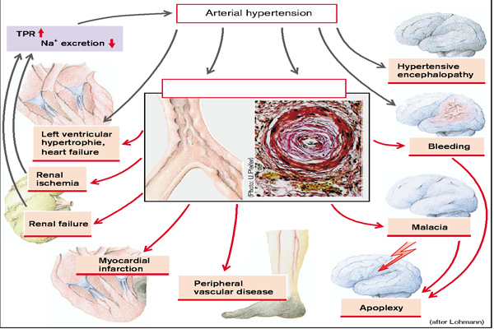
Fig. 5 Consequences of arterial hypertension
(From S. Silbernagl and F. Lang; Color Atlas of Pathophysiology)

PULMONARY HYPERTENSION
The mean pulmonary artery pressure (15 mmHg) is determined by three variables, namely pulmonary vascular resistance (PVR), cardiac output, and left atrial pressure
Pulmonary hypertension (PH) develops when one (or several) of the above variables is raised so much that at rest pulmonary pressure is over 20mmHg; on exercise it is above 32 mmHg (Fig.6).
In principle, PH can have three causes:
- Increased pulmonary vascular resistence, so-called obstructive PH, caused, for example, by pulmonary embolism or emphysema. Pulmonary vascular resistence may further increase because of the resulting hypoxemia and its consequences (pulmonary hypoxic vasoconstriction, increased hematocrit).
- Increased left atrial pressure (normal is 5 mmHg) so-called passive PHT, for example, in mitral stenosis
- Increased cardiac output, except in left-to right shunt. A rise in cardiac output alone will lead to (hyperkinetic) PH only in extreme cases, because the pulmonary vasculature
is very distensible and additional blood vessels can be recruited. A rise in cardiac output (fever, hyperthyroidism, physical exertion) can, however, aggravate an existing PH due to other reasons.
Acute PH almost always results from a reduction in the cross-sectional area of the vascular bed (of at least 50%, because of the high vascular distensibility), as by pulmonary embolism, i.e., migration of thrombi or (rarely) other emboli from their site of origin into the pulmonary arteries. If embolism arises, it is likely that additional (hypoxic) vasoconstriction will develop, which will then reduce the vascular cross-sectional area even more. Sudden vascular obstruction causes acute cor pulmonale (acute right heart load). In acute PHT the right ventricular systolic pressure can rise to over 60mmHg, but may become normal again within 30–60 minutes in certain circumstances, for example, if the thrombus has moved more distally, thus increasing the vascular cross-sectional area. Pressure may also be reduced by thrombolysis or possibly by diminished vasoconstriction. Embolism may result in pulmonary infarction, especially when medium-sized vessels are obstructed and at the same time the blood supply to the bronchial arteries is reduced (e.g., in pulmonary venous congestion or systemic hypotension).
However, massive pulmonary embolism may also lead to acute right heart failure so that flow into the left ventricle and thus its output falls. This in turn leads to a decrease in systemic blood pressure and to circulatory shock and its consequences.
Among the causes of chronic PHT are:
- Lung disease (asthma, emphysema, chronic bronchitis or fibrosis, together accounting for > 90% of chronic cor pulmonale cases);
- Chronic thromboembolism and systemic vascular disease;
- Extrapulmonary causes of abnormal pulmonary function (thoracic deformity, neuromuscular disease, etc.);
- Removal of lung tissue (tuberculosis, tumors);
- Chronic altitude hypoxia with hypoxic constriction ;
- Idiopathic primary PHT of unknown etiology.
In all these disorders the resistance in the pulmonary circulation is chronically elevated, due to either exclusion of large segments of the lung, or generalized vascular obstruction.
The consequence of chronic PHT is right ventricular hypertrophy (chronic cor pulmonale) and ultimately right ventricular failure. The cause of passive PHT is primarily not in the lung but in the left heart (postcapillary PHT). Thus, almost all patients with mitral valve disease or left heart failure develop PHT.
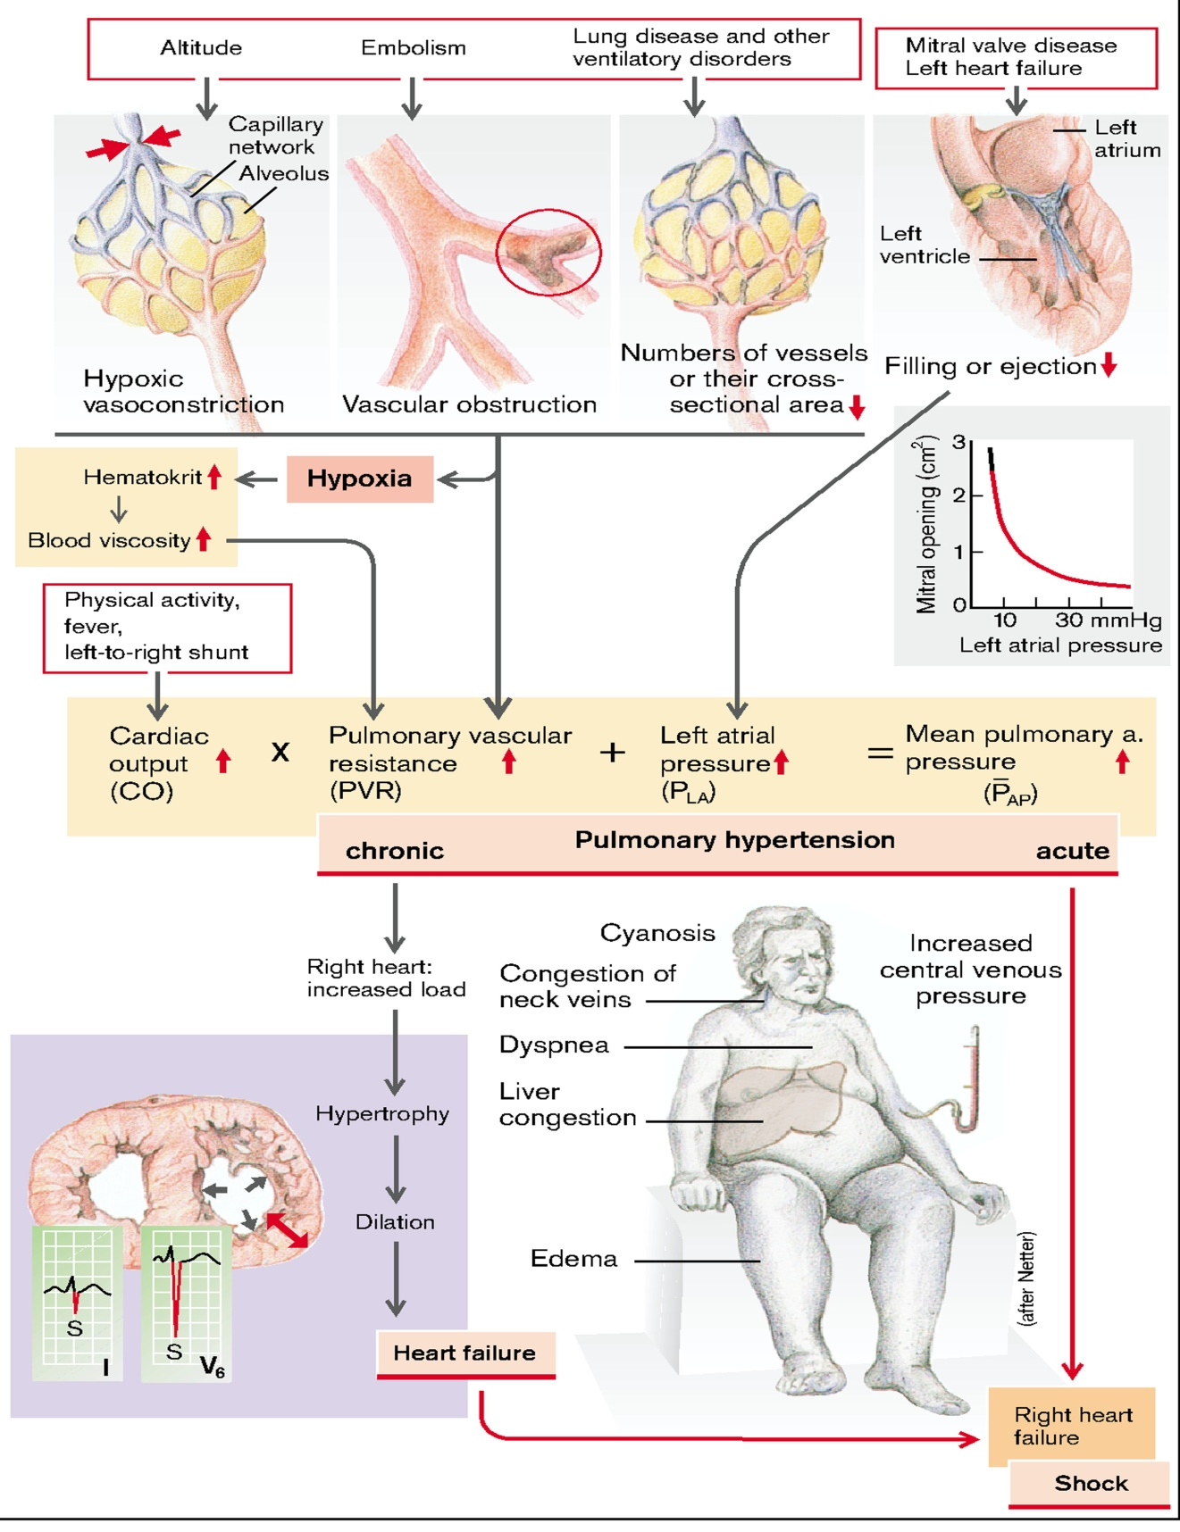
Fig.6 Causes and consequences of pulmonary hypertension
(From S. Silbernagl and F. Lang; Color Atlas of Pathophysiology)

CARDIAC ARRYTHMIAS
The normal cardiac impulse is generated by pacemaker cells in the sinoatrial node situated at the junction of the right atrium and the superior vena cava. This impulse is transmitted slowly through nodal tissue to the anatomically complex atria, where it is conducted more rapidly to the atrioventricular node (AVN), inscribing the P wave of the ECG. There is a perceptible delay in conduction through the anatomically and functionally heterogeneous AVN. The time needed for activation of the atria and the AVN delay is represented as the PR interval of the ECG. The AVN is the only electrical connection between the atria and the ventricles in the normal heart. The electrical impulse emerges from the AVN and is transmitted to the His-Purkinje system, specifically the common bundle of His, then the left and right bundle branches, and then to the Purkinje network, facilitating activation of ventricular muscle. In normal circumstances, the ventricles are activated rapidly in a well-defined fashion that is determined by the course of the Purkinje network, and this inscribes the QRS complex. Recovery of electrical excitability occurs more slowly and is governed by the time of activation and duration of regional action potentials. The relative brevity of epicardial action potentials in the ventricle results in repolarization that occurs first on the epicardial surface and then proceeds to the endocardium, which inscribes a T wave normally of the same polarity as the QRS complex. The duration of activation and recovery is determined by the action potential duration represented on the body surface ECG by the QT interval.
The electrical events that normally take place in the heart are responsible for initiating each cardiac contraction. An action potential can be divided into three phases: the resting or unexcited state, depolarization, and repolarization. The inside of a cardiac cell, like all living cells, contains a negative electrical charge compared with the outside of the cell. During the resting state, the membrane is relatively permeable to potassium but much less so to sodium and calcium. Charges of opposite polarity become aligned along the membrane (positive on the outside and negative on the inside). Depolarization occurs when the cell membrane suddenly becomes selectively permeable to current-carrying ions such as sodium. Sodium ions enter the cell and result in a sharp rise of the intracellular potential to positivity. Repolarization involves reestablishment of the resting membrane potential. It is a complex and somewhat slower process, involving the outward flow of electrical charges and the return of membrane potential to its resting state. During repolarization, the membrane conductance or permeability for potassium greatly increases, allowing the positively charged potassium ions to move outward across the membrane. This outward movement of potassium removes positive charges from inside the cell; thus, the
membrane again becomes negative on the inside and positive on the outside. The sodium potassium membrane pump also assists in repolarization by pumping positively charged sodium ions out across the cell membrane.
Cardiac action potential. The action potential in cardiac muscle is typically divided into five phases: phase 0—upstroke or rapid depolarization, phase 1—early repolarization period, phase 2—plateau, phase 3—final rapid repolarization period, and phase 4— diastolic depolarization . Cardiac muscle has three types of membrane ion channels that contribute to the voltage changes that occur during the phases of the cardiac action potential. They are the fast sodium channels, the slow calcium channels, and the potassium channels. During phase 0, in atrial and ventricular muscle and in the Purkinje system, the fast sodium channels in the cell membrane are stimulated to open, resulting in the rapid influx of sodium. The action potentials in the normal SA and AV nodes have a much slower upstroke and are mediated predominantly by the slow calcium currents. The point at which the sodium gates open is called the depolarization threshold. When the cell has reached this threshold, a rapid influx of sodium occurs. The exterior of the cell now is negatively charged in relation to the highly positive interior of the cell. This rapid influx of sodium produces a rapid, positively directed change in the transmembrane potential, resulting in the electrical spike and overshoot during phase 0 of the action potential. The membrane potential shifts from a resting membrane potential of approximately −90 millivolts (mV) to +20 mV. The rapid depolarization that constitutes phase 0 is responsible for the QRS complex on the electrocardiogram (ECG). Depolarization of a cardiac cell tends to cause adjacent cells to depolarize because the voltage spike of the cell’s depolarization stimulates the sodium channels in nearby cells to open. Therefore, when a cardiac cell is stimulated to depolarize, a wave of depolarization is propagated across the heart, cell by cell.
Phase 1 occurs at the peak of the action potential and signifies inactivation of the fast sodium channels with an abrupt decrease in sodium permeability. The slight downward slope is thought to be caused by the influx of a small amount of negatively charged chloride ions and efflux of potassium. The decrease in intracellular positivity reduces the membrane potential to a level near 0 mV, from which the plateau, or phase 2, arises.
Phase 2 represents the plateau of the action potential. If potassium permeability increased to its resting level at this time, as it does in nerve fibers or skeletal muscle, the cell would repolarize rapidly. Instead, potassium permeability is low, allowing the membrane to remain depolarized throughout the phase 2 plateau. A concomitant influx of calcium into the cell through slow channels contributes to the phase 2 plateau. Calcium ions entering the muscle during this phase also play a key role in the contractile process. These unique features of the phase 2 plateau in these cells cause the action potential of cardiac muscle (several hundred milliseconds) to last 3 to 15 times longer than that of skeletal muscle and cause a corresponding increased period of contraction. The phase 2 plateau coincides with the ST segment of the ECG.
Phase 3 reflects final rapid repolarization and begins with the downslope of the action potential. During the phase 3 repolarization period, the slow channels close, and the influx of calcium and sodium ceases. There is a sharp rise in potassium permeability, contributing to the rapid outward movement of potassium and reestablishment of the resting membrane potential (−90 mV). At the conclusion of phase 3, the distribution of potassium and sodium returns membrane to the normal resting state. The T wave on the ECG corresponds with phase 3 of the action potential.
Phase 4 represents the resting membrane potential. During phase 4, the activity of the sodium-potassium pump contributes to maintenance of the resting membrane potential by transporting sodium out of the cell and moving potassium back in. Phase 4 corresponds to diastole.
The fast and slow response. There are two main types of action potentials in the heart - the fast response and the slow response. The fast response occurs in the normal myocardial cells of the atria, the ventricles, and the Purkinje fibers. It is characterized by the opening of voltage-dependent sodium channels called the fast sodium channels. The fast-response cardiac cells do not normally initiate cardiac action potentials. Instead, impulses originating in the specialized cells of the SA node are conducted to the fast response myocardial cells, where they effect a change in membrane potential to the threshold level. On reaching threshold, the voltage-dependent sodium channels open to initiate the rapid upstroke of the phase 1 action potential. The amplitude and the rate of rise of phase 1 are important to the conduction velocity of the fast response. Myocardial fibers with a fast response are capable of conducting electrical activity at relatively rapid rates (0.5 to 5.0 m/second), thereby providing a high safety factor for conduction.
The slow response occurs in the SA node, which is the natural pacemaker of the heart, and in the conduction fibers of the AV node. The hallmark of these pacemaker cells is a spontaneous phase 4 depolarization. The membrane permeability of these cells allows a slow inward leak of current to occur through the slow channels during phase 4. This leak continues until the threshold for firing is reached, at which point the cell spontaneously depolarizes. Under normal conditions, the slow response, sometimes referred to as the calcium current, does not contribute significantly to myocardial depolarization in the atria and ventricles. Its primary role in normal atrial and ventricular cells is to provide for the entrance of calcium for the excitation-contraction mechanism that couples the electrical activity with muscle contraction. The rate of pacemaker cell discharge varies with the resting membrane potential and the slope of phase 4 depolarization. Catecholamines (epinephrine and norepinephrine) increase the heart rate by increasing the slope or rate of phase 4 depolarization. Acetylcholine, which is released during vagal stimulation of the heart, slows the heart rate by decreasing the slope of phase 4.
The fast response of atrial and ventricular muscle can be converted to a slow pacemaker response under certain conditions. For example, such conversions may occur spontaneously in individuals with severe coronary artery disease, in areas of the heart where blood supply has been markedly compromised or curtailed. Impulses generated by these cells can lead to ectopic beats and serious arrhythmias.

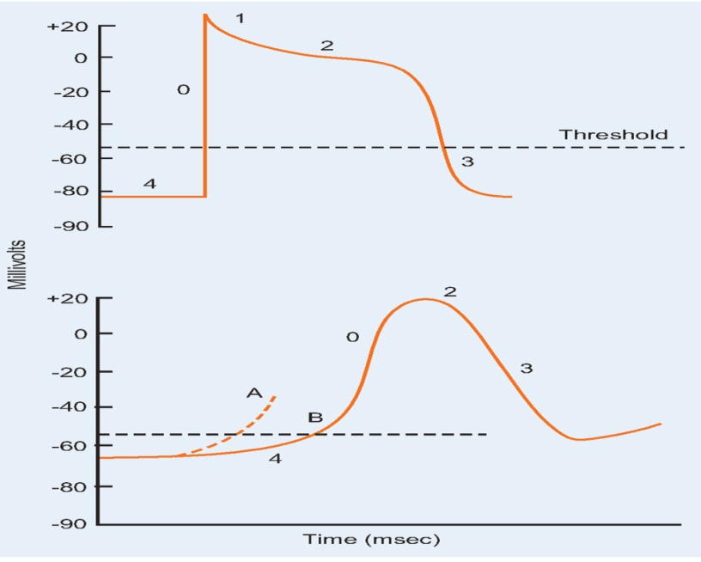
Changes in action potential recorded from a fast response in cardiac muscle cell (top) and from a slow response recorded in the sinoatrial and atrioventricular nodes (bottom). The phases of the action potential are identified by numbers: phase 4, resting membrane potential; phase 0, depolarization; phase 1, brief period of repolarization; phase 2, plateau; phase 3, repolarization. The slow response is characterized by a slow, spontaneous rise in the phase 4 membrane potential to threshold levels; it has a lesser amplitude and shorter duration than the fast response. Increased automaticity (A) occurs when the rate of phase 4 depolarization is increased. (From C. Porth and G. Matfin; Pathophysiology. Concepts of altered health states).

Absolute and relative refractory periods. The pumping action of the heart requires alternating contraction and relaxation. There is a period in the action potential curve during which no stimuli can generate another action potential. This period, which is known as the absolute refractory period, includes phases 0, 1, 2, and part of phase 3. During this time, the cell cannot depolarize again under any circumstances. When repolarization has returned the membrane potential to below threshold, although not to the resting membrane potential (−90 mV), the cell is capable of responding to a greater-than-normal stimulus. This condition is referred to as the relative refractory period. The relative refractory period begins when the transmembrane potential in phase 3 reaches the threshold potential level and ends just before the terminal portion of phase 3. After the relative refractory period is a short period, called the supernormal excitatory period, during which a weak stimulus can evoke a response. The supernormal excitatory period extends from the terminal portion of phase 3 until the beginning of phase 4. It is during this period that cardiac arrhythmias develop. In skeletal muscle, the refractory period is very short compared with the duration of contraction, such that a second contraction can be initiated before the first is over, resulting in a summated tetanized contraction. In cardiac muscle, the absolute refractory period is almost as long as the contraction, and a second contraction cannot be stimulated until the first is over. The longer length of the absolute refractory period of cardiac muscle is important in maintaining the alternating contraction and relaxation that is essential to the pumping action of the heart and for the prevention of fatal arrhythmia.

Mechanisms of cardiac arrhythmias
Heart muscle is unique among other muscles in that it is capable of generating and rapidly conducting its own electrical impulses or action potentials. These action potentials result in excitation of muscle fibers throughout the myocardium. Impulse formation and conduction result in weak electrical currents that spread through the entire body. These impulses are recorded on an electrocardiogram. Disorders of cardiac impulse generation and conduction range from benign arrhythmias that are merely annoying to those causing serious disruption of heart function and sudden cardiac death.
The specialized cells in the conduction system manifest four inherent properties that contribute to the genesis of all cardiac rhythms, both normal and abnormal. They are automaticity, excitability, conductivity, and refractoriness. An alteration in any of these four properties may produce arrhythmias or conduction defects.
➤ Cardiac arrhythmias represent disorders of cardiac rhythm related to alterations in automaticity, excitability, conductivity, or refractoriness of specialized cells in the conduction system of the heart.
➤Automaticity refers to the ability of pacemaker cells in the heart to spontaneously generate an action potential. Normally, the SA node is the pacemaker of the heart because of its intrinsic automaticity.
➤ Excitability is the ability of cardiac tissue to respond to an impulse and generate an action potential.
➤ Conductivity represent the ability of cardiac tissue to conduct action potentials.
➤Refractoriness represents temporary interruptions in conductivity related to the repolarization phase of the action potential
Bradyarrhythmias typically arise from disturbances in impulse formation at the level of the sinoatrial node or from disturbances in impulse propagation at any level, including exit block from the sinus node, conduction block in the AV node, and impaired conduction in the His-Purkinje system. Tachyarrhythmias can be classified according to mechanism, including enhanced automaticity (spontaneous depolarization of atrial, junctional, or ventricular pacemakers), reentry (circus propagation of a depolarizing wavefront), or triggered arrhythmias (initiated by afterdepolarizations) occurring during or immediately after cardiac repolarization, during phase 3 or 4 of the action potential.
Heart arrhythmias due to alterations in impulse initiation: automaticity
The ability of certain cells in the conduction system to initiate an impulse or action potential spontaneously is referred to as automaticity. The SA node has an inherent discharge rate of 60 to 100 times per minute. It normally acts as the pacemaker of the heart because it reaches the threshold for excitation before other parts of the conduction system have recovered sufficiently to be depolarized. If the SA node fires more slowly or SA node conduction is blocked, another site that is capable of automaticity takes over as pacemaker. Other regions that are capable of automaticity include the atrial fibers that have plateau-type action potentials, the AV node, the bundle of His, and the bundle branch Purkinje fibers. These pacemakers have a
slower rate of discharge than the SA node. The AV node has an inherent firing rate of 40 to 60 times per minute, and the Purkinje system fires at a rate of 20 to 40 times per minute. The SA node may be functioning properly, but because of additional precipitating factors, other cardiac cells can assume accelerated properties of automaticity and begin to initiate impulses. These additional factors might include injury, hypoxia, electrolyte disturbances, enlargement or hypertrophy of the atria or ventricles, and exposure to certain chemicals or drugs.
The potential in the cells of the sinus node is a pacemaker potential. It has no constant resting potential, but rises after each repolarization. The most negative value of the latter is called maximal diastolic potential (MDP – 70 mV). It rises steadily until the threshold potential (TP – 40 mV) is reached once more and an action potential (AP) is again triggered. The following changes in ionic conductance of the plasma membrane and thus of ionic currents cause these potentials: Beginning with the MDP, nonselective conductance is increased and influx of cations into the cell leads to slow depolarization (prepotential = PP or spontaneous diastolic depolarization). Once the TP has been reached, gCa now rises relatively rapidly, the potential rising more steeply so that an increased influx of Ca²⁺ produces the upstroke of the AP. While the potential overshoots to positive values, leading to an outward K⁺ flux, the pacemaker cell is again repolarized to the MDP. Spontaneous diastolic depolarization (phase 4 depolarization) underlies the property of automaticity (pacemaking) characteristic of cells in the sinoatrial (SA) and atrioventricular (AV) nodes, His-Purkinje system. Phase 4 depolarization results from the concerted action of a number of ionic currents, including K⁺ currents, Ca²⁺ currents, electrogenic Na, K-ATPase, the Na-Ca exchanger; however, the relative importance of these currents remains controversial. The rate of phase 4 depolarization and, therefore, the firing rates of pacemaker cells are dynamically regulated. Prominent among the factors that modulate the spontaneous diastolic depolarization is autonomic nervous system tone. The negative chronotropic effect of activation of the parasympathetic nervous system is a result of the release of acetylcholine that binds to muscarinic receptors, releasing G protein subunits that activate a potassium current in nodal and atrial cells. The resulting increase in K⁺ conductance opposes membrane depolarization, slowing the rate of rise of phase 4 of the action potential.
The heart rate is lower if:
– The rise of the slow depolarization becomes less steep,
– The TP becomes less negative,
– The MDP becomes more negative so that spontaneous depolarization begins at a
lower level;
– Repolarization in an AP starts later or is slower.
What the first three processes have in common is that the threshold is reached later than before (Fig.7).
Conversely, augmentation of sympathetic nervous system tone increases myocardial catecholamine concentrations, which activate both α and β adrenergic receptors. The effect of β₁-adrenergic stimulation predominates in pacemaking cells, augmenting both L-type Ca current, thus
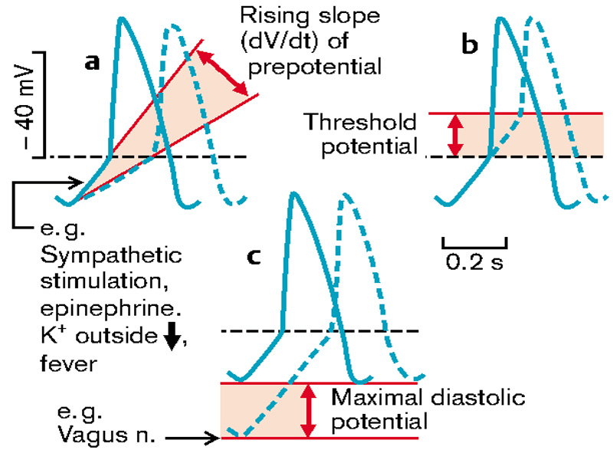
Fig. 7 Changes in pacemaker potential
(From S. Silbernagl and F. Lang; Color Atlas of Pathophysiology)

During sleep and in trained athletes at rest (vagotonia) and also in hypothyroidism, the rate can drop below 60 per minute (sinus bradycardia), while during physical exercise, excitement, fever or hyperthyroidism it may rise to well above 100 per minute (sinus tachycardia). In both cases the rhythm is regular, while the rate varies in sinus arrhythmia. This arrhythmia is normal in juveniles and varies with respiration, the rate accelerating in inspiration, slowing in expiration. The SA node may be functioning properly, but because of additional precipitating factors, other cardiac cells can assume accelerated properties of automaticity and begin to initiate impulses. These additional factors might include injury, hypoxia, electrolyte disturbances, enlargement or hypertrophy of the atria or ventricles, and exposure to certain chemicals or drugs.
Sinus node arrhythmias
In a healthy heart driven by sinus node discharge, the rate ranges between 60 and 100 beats per minute. On the ECG, a P wave may be observed to precede every QRS complex. Historically, normal sinus rhythm has been considered the “normal” rhythm of a healthy heart. In normal sinus rhythm, a P wave precedes each QRS complex, and the RR intervals, remain relatively constant over time. Alterations in the function of the SA node lead to changes in rate or rhythm of the heartbeat.
Years ago, it was believed that sinus rhythm should be regular; that is, all RR intervals should be equal. Today, it is accepted that a more optimal rhythm is respiratory sinus arrhythmia. Respiratory sinus arrhythmia is a cardiac rhythm characterized by gradual lengthening and shortening of RR intervals (Fig.8, D). This variation in cardiac cycles is related to intrathoracic pressure changes that occur with respiration and resultant alterations in autonomic control of the SA node. Inspiration causes acceleration of the heart rate, and expiration causes slowing. Respiratory sinus arrhythmia accounts for most heart rate variability in healthy individuals. Decreased heart rate variability has been associated with altered health states, including myocardial infarction, congestive heart failure, hypertension, diabetes mellitus, and prematurity in infants.
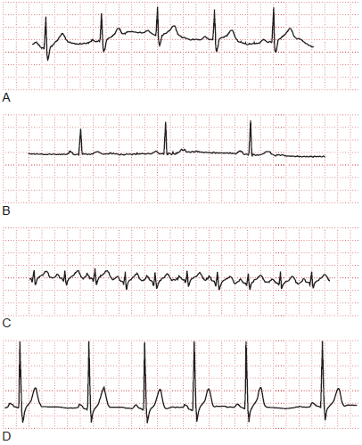
Fig. 8 Electrocardiographic (ECG) tracings of rhythms originating
in the sinus node
(A) Normal sinus rhythm (60 to 100 beats per minute). (B) Sinus bradycardia (<60 beats per minute). (C) Sinus tachycardia (>100 beats per minute). (D) Respiratory sinus arrhythmia, characterized by gradually lengthening and shortening of RR intervals (From C. Porth and G. Matfin; Pathophysiology. Concepts of altered health states).

Sinus bradycardia. Sinus bradycardia describes a slow (<60 beats per minute) heart rate (Fig. 8, B). In sinus bradycardia, a P wave precedes each QRS. A normal P wave and PR interval (0.12 to 0.20 second) indicate that the impulse originated in the SA node rather than in another area of the conduction system that has a slower inherent rate. Vagal stimulation decreases the firing rate of the SA node and conduction through the AV node to cause a decrease in heart rate. This rhythm may be normal in trained athletes, who maintain a large stroke volume, and during sleep. Sinus bradycardia may be an indicator of poor prognosis when it occurs in conjunction with acute myocardial infarction, particularly if associated with hypotension.
Sinus tachycardia. Sinus tachycardia refers to a rapid heart rate (>100 beats per minute) that has its origin in the SA node (Fig.8, C). A normal P wave and PR interval should precede each QRS complex. The mechanism of sinus tachycardia is enhanced automaticity related to sympathetic stimulation or withdrawal of vagal tone (see above). Sinus tachycardia is a normal response during fever and exercise and in situations that incite sympathetic stimulation. It may be associated with congestive heart failure, myocardial infarction, and hyperthyroidism. Pharmacologic agents such as atropine, isoproterenol, epinephrine, and quinidine also can cause sinus tachycardia.
Sinus arrest. Sinus arrest refers to failure of the SA node to discharge and results in an irregular pulse. An escape rhythm develops as another pacemaker takes over. Sinus arrest may result in prolonged periods of asystole and often predisposes to other arrhythmias. Causes of sinus arrest include disease of the SA node, digitalis toxicity, myocardial infarction, acute myocarditis, excessive vagal tone, quinidine, acetylcholine, and hyperkalemia or hypokalemia.
Arrhythmias due to disturbances in excitability
Excitability describes the ability of a cell to respond to an impulse and generate an action potential. Myocardial cells that have been injured or replaced by scar tissue do not possess normal excitability. For example, during the acute phase of an ischemic event, involved cells become depolarized. These ischemic cells remain electrically coupled to the adjacent non-ischemic area; current from the ischemic zone can induce reexcitation of cells in the non-ischemic zone. An ectopic pacemaker is an excitable focus outside the normally functioning SA node. These pacemakers can reside in other parts of the conduction system or in muscle cells of the atria or ventricles. A premature contraction or extrasystole occurs when an ectopic pacemaker initiates a beat. Premature contractions do not follow the normal conduction pathways, they are not coupled with normal mechanical events, and they often render the heart refractory or incapable of responding to the next normal impulse arising in the SA node. They occur without incident in persons with healthy hearts in response to sympathetic nervous system stimulation or other stimulants such as caffeine. In the diseased heart, premature contractions may lead to more serious arrhythmias.
Causes of extrasystole as disorders of excitability in the heart are:
– A less negative diastolic membrane potential in the cells of the conduction system or myocardium. This is because depolarization also results in the potential losing its stability and depolarizing spontaneously;
- Afterdepolarizations and triggered automaticity or depolarizing after-potentials which can occur during repolarization (“early”) or after its end (“late”) (Fig.9).
Afterdepolarizations and triggered automaticity. Triggered automaticity or activity refers to impulse initiation that is dependent on afterdepolarizations. Afterdepolarizations are membrane voltage oscillations that occur during an action potential (early afterdepolarizations) or after it (delayed afterdepolarizations).
Early afterdepolarizations (EAD) occur during the action potential and interrupt the orderly repolarization of the myocyte. EADs occur when the AP duration is markedly prolonged, which registers in the ECG as a prolonged QT interval (long QT syndrome). Causes of EAD are bradycardia (ex in hypothyroidism, β1 block), hypokalemia, hypomagnesemia (loop diuretics), and certain drugs such as the Na⁺ channel blockers quinidine, procainamide, and disopyramide, as well as the Ca²⁺ channel blockers verapamil and diltiazem. Certain genetic defects in the Na⁺ channels or in one of the K⁺ channels lead to EAD due to a lengthening of the QT interval. If such EAD occur in the Purkinje cells, they trigger ventricular ES in the more distal myocardium (the myocardium has a shorter AP than the Purkinje fibers and is therefore already repolarized when the DAP reaches it).
Traditionally, EADs have been thought to arise from action potential prolongation and reactivation of depolarizing currents, but more recent experimental evidence suggests a previously unappreciated interrelationship between intracellular calcium loading and EADs. Cytosolic calcium may increase when action potentials are prolonged. This, in turn, appears to enhance L-type Ca current, further prolonging action potential duration as well as providing the inward current driving EADs. The interrelationship among intracellular [Ca²⁺] and EADs may be one explanation for the susceptibility of hearts that are calcium loaded (e.g., in ischemia or congestive heart failure) to develop arrhythmias, particularly on exposure to action potential–prolonging drugs.
The delayed afterdepolarizations (DADs) are usually preceded by posthyperpolarization that changes into postdepolarization. If the amplitude of the latter reaches the threshold potential, a new AP is triggered. The cellular feature common to the induction of DADs is the presence of an increased Ca²⁺ load in the cytosol and sarcoplasmic reticulum. Digitalis glycoside toxicity, catecholamines, and ischemia all can enhance Ca²⁺ loading sufficiently to produce DAD. Accumulation of lysophospholipids in ischemic myocardium with consequent Na⁺ and Ca²⁺ overload has been suggested as a mechanism for DADs and triggered automaticity. Cells from damaged areas or cells that survive a myocardial infarction may display spontaneous release of calcium from the sarcoplasmic reticulum, and this may generate "waves" of intracellular calcium elevation and arrhythmias.
Structural heart disease such as cardiac hypertrophy and failure may also delay ventricular repolarization (so-called electrical remodeling) and predispose to arrhythmias related to abnormalities of repolarization. The abnormalities of repolarization in hypertrophy and heart failure are often magnified by concomitant drug therapy or electrolyte disturbances.

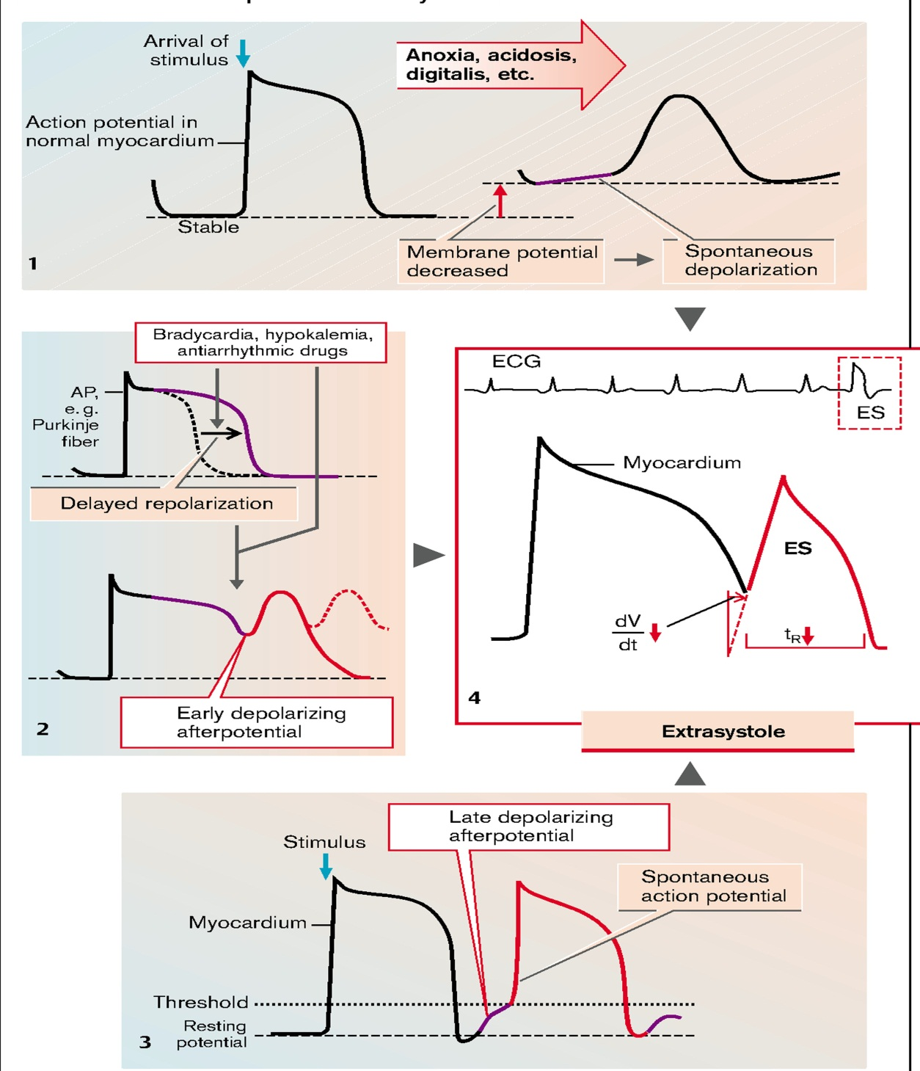
Fig. 9. Mechanisms of heart excitability disturbances
(From S. Silbernagl and F. Lang; Color Atlas of Pathophysiology)

Abnormal impulse conduction: reentry as mechanisms of disturbances in heart excitability
Almost all tachyarrhythmias are the result of a phenomenon known as reentry. Under normal conditions, an electrical impulse is conducted through the heart in an orderly, sequential manner. The electrical impulse then dies out and does not reenter adjacent tissue because that tissue has already been depolarized and is refractory to immediate stimulation. However, fibers that were not activated during the initial wave of depolarization can recover excitability before the initial impulse dies out, and they may serve as a link to reexcite areas of the heart that were just discharged and have recovered from the initial depolarization. This activity disrupts the normal conduction sequence. Reentry may occur anywhere in the conduction system. The functional components of a reentry circuit can be large and include an entire specialized conduction system, or the circuit can be microscopic. It can include myocardial tissue, AV nodal cells, junctional tissue or the ventricles. Factors contributing to the development of a reentrant circuit include ischemia, infarction, and elevated serum potassium levels. For reentry to occur, there should be several predisposing factors: the maximal length of the loop s has increased, for example, in ventricular hypertrophy, the refractory time tR has shortened, and/or the velocity of the spread of excitation " is diminished (Fig.10
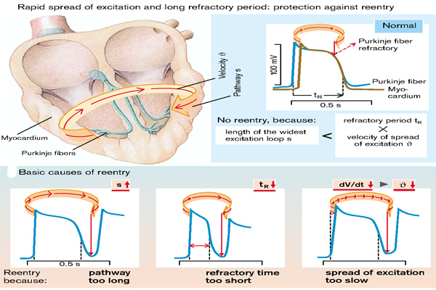
Fig.10 Schematic diagram of reentry
A. The circuit contains two limbs, one with slow conduction. B. A premature impulse blocks in the fast pathway and conducts over the slow pathway, allowing the fast pathway to recover so that the activation wave can reenter the fast pathway from the retrograde direction. C. During sustained reentry utilizing such a circuit, a gap (excitable gap) exists between the activating head of the wave and the recovering tail. D. One mechanism of termination of reentry occurs when the conduction and recovery characteristics of the circuit change and the activating head of the wave collides with the tail, extinguishing the tachycardia. (From S. Silbernagl and F. Lang; Color Atlas of Pathophysiology)

There are several forms of reentry. The first is anatomic reentry. It involves an anatomic obstacle around which the circulating current must pass and results in an excitation wave that travels in a set pathway. Arrhythmias that arise as a result of anatomic reentry are paroxysmal supraventricular tachycardias, as seen in Wolff-Parkinson-White syndrome, atrial fibrillation, atrial flutter, AV nodal reentry, and some ventricular tachycardias. Functional reentry does not rely on an anatomic structure to circle; but instead depends on the local differences in conduction velocity and refractoriness among neighboring fibers that allow an impulse to circulate repeatedly around in area. Spiral reentry is the most common form of this type of reentry. It is initiated by a wave of electrical current that does not propagate normally after meeting refractory tissue. The broken end of the wave curls, forms a vortex, and permanently rotates. This phenomenon suppresses normal pacemaker activity and can result in atrial fibrillation.
Structural heart disease is associated with changes in conduction and refractoriness that increase the risk of reentrant arrhythmias. Chronically ischemic myocardium exhibits a downregulation of the gap junction channel protein (connexin 43) that carries intercellular ionic current. The border zones of infarcted and failing ventricular myocardium exhibit not only functional alterations of ionic currents but also remodeling of tissue and altered distribution of gap junctions. The changes in gap junction channel expression and distribution, in combination with macroscopic tissue alterations, support a role for slowed conduction in reentrant arrhythmias that complicate chronic coronary artery disease (CAD). Aged human atrial myocardium exhibits altered conduction, manifest as highly fractionated atrial electrograms, producing an ideal substrate for the reentry that may underlie the very common development of atrial fibrillation in the elderly.
Arrhythmias of atrial origin
Impulses from the SA node pass through the conductive pathways in the atria to the AV node. Arrhythmias of atrial origin include premature atrial contractions (atrial extrasystole), paroxysmal supraventricular tachycardia, atrial flutter, and atrial fibrillation (Fig.11).
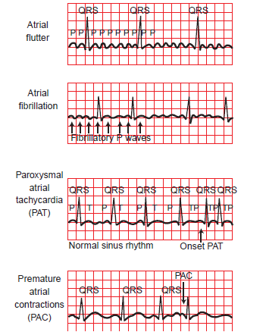
Fig. 11 Electrocardiographic tracings of atrial arrhythmias.
Atrial flutter (first tracing) is characterized by the atrial flutter (F) waves occurring at a rate of 240 to 450 beats per minute. The ventricular rate remains regular because of the conduction of every sixth atrial contraction. Atrial fibrillation (second tracing) has grossly disorganized atrial electrical activity that is irregular with respect to rate and rhythm. The ventricular response is irregular, and no distinct P waves are visible. The third tracing illustrates paroxysmal atrial tachycardia (PAT), preceded by a normal sinus rhythm. The fourth tracing illustrates premature atrial complexes (PAC) (From C. Porth and G. Matfin; Pathophysiology. Concepts of altered health states).
.
Premature atrial contractions (atrial extrasystole). Premature atrial contractions (PACs) are contractions that originate in the atrial conduction pathways or atrial muscle cells and occur before the next expected SA node impulse. This impulse to contract usually is transmitted to the ventricle and back to the SA node. The location of the ectopic focus determines the configuration of the P wave. In general, the closer the ectopic focus is to the SA node, the more the ectopic complex resembles a normal sinus complex. The retrograde transmission to the SA node often interrupts the timing of the next sinus beat, such that a pause occurs between the two normally conducted beats (partial compensatory pause or post-extrasystolic pause). In healthy individuals, atrial extrasystole may be the result of stress, tobacco, or caffeine. They also have been associated with myocardial infarction, digitalis toxicity, low serum potassium or magnesium levels and hypoxia.
Atrial flutter. Atrial flutter is a rapid atrial ectopic tachycardia, with an atrial rate that ranges from 240 to 450 beats per minute. There are two types of atrial flutter. Type I flutter (typical) is the result of a reentry mechanism in the right atrium and can be entrained and interrupted with atrial pacing techniques. The atrial rate in typical type I flutter usually is in the vicinity of 300 beats per minute, but it can range from 240 to 340 beats per minute. Other forms of atrial flutter (the so called atypical or type II flutters) are now recognized as distinct types and include atrial macro-reentry caused by surgical scars, idiopathic fibrosis in areas of the atrium, or other anatomic or functional barriers in the atria. Because the barriers that constrain these flutters are variable, the ECG pattern of the atypical flutters can vary. Often, the flutter wave changes morphologically during the same episode of flutter, indicating multiple circuits or non-fixed conduction barriers.
In typical atrial flutter, ECG, atrial flutter reveals a defined sawtooth pattern in leads aVF, and V1 and V5. The ventricular response rate and regularity are variable and depend on the AV conduction sequence. When regular, the ventricular response rate usually is a defined fraction of the atrial rate (i.e., when conduction from the atria to the ventricles is 2:1, an atrial flutter rate of 300 would result in a ventricular response rate of 150 beats per minute). The QRS complex may be normal or abnormal, depending on the presence or absence of preexisting intraventricular conduction defects or aberrant ventricular conduction.
Atrial fibrillation. Atrial fibrillation is characterized by chaotic impulses propagating in different directions and causing disorganized atrial depolarizations without effective atrial contraction. In most cases, multiple, small reentrant circuits are constantly arising in the atria, colliding, being extinguished, and arising again. Fibrillation occurs when the atrial cells cannot repolarize in time for the next incoming stimulus. Atrial fibrillation is characterized on the ECG by a grossly disorganized pattern of atrial electrical activity that is irregular with respect to rate and rhythm and the absence of discernible P waves. Atrial activity is depicted by fibrillatory (f) waves of varying amplitude, duration, and morphology. These f waves appear as random oscillation of the baseline. Because of the random conduction through the AV node, QRS complexes appear in an irregular pattern.
Atrial fibrillation is the only common arrhythmia in which the ventricular rate is rapid and the rhythm irregular. The atrial rate typically ranges from 400 to 600 beats per minute, with many impulses blocked at the AV node. The ventricular response is completely irregular, ranging from 80 to 180 beats per minute in the untreated state. Because of changes in stroke volumes resulting from varying periods of diastolic filling, not all ventricular beats produce a palpable pulse. The difference between the apical rate and the palpable peripheral pulses is called the pulse deficit. The pulse deficit may increase when the ventricular rate is high.
Atrial fibrillation may appear paroxysmally or as a chronic phenomenon. It can be seen in persons without any apparent disease, or it may occur in individuals with coronary artery disease, mitral valve disease, ischemic heart disease, hypertension, myocardial infarction, pericarditis, congestive heart failure, digitalis toxicity, and hyperthyroidism. Spontaneous conversion to sinus rhythm within 24 hours of atrial fibrillation is common, occurring in up to two thirds of persons with the disorder. Once the duration exceeds 24 hours, the likelihood of conversion decreases, and after 1 week of persistent arrhythmia, spontaneous conversion is rare.
Ventricular arrhythmias
Arrhythmias that arise in the ventricles commonly are considered more serious than those that arise in the atria because they afford the potential for interfering with the pumping action of the heart.
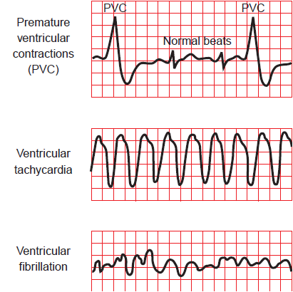
Fig.11 Electrocardiographic (ECG) tracings of ventricular arrhythmias.
Premature ventricular contractions (PVCs) (top tracing) originate from an ectopic focus in the ventricles, causing a distortion of the QRS complex. Because the ventricle usually cannot repolarize sufficiently to respond to the next impulse that arises in the sinoatrial node, a PVC frequently is followed by a compensatory pause. Ventricular tachycardia (middle tracing) is characterized by a rapid ventricular rate of 70 to 250 beats per minute and the absence of P waves. In ventricular fibrillation (bottom tracing), there are no regular or effective ventricular contractions, and the ECG tracing is totally disorganized (From C. Porth and G. Matfin; Pathophysiology. Concepts of altered health states).

Premature ventricular contractions (ventricular extrasystole). A premature ventricular contraction (PVC) is caused by a ventricular ectopic pacemaker. After a PVC, the ventricle usually is unable to repolarize sufficiently to respond to the next impulse that arises in the SA node. This delay is commonly referred to as a compensatory pause, occurs while the ventricle waits to reestablish its previous rhythm (Fig. 11). When a PVC occurs, the diastolic volume usually is insufficient for ejection of blood into the arterial system. As a result, PVCs usually do not produce a palpable pulse, or the pulse amplitude is significantly diminished. In the absence of heart disease, PVCs typically are not clinically significant. The incidence of PVCs is greatest with ischemia, acute myocardial infarction, history of myocardial infarction, ventricular hypertrophy, infection, increased sympathetic nervous system activity, or increased heart rate. PVCs also can be the result of electrolyte disturbances or medications.
A special pattern of PVC called ventricular bigeminy is a condition in which each normal beat is followed by or paired with a PVC. This pattern often is an indication of digitalis toxicity or heart disease. The occurrence of frequent PVCs in the diseased heart predisposes the patient to the development of other, more serious arrhythmias, including ventricular tachycardia and ventricular fibrillation.
Ventricular flutter and fibrillation. These arrhythmias represent severe derangements of cardiac rhythm that terminate fatally within minutes unless corrective measures are taken promptly. The ECG pattern in ventricular flutter has a sine wave appearance with large oscillations occurring at a rate of 150 to 300 per minute. In ventricular fibrillation, the ventricle quivers but does not contract. The classic ECG pattern of ventricular fibrillation is that of gross disorganization without identifiable waveforms or intervals. When the ventricles do not contract, there is no cardiac output, and there are no palpable or audible pulses. The immediate defibrillation using a non-synchronized DC electrical shock is mandatory for ventricular fibrillation and for ventricular flutter that has caused loss of consciousness.
Disorders of atrioventricular conduction
Under normal conditions, the AV junction, which consists of the AV node with its connections to the entering atrial internodal pathways, the AV bundle, and the non-branching portion of the bundle of His, provides the only connection for transmission of impulses between the atrial and ventricular conduction systems. Junctional fibers in the AV node have high-resistance characteristics that cause a delay in the transmission of impulses from the atria to the ventricles. This delay provides optimal timing for atrial contribution to ventricular filling and protects the ventricles from abnormally rapid rates that arise in the atria. Conduction defects of the AV node are most commonly associated with fibrosis or scar tissue in fibers of the conduction system. Conduction defects also may result from medications, including digoxin, β-adrenergic–blocking agents, calcium channel–blocking agents, and class 1A antiarrhythmic agents. Additional contributing factors include electrolyte imbalances, inflammatory disease, or cardiac surgery.
Heart block refers to abnormalities of impulse conduction. It may be normal, physiologic (vagal tone), or pathologic. It may occur in the AV nodal fibers or in the AV bundle (bundle of His), which is continuous with the Purkinje conduction system that supplies the ventricles. The PR interval on the ECG corresponds with the time it takes for the cardiac impulse to travel from the SA node to the ventricular pathways. Normally, the PR interval ranges from 0.12 to 0.20 second (Fig.12).
Second-degree AV block. Second-degree AV block is characterized by intermittent failure of conduction of one or more impulses from the atria to the ventricles. The non-conducted P wave can appear intermittently or frequently. A distinguishing feature of second-degree AV block is that conducted P waves relate to QRS complexes with recurring PR intervals; that is, the association of P waves with QRS complexes is not random. Second-degree AV block has been divided into two types: type I (Mobitz type I or Wenckebach’s phenomenon) and type II (Mobitz type II). A Mobitz type I AV block is characterized by progressive lengthening of the PR interval until an impulse is blocked and the sequence begins again. It frequently occurs in persons with inferior wall myocardial infarction, particularly with concomitant right ventricular infarction. The condition usually is associated with an adequate ventricular rate and rarely is symptomatic. It usually is transient and does not require temporary pacing. In the Mobitz type II AV block, an intermittent block of atrial impulses occurs, with a constant PR interval. It frequently accompanies anterior wall myocardial infarction and can require temporary or permanent pacing. This condition is associated with a high mortality rate. In addition, Mobitz type II AV block is associated with other types of organic heart disease and often progresses to complete heart block.
Third-degree AV block. Third-degree, or complete, AV block occurs when the conduction link for all impulses from the SA node and atria through the AV node is blocked, resulting in depolarization of the atria and ventricles being controlled by separate pacemakers. The atrial pacemaker can be sinus or ectopic in origin. The ventricular pacemaker usually is located just below the region of the block. The atria usually continue to beat at a normal rate, and the ventricles develop their own rate, which normally is slow (30 to 40 beats per minute). The atrial and ventricular rates are regular but dissociated. Third-degree AV block can result from an interruption at the level of the AV node, in the bundle of His, or in the Purkinje system. Third-degree blocks at the level of the AV node usually are congenital, whereas blocks in the Purkinje system usually are acquired. Normal QRS complexes, with rates ranging from 40 to 60 complexes per minute, usually are displayed on the ECG when the block occurs proximal to the bundle of His. Complete heart block causes a decrease in cardiac output with possible periods of syncope (fainting), known as a Stokes-Adams attack. Other symptoms include dizziness, fatigue, exercise intolerance, or episodes of acute heart failure. Most persons with complete heart block require a permanent cardiac pacemaker.
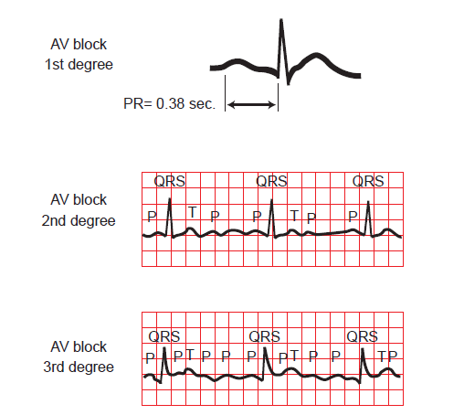
Fig.12 Electrocardiographic changes that occur with alterations in
atrioventricular (AV) node conduction
The top tracing shows the prolongation of the PR interval, which is characteristic of first-degree AV block. The middle tracing illustrates Mobitz type II second-degree AV block, in which the conduction of one or more P waves is blocked. In third-degree AV block (bottom tracing), complete block in conduction of impulses through the AV node occurs, and the atria and ventricles develop their own rates of impulse generation . (From C. Porth and G. Matfin; Pathophysiology. Concepts of altered health states).

