PATHOPHYSIOLOGY OF RESPIRATORY SYSTEM
 Lungs and respiratory airways
The lungs are the functional structures of the respiratory system. In addition to their gas exchange function, they inactivate vasoactive substances such as bradykinin, convert angiotensin I to angiotensin II, and serve as a reservoir for blood storage. Heparin-producing cells are particularly abundant in the capillaries of the lung, where small clots may be trapped.
The gas exchange function of the lung takes place in the lobules of the lungs. Each lobule, which is the smallest functional unit of the lung, is supplied by a terminal bronchiole, an arteriole, pulmonary capillaries, and a venule. Gas exchange takes place in the terminal respiratory bronchioles and the alveolar ducts and sacs. Blood enters the lobules through a pulmonary artery and exits through a pulmonary vein. Lymphatic structures surround the lobule and aid in the removal of plasma proteins and other particles from the interstitial spaces.

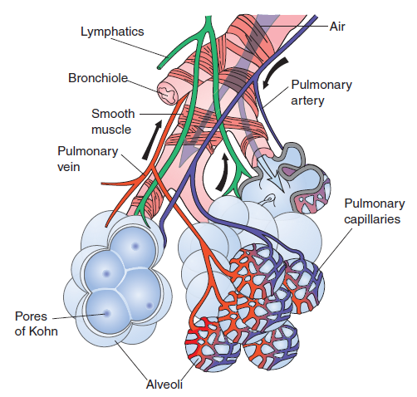
Lobule of the lung, showing the bronchial smooth muscle fibers, pulmonary blood vessels, and lymphatics
(From C. Porth and G. Matfin; Pathophysiology. Concepts of altered health states).

The alveoli are the terminal air spaces of the respiratory tract and the actual sites of gas exchange between the air and the blood. Each alveolus is a small outpouching of respiratory bronchioles, alveolar ducts, and alveolar sacs. The alveolar sacs are cup-shaped, thin-walled structures that are separated from each other by thin alveolar septa. A single network of capillaries occupies most of the septa, so blood is exposed to air on both sides. There are approximately 300 million alveoli in the adult lung, with a total surface area of approximately 50 to 100 m². Unlike the bronchioles, which are tubes with their own separate walls, the alveoli are interconnecting spaces that have no separate walls. As a result of this arrangement, there is a continual mixing of air in the alveolar structures. Small holes in the alveolar walls, the pores of Kohn, also contribute to the mixing of air. The alveolar epithelium is composed of two types of cells: type I and type II alveolar cells. The alveoli also contain brush cells and macrophages. The brush cells, which are few in number, are thought to act as receptors that monitor the air quality of the lungs. The macrophages, which are present in both the alveolar lumen and the septum of the alveoli, function to remove offending material from the lung.
Type I alveolar cells. The type I alveolar cells, also known as type I pneumocytes, are extremely thin squamous cells with a thin cytoplasm and flattened nucleus that occupy about 95% of the surface area of the alveoli. They are joined to one another and to other cells by occluding junctions. These junctions form an effective barrier between the air and the components of the alveolar wall. Type I alveolar cells are not capable of regeneration.
Type II alveolar cells. The type II alveolar cells, also called type II pneumocytes, are secretory cells that produce the surface-active agent called surfactant. These cuboidal cells, which are found interspersed among the type I cells, tend to bulge into the air spaces. Type II cells are as numerous as type I cells, but because of their different shape, they cover only about 5% of the alveolar surface area. In addition to secreting surfactant, type II alveolar cells are the progenitor cells for type I cells. Following lung injury, they proliferate and restore both type I and type II alveolar cells.
The surfactant molecules produced by the type II alveolar cells reduce the surface tension at the air–epithelium interface and they modulate the immune functions of the lung. Recent research has identified four types of surfactant, each with a different molecular structure: surfactant protein A (SP-A), B (SP-B), C (SP-C), and D (SP-D). SP-B and SP-C reduce the surface tension at the air–epithelium interface and increase lung compliance and ease of lung inflation. SP-B is particularly important to the generation of the surface-reducing film that makes lung expansion possible. SP-A and SP-D do not reduce surface tension, but contribute to host defenses that protect against pathogens that have entered the lung. They are members of the collectin family that function as a part of the innate immune system. Collectively they opsonize pathogens, including bacteria and viruses, to facilitate phagocytosis by macrophages. They also regulate the production of inflammatory mediators. Evidence also suggests that SP-A and SP-D are directly bacteriocidal, meaning they can kill bacteria in the absence of immune system effector cells.

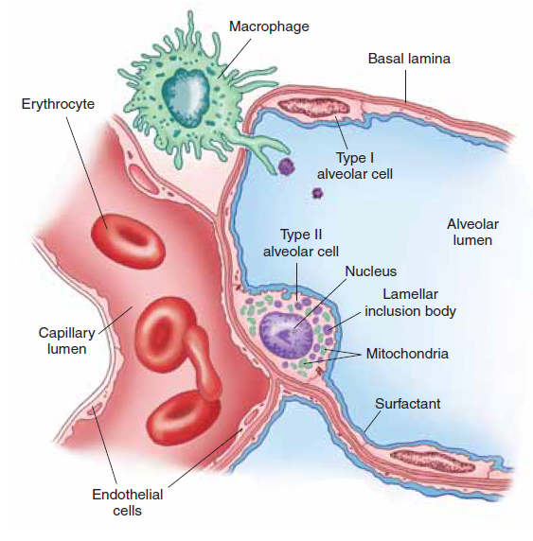
Schematic illustration of type I and type II alveolar cells and their relationship to the alveoli and pulmonary capillaries. Type I alveolar cells comprise most of the alveolar surface. The type II alveolar cells, which produce surfactant, are located at the corners between adjacent alveoli. Also shown are the endothelial cells, which line the pulmonary capillaries, and an alveolar macrophage (From C. Porth and G. Matfin; Pathophysiology. Concepts of altered health states).

Alveolar macrophages. The alveolar macrophages, which are present in both the connective tissue of the septum and in the air spaces of the alveolus, are responsible for the removal of offending substances from the alveoli. In the air spaces, they scavenge the surface to remove inhaled particulate matter, such as dust and pollen. Some macrophages move up the bronchial tree in the mucus and are disposed of by swallowing or coughing when they reach the pharynx. Others enter the septal connective tissue, where, filled with phagocytosed materials, they remain for life. Thus, at autopsy, urban dwellers, as well as smokers, usually show many alveolar macrophages filled with carbon and other polluting particles from the environment. The alveolar macrophages also phagocytose insoluble infectious agents such as Mycobacterium tuberculosis. The activated macrophages then aggregate to form a fibrin-encapsulated granuloma, called a tubercle, that serves to contain the infection. The tubercle bacillus can remain dormant in this stage or be reactivated years later, when the person’s immunologic tolerance wanes as the result of conditions such as immunosuppressive therapy or acquired immunodeficiency disease (AIDS).
Pulmonary and bronchial circulations. The lungs are provided with a dual blood supply: the pulmonary and bronchial circulations. The pulmonary circulation arises from the pulmonary artery and provides for the gas exchange function of the lungs. Deoxygenated blood leaves the right heart through the pulmonary artery, which divides into a left pulmonary artery that enters the left lung and a right pulmonary artery that enters the right lung. Return of oxygenated blood to the heart occurs by way of the pulmonary veins, which empty into the left atrium. It is important to note that this is the only part of the circulation in which arteries carry deoxygenated blood and veins carry oxygenated blood. The bronchial circulation supplies the blood supply for the conducting airways and the supporting structures of the lung. It also has a secondary function of warming and humidifying incoming air as it moves through the conducting airways. The bronchial arteries arise from the thoracic aorta and enter the lungs with the major bronchi, dividing and subdividing along with the bronchi as they move out into the lung, supplying them and other lung structures with oxygen. The blood from the capillaries in the bronchial circulation drains into the bronchial veins, with the blood from the larger bronchial veins emptying into the vena cava and blood from the smaller bronchial veins emptying into the pulmonary veins. Because the bronchial circulation does not participate in gas exchange, this blood is deoxygenated. As a result, it dilutes the oxygenated blood returning to the left side of the heart by way of the pulmonary veins. The bronchial blood vessels are the only ones that can undergo angiogenesis (formation of new vessels) and develop collateral circulation when vessels in the pulmonary circulation are obstructed, as in pulmonary embolism. The development of new blood vessels helps to keep lung tissue alive until the pulmonary circulation can be restored.
Pleura. A thin, transparent, double-layered serous membrane, called the pleura, lines the thoracic cavity and encases the lungs. The outer parietal layer lines the pulmonary cavities and adheres to the thoracic wall, the mediastinum, and the diaphragm. The inner visceral pleura closely covers the lung and is adherent to all its surfaces. It is continuous with the parietal pleura at the hilus of the lung, where the major bronchus and pulmonary vessels enter and leave the lung. A thin film of serous fluid separates the two pleural layers, allowing the two layers to glide over each other and yet hold together, so there is no separation between the lungs and the chest wall. The pleural cavity is a potential space in which serous fluid or inflammatory exudate can accumulate. The term pleural effusion is used to describe an abnormal collection of fluid in the pleural cavity.
Control of breathing. Unlike the heart, which has inherent rhythmic properties and can beat independently of the nervous system, the muscles that control respiration require continuous input from the nervous system. Movement of the diaphragm, intercostal muscles, sternocleidomastoid, and other accessory muscles that control ventilation is integrated by neurons located in the pons and medulla. These neurons are collectively referred to as the respiratory center.
Respiratory center. The respiratory center consists of two dense, bilateral aggregates of respiratory neurons involved in initiating inspiration and expiration and incorporating afferent impulses into motor responses of the respiratory muscles. The first, or dorsal, group of neurons in the respiratory center is concerned primarily with inspiration. These neurons control the activity of the phrenic nerves that innervate the diaphragm and drive the second, or ventral, group of respiratory neurons. They are thought to integrate sensory input from the lungs and airways into the ventilatory response. The second group of neurons, which contains inspiratory and expiratory neurons, controls the spinal motor neurons of the intercostal and abdominal muscles.
The pacemaker properties of the respiratory center result from the cycling of the two groups of respiratory neurons: the pneumotaxic center in the upper pons and the apneustic center in the lower pons. These two groups of neurons contribute to the function of the respiratory center in the medulla. The apneustic center has an excitatory effect on inspiration, tending to prolong inspiration. The pneumotaxic center switches inspiration off, assisting in the control of respiratory rate and inspiratory volume. Brain injury, which damages the connections between the pneumotaxic and apneustic centers, results in an irregular breathing pattern that consists of prolonged inspiratory gasps interrupted by expiratory efforts.
Axons from the neurons in the respiratory center cross in the midline and descend in the ventrolateral columns of the spinal cord. The tracts that control expiration and inspiration are spatially separated in the cord, as are the tracts that transmit specialized reflexes (i.e., coughing and hiccuping) and voluntary control of ventilation. Only at the level of the spinal cord are the respiratory impulses integrated to produce a reflex response.

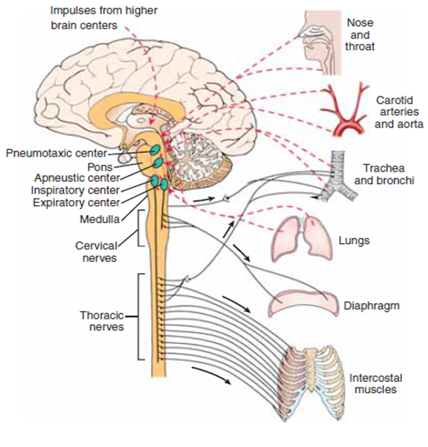
Schematic representation of activity in the respiratory center. Impulses traveling over afferent neurons (dashed lines) communicate with central neurons, which activate efferent neurons that supply the muscles of respiration. Respiratory movements can be altered by a variety of stimuli
((From C. Porth and G. Matfin; Pathophysiology. Concepts of altered health states).

Regulation of breathing. The control of breathing has both automatic and voluntary components. The automatic regulation of ventilation is controlled by input from two types of sensors or receptors: chemoreceptors and lung and chest wall receptors. Chemoreceptors monitor blood levels of oxygen, carbon dioxide, and pH and adjust ventilation to meet the changing metabolic needs of the body. Lung receptors monitor breathing patterns and lung function. Receptors in the joints, tendons, and muscles of chest wall structures may also play a role in breathing, particularly when quiet breathing is called for or when breathing efforts are opposed by increased airway resistance or reduced lung compliance. Voluntary regulation of ventilation integrates breathing with voluntary acts such as speaking, blowing, and singing. These acts, which are initiated by the motor and premotor cortex, cause a temporary suspension of automatic breathing. The automatic and voluntary components of respiration are regulated by afferent impulses that are transmitted to the respiratory center from a number of sources. Afferent input from higher brain centers is evidenced by the fact that a person can consciously alter the depth and rate of respiration. Fever, pain, and emotion exert their influence through lower brain centers. Vagal afferents from sensory receptors in the lungs and airways are integrated in the dorsal area of the respiratory center.
Chemoreceptors. The needs of body tissues for oxygen and the removal of carbon dioxide are regulated by chemoreceptors that monitor blood levels of these gases. Input from these sensors is transmitted to the respiratory center, and ventilation is adjusted to maintain the arterial blood gases within a normal range. There are two types of chemoreceptors: central and peripheral. The central chemoreceptors are located in the brain stem and the peripheral chemoreceptors in the carotid arteries and aorta.
Ventilatory drive is exquisitely sensitive to the PaCO₂ levels of the blood perfusing the central chemoreceptors. These receptors are located in chemosensitive regions near the respiratory center in the medulla and are bathed in cerebrospinal fluid (CSF). Although the central chemoreceptors monitor carbon dioxide levels, the actual stimulus for these receptors is provided by hydrogen ions in the CSF. The CSF is separated from the blood by the blood-brain barrier, which permits free diffusion of carbon dioxide but not hydrogen ions. For this reason, changes in the pH of the blood have considerably less effect in stimulating ventilation than carbon dioxide, which stimulates the central chemoreceptors indirectly by changing the hydrogen ion concentration of the CSF. This occurs as the carbon dioxide that crosses the blood-brain barrier rapidly combines with water to form carbonic acid, which then dissociates into bicarbonate and hydrogen ions; with the hydrogen ions producing a direct stimulating effect on respiration. The central chemoreceptors are extremely sensitive to short-term changes in blood PaCO₂ levels. An increase in the PaCO₂ of the blood produces an increase in ventilation that reaches its peak within a minute or so and then declines if the PaCO₂ level remains elevated. Thus, persons with chronically elevated blood PaCO₂ levels no longer respond to this stimulus increased ventilation but rely on the stimulus provided by a decrease in arterial PaO₂ levels that is sensed by the peripheral chemoreceptors.
The peripheral chemoreceptors, which are located in the bifurcation of the common carotid arteries and in the arch of the aorta, monitor arterial PaO₂ levels. Although the peripheral chemoreceptors also monitor changes in PaCO₂ and pH, they play a much more important role in monitoring PaO₂ levels. These receptors exert little control over ventilation until the PaO₂ has dropped below 60 mm Hg. Thus, hypoxia is the main stimulus for ventilation in persons with chronically elevated levels of carbon dioxide. If these patients are given oxygen therapy at a level sufficient to increase the PaO₂ above that needed to stimulate the peripheral chemoreceptors, their ventilation may be seriously depressed.
Lung receptors. Lung receptors monitor the status of breathing in terms of airway resistance and lung expansion. There are three types of lung receptors: stretch, irritant, and juxtacapillary receptors. Stretch receptors are located in the smooth muscle layers of the conducting airways. They respond to changes in pressure in the walls of the airways. When the lungs are inflated, these receptors inhibit inspiration and promote expiration. They are important in establishing breathing patterns and minimizing the work of breathing by adjusting respiratory rate and TV to accommodate changes in lung compliance and airway resistance. The irritant receptors are located between the airway epithelial cells. They are stimulated by noxious gases, cigarette smoke, inhaled dust, and cold air. Stimulation of the irritant receptors leads to airway constriction and a of rapid, shallow breathing. This pattern of breathing probably protects respiratory tissues from the damaging effects of toxic inhalants. It also is thought that the mechanical stimulation of these receptors may ensure more uniform lung expansion by initiating periodic sighing and yawning. It is possible that these receptors are involved in the bronchoconstriction response that occurs in some persons with bronchial asthma. The juxtacapillary or J receptors are located in the alveolar wall, close to the pulmonary capillaries. It is thought that these receptors sense lung congestion. These receptors may be responsible for the rapid, shallow breathing that occurs with pulmonary edema, pulmonary embolism, and pneumonia.
In addition to the central nervous system respiratory control mechanisms operating entirely within the brain stem, sensory nerve signals from the lungs also help control respiration. Most important, located in the muscular portions of the walls of the bronchi and bronchioles throughout the lungs are stretch receptors that transmit signals through the vagi into the dorsal respiratory group of neurons when the lungs become overstretched. These signals affect inspiration in much the same way as signals from the pneumotaxic center; that is, when the lungs become overly inflated, the stretch receptors activate an appropriate feedback response that “switches off” the inspiratory ramp and thus stops further inspiration. This is called the Hering- Breuer inflation reflex. This reflex also increases the rate of respiration, as is true for signals from the pneumotaxic center. In human beings, the Hering-Breuer reflex probably is not activated until the tidal volume increases to more than three times normal (greater than about 1.5 liters per breath). Therefore, this reflex appears to be mainly a protective mechanism for preventing excess lung inflation rather than an important ingredient in normal control of ventilation.
Exchange of gases between the atmosphere and the lungs. The air we breathe is made up of a mixture of gases, mainly nitrogen and oxygen. These gases exert a combined pressure called the atmospheric pressure. The pressure at sea level is defined as 1 atmosphere, which is equal to 760 millimeters of mercury (mm Hg) or 14.7 pounds per square inch (PSI). When measuring respiratory pressures, atmospheric pressure is assigned a value of 0. This means that a respiratory pressure of +15 mm Hg is 15 mm Hg above atmospheric pressure, and a respiratory pressure of –15 mm Hg is 15 mm Hg less than atmospheric pressure. Respiratory pressures often are expressed in centimeters of water (cm H₂O) because of the small pressures involved (1 mm Hg = 1.35 cm H₂O pressure). The pressure exerted by a single gas in a mixture is called the partial pressure. The capital letter “P” followed by the chemical symbol of the gas (e.g., PO₂) is used to denote its partial pressure. The law of partial pressures states that the total pressure of a mixture of gases, as in the atmosphere, is equal to the sum of the partial pressures of the different gases in the mixture. If the concentration of oxygen at 760 mm Hg (1 atmosphere) is 20%, its partial pressure is 152 mm Hg (760 × 0.20). Water vapor is different from other types of gases; its partial pressure is affected by temperature but not atmospheric pressure. The relative humidity refers to the percentage of moisture in the air compared with the amount that the air can hold without causing condensation (100% saturation). Warm air holds more moisture than cold air. This is the reason that precipitation in the form of rain or snow commonly occurs when the relative humidity is high and there is a sudden drop in atmospheric temperature. The air in the alveoli, which is 100% saturated at normal body temperature, has a water vapor pressure of 47 mm Hg. The water vapor pressure must be included in the sum of the total pressure of the gases in the alveoli (i.e., the total pressure of the other gases in the alveoli is 760 - 47 = 713 mm Hg).
Air moves between the atmosphere and the lungs because of a pressure difference or gradient. According to the laws of physics, the pressure of a gas varies inversely with the volume of its container, provided the temperature remains constant. If equal amounts of a gas are placed in two different-size containers, the pressure of the gas in the smaller container will be greater than the pressure in the larger container. The movement of gases is always from the container with the greater pressure to the one with the lesser pressure. The chest cavity can be viewed as a volume container. During inspiration, air moves into the lungs as the size of the chest cavity increases, and during expiration, air moves out as the size of the chest cavity decreases.

Pathophysiology of respiratory system (overview)

Breathing through the lungs has two functions: firstly, to supply O₂ to the blood and, secondly, to regulate the acid-base balance via the CO₂ concentration in the blood. The mechanics of breathing serve to ventilate the alveoli, through whose walls O₂ can diffuse into the blood and CO₂ can diffuse out. Respiratory gases in the blood are largely transported in bound form. The amount transported depends, among other factors, on the concentration in blood and on pulmonary blood flow (perfusion). It is the task of respiratory regulation to adapt ventilation to the specific requirements. A number of disorders can affect breathing in such a manner that ultimately sufficient O₂ uptake and CO₂ release can no longer be guaranteed.
In obstructive lung disease (foreign bodies, asthma, pulmonary emphysema) flow resistance in the respiratory tract is raised and ventilation of the alveoli is thus impaired. The primary consequence is hypoventilation in some alveoli (abnormal distribuition) or of all alveoli (global hypoventilation). If alveolar ventilation ceases completely, a functional arteriovenous shunt occurs. However, hypoxia leads to constriction of the supplying vessels (hypoxic vasoconstriction, Euler-Liljestrand reflex), thus diminishing blood flow to the underventilated alveoli. In restrictive lung disease (pneumonia, pulmonary edema, pulmonary fibrosis, atelectasis, pneumothorax) the loss of functioning lung tissue reduces the area of diffusion and in this way impairs gaseous exchange. There is also a reduced area of diffusion in emphysema, a condition characterized by alveoli that have a large lumen but are also diminished in number. Disorders of diffusion can also be caused by an increased distance between alveoli and blood capillaries. If alveoli and capillaries are completely separated from one another, this results in both a functional dead space (non-perfused alveoli) and an arteriovenous shunt. Restrictive and obstructive lung disease as well as cardiovascular disease may affect lung perfusion. Decreased perfusion results in a reduced amount of gases being transported in blood, despite adequate O₂ saturation and CO₂ removal in the alveoli. If flow resistance is increased, severe consequences for the circulation are possible, because the entire cardiac output (CO) must pass through the lungs (Fig.1).
Breathing is also impaired in dysfunction of the respiratory neurons as well as of the motoneurons, nerves, and muscles that are controlled by them (hydroelectrolytic disturbances, metabolic disturbances, pH disturbances, head trauma, coma, head stroke, increased intracranial pressure, tumors). The changes in movement that occur when the breathing regulation is abnormal do not, however, necessarily lead to corresponding changes of alveolar ventilation.
The supply of O₂ to the cells as well as the removal of CO₂ from the periphery do not only depend on adequate respiration but also on unimpaired oxygen transport in the blood and on intact circulation. Thus, this can be changed in patients with heart failure, anemia, hemoglobinopathy.
Consequences of inadequate breathing can be hypoxemia, hypercapnia or hypocapnia (decreased CO₂ content) in arterialized blood, changes in pH (respiratory alkalosis or respiratory acidosis).
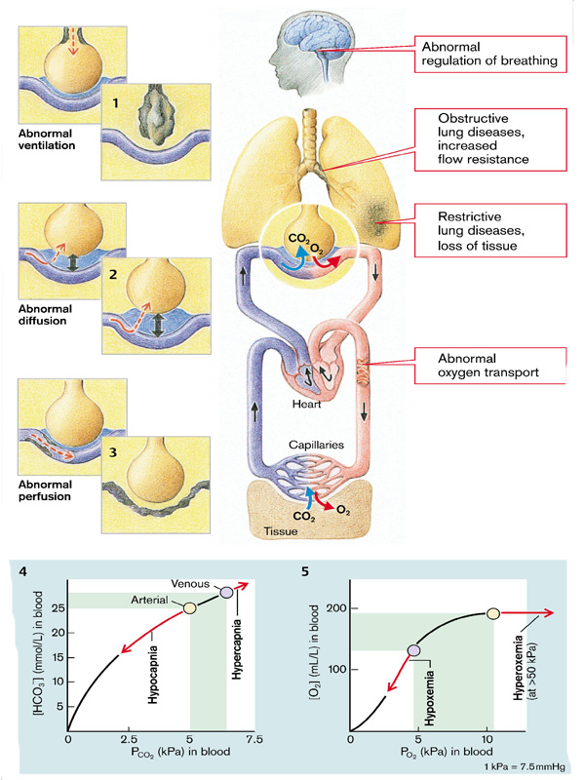
Fig.1 Pathophysiology of respiration (overview)
(From S. Silbernagl and F. Lang; Color Atlas of Pathophysiology)

Hypoxemia
Hypoxemia refers to a reduction in blood oxygen levels (PaO₂ less than 50-60 mmHg). Hypoxemia can result from an inadequate amount of oxygen in the air, disease of the respiratory system, or alterations in circulatory function. The mechanisms whereby respiratory disorders lead to a significant reduction in PaO₂ are hypoventilation, impaired diffusion of gases, shunt, and mismatching of ventilation and perfusion. Another cause of hypoxemia, reduction of the partial pressure of oxygen in the inspired air, occurs only under special circumstances, such as at high altitudes. Often, more than one mechanism contributes to hypoxemia in a person with respiratory or cardiac disease.
Manifestations. Hypoxemia produces its effects through tissue hypoxia and the compensatory mechanisms that the body uses to adapt to the lowered oxygen level. Body tissues vary considerably in their vulnerability to hypoxia; those with the greatest need are the nervous system and heart. Cessation of blood flow to the cerebral cortex results in loss of consciousness within 10 to 20 seconds. If the PaO₂ of the tissues falls below a critical level, aerobic metabolism ceases, and anaerobic metabolism takes over, with formation and release of lactic acid.
The signs and symptoms of hypoxia can be grouped into two categories: those resulting from impaired function of vital centers and those resulting from activation of compensatory mechanisms. Mild hypoxemia produces few manifestations. There may be slight impairment of mental performance and visual acuity and sometimes hyperventilation. This is because hemoglobin saturation still is approximately 90% when the PaO₂ is only 60 mm Hg. More pronounced hypoxemia may produce personality changes, restlessness, agitated or combative behavior, uncoordinated muscle movements, euphoria, impaired judgment, delirium, and eventually, stupor and coma. Recruitment of sympathetic nervous system compensatory mechanisms produces an increase in heart rate, peripheral vasoconstriction, diaphoresis, and a mild increase in blood pressure. Profound acute hypoxemia can cause convulsions, retinal hemorrhages, and permanent brain damage. Hypotension and bradycardia often are pre-terminal events in persons with hypoxemia, indicating the failure of compensatory mechanisms.
The body compensates for hypoxemia by increased ventilation, pulmonary vasoconstriction, and increased production of red blood cells. Hyperventilation results from the hypoxic stimulation of the chemoreceptors. Increased production of red blood cells results from the release of erythropoietin from the kidneys in response to hypoxia. Polycythemia increases the red blood cell concentration and the oxygen-carrying capacity of the blood. Pulmonary vasoconstriction occurs as a local response to alveolar hypoxia; it increases pulmonary arterial pressure and improves the matching of ventilation and blood flow. Other adaptive mechanisms include a shift to the right in the oxygen dissociation curve as a means of increasing oxygen release to the tissues. In conditions of chronic hypoxemia, the manifestations may be insidious in onset and attributed to other causes, particularly in chronic lung disease. Decreased sensory function, such as impaired vision or fewer complaints of pain, may be an early sign of worsening hypoxemia. This is probably because the involved sensory neurons have the same need for high levels of oxygen, as do other parts of the nervous system. Pulmonary hypertension is common because of associated alveolar hypoxia.
Diagnosis of hypoxemia is based on clinical observation and diagnostic measures of oxygen levels. The analysis of arterial blood gases provides a direct measure of the oxygen content of the blood and is a good indicator of the lungs’ ability to oxygenate the blood. Continuous mixed venous oxygen saturation (SV–O₂) can be monitored using a special type of pulmonary artery catheter. This method, which measures the mixed venous blood that is being returned to the lungs, reflects the use of oxygen by the peripheral tissues. Arterial blood gases and SV–O₂ often are monitored in critically ill patients. Both measurements are invasive and require direct sampling of the patient’s blood through a peripheral arterial catheter (for blood gases) or a pulmonary artery catheter (for SV–O₂).
Noninvasive measurements of arterial oxygen saturation of hemoglobin can be obtained using an instrument called the pulse oximeter. The pulse oximeter uses light-emitting diodes and combines plethysmography (i.e., changes in light absorbance and vasodilatation) with spectrophotometry. Spectrophotometry uses a red wave-length light that passes through oxygenated hemoglobin and is absorbed by deoxygenated hemoglobin and an infrared-wavelength light that is absorbed by oxygenated hemoglobin and passes through deoxygenated hemoglobin. Sensors that can be placed on the ear, finger, toe, or forehead are available. These methods, although not as accurate as the invasive methods, provide a means for continuous monitoring of oxygen levels and are useful indicators of respiratory and circulatory status. The pulse oximeters cannot distinguish between oxygen-carrying hemoglobin and carbon monoxide–carrying hemoglobin. In addition, the pulse oximeter cannot detect elevated levels of methemoglobin.

Cyanosis refers to the bluish discoloration of the skin and mucous membranes that result from an excessive concentration of reduced or deoxygenated hemoglobin in the small blood vessels. It usually is most marked in the lips, nail beds, ears, and cheeks. The degree of cyanosis is modified by the amount of cutaneous pigment, skin thickness, and the state of the cutaneous capillaries. Cyanosis is more difficult to distinguish in persons with dark skin and in areas of the body with increased skin thickness.
Although cyanosis may be evident in persons with respiratory failure, it often is a late sign. A concentration of approximately 5 g/dL of deoxygenated hemoglobin is required in the circulating blood for cyanosis. The absolute quantity of reduced hemoglobin, rather than the relative quantity, is important in producing cyanosis. Persons with anemia and low hemoglobin levels are less likely to exhibit cyanosis (because they have less hemoglobin to deoxygenate), even though they may be relatively hypoxic because of their decreased ability to transport oxygen, than persons who have high hemoglobin concentrations. Someone with a high hemoglobin level because of polycythemia may be cyanotic without being hypoxic.
Cyanosis can be divided into two types: central or peripheral. Central cyanosis is evident in the tongue and lips. It is caused by an increased amount of deoxygenated hemoglobin or an abnormal hemoglobin derivative in the arterial blood. Abnormal hemoglobin derivatives include methemoglobin, in which the nitrite ion reacts with hemoglobin. Because methemoglobin has a low affinity for oxygen, large doses of nitrites can result in cyanosis and tissue hypoxia. Although nitrites are used in treating angina, the therapeutic dose is too small to cause cyanosis. Sodium nitrite is used as a curing agent for meat. In nursing infants, the intestinal flora is capable of converting significant amounts of inorganic nitrate (e.g., from well water) into nitrite ion.
Peripheral cyanosis occurs in the extremities and on the tip of the nose or ears. It is caused by slowing of blood flow to an area of the body, with increased extraction of oxygen from the blood. It results from vasoconstriction and diminished peripheral blood flow, as occurs with cold exposure, shock, congestive heart failure, and peripheral vascular disease. Acute arterial obstruction in an extremity, such as occurs with an embolus or arterial spasm, usually presents with pallor and coldness, although there may be cyanosis.

Hypercapnia
Hypercapnia refers to an increase in the carbon dioxide content of the arterial blood (PaCO₂>46 mmHg). The diagnosis of hypercapnia is based on physiologic manifestations, arterial pH, and arterial blood gas levels. The carbon dioxide level in the arterial blood, or PaCO₂, is proportional to carbon dioxide production and inversely related to alveolar ventilation. The diffusing capacity of carbon dioxide is 20 times that of oxygen; therefore, hypercapnia is observed only in situations of hypoventilation sufficient to cause hypoxia.
Hypercapnia can occur in a number of disorders that cause hypoventilation or mismatching of ventilation and perfusion. Hypoventilation is a cause of hypercapnia in respiratory failure due to depression of the respiratory center in drug overdose, neuromuscular diseases such as Guillain-Barré syndrome, or chest wall deformities such as seen with severe scoliosis. Hypercapnia due to ventilation-perfusion inequalities is seen most commonly in persons with chronic obstructive pulmonary disease. Conditions that increase carbon dioxide production, such as an increase in metabolic rate or a highcarbohydrate diet, can contribute to the degree of hypercapnia that occurs in persons with impaired respiratory function.
The function of the respiratory center, which controls the activity of the muscles of respiration, is a crucial determinant of ventilation and elimination of carbon dioxide. The activity of the respiratory center is regulated by chemoreceptors that monitor changes in the chemical composition of the blood. The most important chemoreceptors in terms of the minute-by-minute control of ventilation are the central chemoreceptors that respond to changes in the hydrogen ion (H⁺) concentration of the cerebrospinal fluid. Although the blood–brain barrier is impermeable to H⁺ ions, CO₂ crosses it with ease. The CO₂, in turn, reacts with water to form carbonic acid, which dissociates to form H⁺ and bicarbonate (HCO₃⁻) ions. When the CO₂ content of the blood rises, CO₂ crosses the blood–brain barrier, liberating H⁺ ions that stimulate the central chemoreceptors. The excitation of the respiratory center due to CO₂ is greatest during the first 1 to 2 days that blood levels are elevated, but it gradually declines over the next 1 to 2 days. Part of this decline results from renal compensatory mechanisms that readjust the blood pH by increasing blood bicarbonate levels. PaCO2 > 70 mmHg leads to paralysis of respiratory centre and arrest of ventilation.
In persons with respiratory problems that cause chronic hypoxia and hypercapnia, the peripheral chemoreceptors become the driving force for ventilation. These chemoreceptors, which are located in the bifurcation of the common carotid arteries and in the aortic arch, respond to changes in PaO₂. Administration of high-flow oxygen to these persons can abolish the input from these peripheral receptors, causing a decrease in alveolar ventilation and a further rise in PaCO₂ levels.

DISTURBANCES OF PULMONARY VENTILATION
Ventilation and the mechanics of breathing. Ventilation is concerned with the movement of gases into and out of the lungs. It relies on a system of open airways and a change in pressure that is created as the respiratory muscles change the size of the chest cage. The degree to which the lungs inflate and deflate depends on the movement of the chest cage and pressures created by respiratory muscles, the resistance that the air encounters as it moves through the airways, and the compliance or ease with which the lungs can be inflated.
Respiratory pressures. The pressure inside the airways and alveoli of the lungs is called the intrapulmonary pressure or alveolar pressure. The gases in this area of the lungs are in communication with atmospheric pressure (Fig. 3). When the glottis is open and air is not moving into or out of the lungs, as occurs just before inspiration or expiration, the intrapulmonarypressure is zero or equal to atmospheric pressure.
The pressure in the pleural cavity is called the intrapleural pressure. The intrapleural pressure is always negative in relation to alveolar pressure in the normally inflated lung, approximately _4 mm Hg between breaths when the glottis is open and the alveolar spaces are open to the atmosphere. The lungs and the chest wall have elastic properties, each pulling in the opposite direction. If removed from the chest, the lungs would contract to a smaller size, and the chest wall, if freed from the lungs, would expand. The opposing forces of the chest wall and lungs create a pull against the visceral and parietal layersof the pleura, causing the pressure in the pleural cavity tobecome negative. During inspiration, the elastic recoil of the lungs increases, causing intrapleural pressure to become more negative than during expiration. Without the negative intrapleural pressure holding the lungs against the chest wall, their elastic recoil properties would cause them to collapse. Although the intrapleural pressure of the inflated lung is always negative in relation to alveolar pressure, it may become positive in relation to atmospheric pressure (e.g., during forced expiration and coughing). The intrathoracic pressure is the pressure in the thoracic cavity. It is essentially equal to intrapleural pressure and is the pressure to which the lungs, heart, and great vessels are exposed. Forced expiration against a closed glottis (Valsalva maneuver) compresses the air in the thoracic cavity and produces marked increases in intrathoracic and intrapleural pressures.
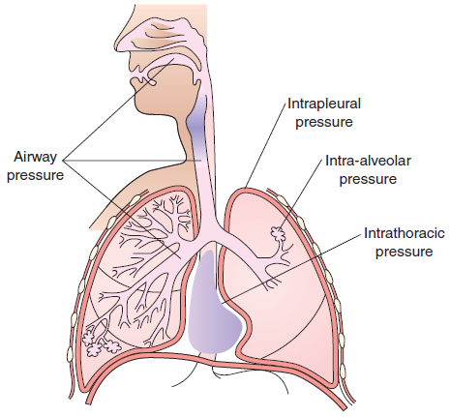
Partitioning of respiratory pressures
(From C. Porth and G. Matfin; Pathophysiology. Concepts of altered health states).

The chest cage and respiratory muscles. The lungs and major airways share the chest cavity with the heart, great vessels, and esophagus. The chest cavity is a closed compartment bounded on the top by the neck muscles and at the bottom by the diaphragm. The outer walls of the chest cavity are formed by 12 pairs of ribs, the sternum, the thoracic vertebrae, and the intercostal muscles that lie between the ribs. Mechanically, ventilation or the act of breathing depends on the fact that the chest cavity is a closed compartment whose only opening to the exterior is the trachea.
Ventilation consists of inspiration and expiration. During inspiration, the size of the chest cavity increases, the pressure becomes more negative, and air is drawn into the lungs. Expiration occurs as the elastic components of the chest wall and lung structures that were stretched during inspiration recoil, causing the size of the chest cavity to decrease and the pressure in the chest cavity to increase. The diaphragm is the principal muscle of inspiration.When the diaphragm contracts, the abdominal contents are forced downward and the chest expands from top to bottom. During normal levels of inspiration, the diaphragm moves approximately 1 cm, but this can be increased to 10 cm on forced inspiration. The diaphragm is innervated by the phrenic nerve roots, which arise from the cervical level of the spinal cord, mainly from C₄ but also from C₃ and C₅. Persons with spinal cord injury above this level require mechanical ventilation. Paralysis of one side of the diaphragm causes the chest to move up on that side rather than down during inspiration because of the negative pressure in the chest. This is called paradoxical movement.
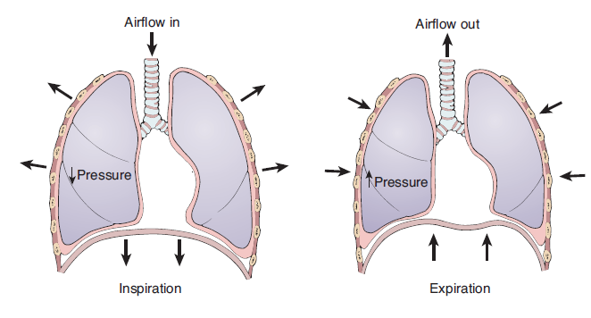
Movement of the diaphragm and changes in chest volume and pressure during inspiration and expiration.
During inspiration, contraction of the diaphragm and expansion of the chest cavity produce a decrease in intrathoracic pressure, causing air to move into the lungs. During expiration, relaxation of the diaphragm and chestcavity produces an increase in intrathoracic pressure, causing air to move out of the lungs.
(From C. Porth and G. Matfin; Pathophysiology. Concepts of altered health states).

The external intercostal muscles, which also aid in inspiration, connect to the adjacent ribs and slope downward and forward. When they contract, they raise the ribs and rotate them slightly so that the sternum is pushed forward; this enlarges the chest from side to side and from front to back. The intercostal muscles receive their innervation from nerves that exit the central nervous system at the thoracic level of the spinal cord. Paralysis of these muscles usually does not have a serious effect on respiration because of the effectiveness of the diaphragm.
The accessory muscles of inspiration include the scalene muscles and the sternocleidomastoid muscles. The scalene muscles elevate the first two ribs, and the sternocleidomastoid muscles raise the sternum to increase the size of the chest cavity. These muscles contribute little to quiet breathing but contract vigorously during exercise. For the accessory muscles to assist in ventilation, they must be stabilized in some way. For example, persons with bronchial asthma often brace their arms against a firm object during an attack as a means of stabilizing their shoulders so that the attached accessory muscles can exert their full effect on ventilation. The head commonlyis bent backward so that the scalene and sternocleidomastoid muscles can elevate the ribs more effectively. Other muscles that play a minor role in inspiration are the alae nasi, which produce flaring of the nostrils during obstructed breathing.
Expiration is largely passive. It occurs as the elastic components of the chest wall and lung structures that were stretched during inspiration recoil, causing air to leave the lungs as the intrathoracic pressure increases. When needed, the abdominal and the internal intercostal muscles can be used to increase expiratory effort (see Fig. 5). The increase in intra-abdominal pressure that accompanies the forceful contraction of the abdominal muscles pushes the diaphragm upward and results in an increase in intrathoracic pressure. The internal intercostal muscles move inward, which pulls the chest downward, increasing expiratory effort.
Lung volumes. Lung volumes, or the amount of air exchanged during ventilation, can be subdivided into three components: (1) the tidal volume (TV), (2) the inspiratory reserve volume (IRV), and (3) the expiratory reserve volume (ERV). The TV, usually about 500 mL, is the amount of air that moves into and out of the lungs during a normal breath. The IRV is the maximum amount of air that can be inspired in excess of the normal TV, and the ERV is the maximum amount that can be exhaled in excess of the normal TV. Approximately 1200 mL of air always remains in the lungs after forced expiration; this air is the residual volume (RV). The RV increases with age because there is more trapping of air in the lungs at the end of expiration. The lung volumes can be measured using an instrument called a spirometer.
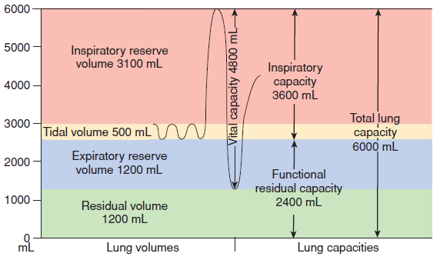
Spirometry recoding of respiratory volumes (left) and diagram of lung capacities (right).
The tidal volume (TV, yellow) is the volume of air inhaled and exhaled during normal breathing;the inspiratory reserve volume (IRV, pink), the maximal volume of air that can be forcefully inhaled in excess of the TV; the expiratory reserve volume (ERV, blue), the maximal volume of air that can be exhaled in excess of the TV; and the residual volume (RV, green), the air that continues to remainin the lung after maximal respiratory effort. The inspiratory capacity (IC) is the sum of the IRV and the TV; the functional residual capacity (FRC), the sum of the IRV, TV, and ERV; and the total lung capacity (TLC) the sum of all the volumes. The vital capacity (VC, not shown) is the IRV, TV, and ERV. (From C. Porth and G. Matfin; Pathophysiology. Concepts of altered health states).

Lung capacities include two or more lung volumes. The vital capacity (VC) equals the IRV plus the TV plus the ERV and is the amount of air that can be exhaled from the point of maximal inspiration. The inspiratory capacity (IC) equals the TV plus the IRV. It is the amount of air a person can breathe in beginning at the normal expiratory level. The functional residual capacity (FRC) is the sum of the RV and ERV; it is the volume of air that remains in the lungs at the end of normal expiration. The total lung capacity (TLC) is the sum of all the volumes in the lungs. The RV cannot be measured with the spirometer because this air cannot be expressed from the lungs. It is measured by indirect methods, such as the helium dilution methods, the nitrogen washout methods, or body plethysmography. Lung volumes and capacities are summarized bellow.

Lung Volumes and Capacities
(From C. Porth and G. Matfin; Pathophysiology. Concepts of altered health states).
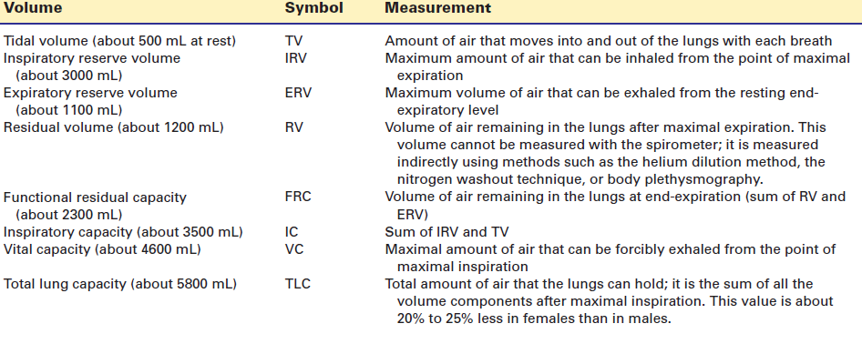

Pulmonary function studies
The previously described lung volumes and capacities are anatomic or static measures, determined by spirometry and measured without relation to time. The spirometer also is used to measure dynamic lung function (i.e., ventilation with respect to time); these tests often are used in assessing pulmonary function. The maximum voluntary ventilation measures the volume of air that a person can move into and out of the lungs during maximum effort lasting for a specific period of time. This measurement usually is converted to liters per minute. Two other useful tests are the forced vital capacity (FVC) and the forced expiratory volume (FEV). The FVC involves full inspiration to total lung capacity followed by forceful maximal expiration. Obstruction of airways produces an FVC that is lower than that observed with more slowly performed vital capacity measurements. The FEV is the expiratory volume achieved in a given time period. The FEV_{1.0} is the forced expiratory volume that can be exhaled in 1 second. The FEV_{1.0} frequently is expressed as a percentage of the FVC. The FEV_{1.0} and FVC are used in the diagnosis of obstructive lung disorders.

Pulmonary function tests
(From C. Porth and G. Matfin; Pathophysiology. Concepts of altered health states).
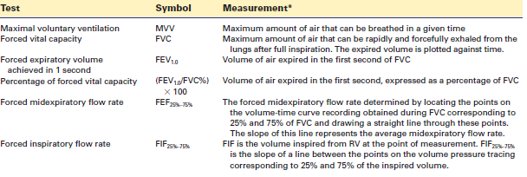

Ventilation refers to the exchange of gases in the respiratory system. There are two types of ventilation: pulmonary and alveolar. Pulmonary ventilation refers to the total exchange of gases between the atmosphere and the lungs. Alveolar ventilation is the exchange of gases within the gas exchange portion of the lungs. Ventilation requires a system of open airways and a pressure difference that moves air into and out of the lungs. It is affected by body position and lung volume as well as by disease conditions that affect the heart and respiratory system.
To reach the alveoli, inspired air must pass through those respiratory pathways in which no gaseous exchange takes place (dead space), normally the mouth, pharynx and larynx, trachea, bronchi and bronchioles. On its way the air will be warmed, saturated with water vapor, and cleansed. The tidal volume (VT) contains, in addition to the volume of air that reaches the alveoli (VA), the volume of air that remains in the dead space (VD). If tidal volume is less than VD (normally ca. 150ml), the alveoli are not ventilated with fresh air. When tidal volume is greater than VD, the proportion of alveolar ventilation rises with increasing VT. Alveolar ventilation may even be reduced during hyperpnea, if the depth of each breath, VT, is low and mainly fills the dead space.
Increased ventilation can occur as a result of either physiologically (e.g., during work) or pathophysiologically (e.g., in metabolic acidosis) increased demand, or due to an inappropriate hyperactivity of the respiratory neurons. Decreased ventilation can occur not only when the demand is reduced, but also when the respiratory cells are damaged, or when neural or neuromuscular transmission is abnormal. Further causes include diseases of the respiratory muscles, decreased thoracic mobility (e.g., deformity, inflammation of the joints), enlargement of the pleural space by pleural effusion or pneumothorax as well as restrictive or obstructive lung disease (Fig.1).
Changes in alveolar ventilation do not have the same effect on O₂ uptake into the blood and CO₂ release into the alveoli. Because of the sigmoid shape of the O₂ dissociation curve, O₂ uptake in the lungs is largely independent of alveolar partial pressure (P_{A}O₂). If there is only minor hypoventilation, the partial pressure of O₂ in the alveoli and thus in blood is reduced, but the O₂ dissociation is at the flat part of the curve, so that the degree of hemoglobin saturation and thus O₂ uptake in blood is practically unchanged. On the other hand, the simultaneous increase in CO₂ partial pressure in the alveoli and blood leads to a noticeable impairment of CO₂ release. Massive hypoventilation lowers the O₂ partial pressure in the alveoli and blood, so that oxygen is at the steep part of the O₂ binding curve of hemoglobin and O₂ uptake is therefore impaired much more than CO₂ release is (Fig.2).
Hyperventilation increases the O₂ partial pressure in the alveoli and blood, but cannot significantly raise the level of O₂ uptake into the blood because the hemoglobin is already saturated. However, hyperventilation boosts CO₂ release (Fig.2).

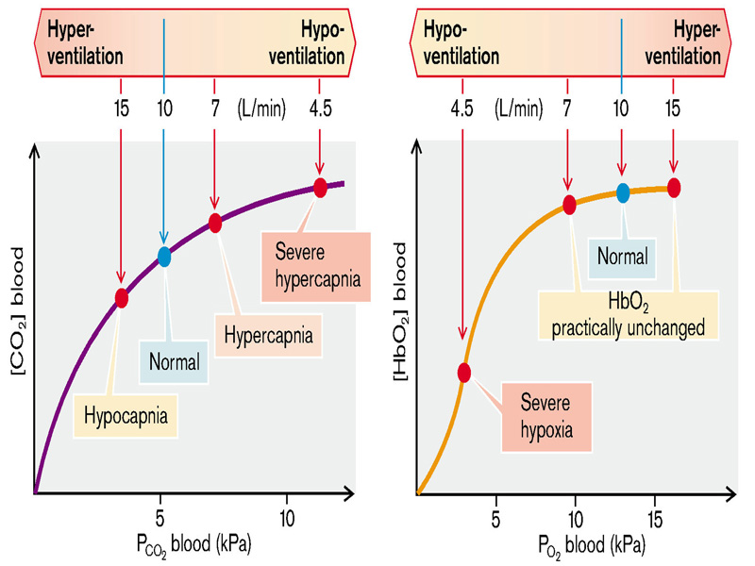

Fig.2 O₂ and CO₂ of arterial blood in abnormal ventilation
(From S. Silbernagl and F. Lang; Color Atlas of Pathophysiology)

Disturbances in pulmonary ventilation due to disorders in central regulation of breathing (reactive changes of breathing)
Numerous factors influence the respiratory neurons in the medulla oblongata (Fig.3 A):
- Ventilation is increased by acidosis, hypercapnia, hypoxia, and a decrease of Ca²⁺ and Mg²⁺ in cerebrospinal fluid (CSF). Pain, intensive cold or heat stimuli to the skin, an increase or moderate fall in body temperature, a drop in blood pressure, and muscular activity (joint innervation) all increase ventilation. Other stimulating factors are epinephrine and norepinephrine in the blood, histamine, acetylcholine and prostaglandins in the central nervous system, progesterone, testosterone, and corticotropin.
- Ventilation is reduced by alkalosis, hypocapnia, peripheral hyperoxia, and Ca²⁺ and Mg²⁺ increase in the CSF. Hypoxia in the CNS, deep hypothermia, rise in blood pressure, ganglion blockers as well as high concentrations of atropine, catecholamines, endorphins and glycine in the CNS also diminish ventilation.
Normally the pH around the respiratory neurons or the pH in the CSF has a decisive influence on ventilation. A shift in pH in the brain following rapid changes in PaCO₂ is accentuated by the low buffering power of CSF (low protein concentration). Because CO₂, but not HCO₃⁻ or H⁺, quickly passes through the blood–CSF and blood–brain barriers, changes in CO₂ concentration in the blood result in very rapid adaptation of ventilation, while adaptation after changes in blood pH or blood HCO₃– occurs only after a delay of several days. If sudden metabolic acidosis occurs, respiratory compensation will thus occur only slowly. Conversely, treatment of a partly compensated respiratory acidosis, for example, by infusion of HCO₃–, often leaves behind respiratory alkalosis. Also, with a sudden fall of O₂ partial pressure in inspiratory air (at high altitude) ventilation is not immediately and adequately raised. The onset of hyperventilation leads to hypocapnia, and the resulting intracerebral alkalosis will then transiently inhibit any further rise in ventilation. Complete adaptation of breathing to a reduced O₂ supply requires an increase in renal HCO₃– excretion with subsequent decrease in HCO₃– concentration in plasma and (after a delay) in CSF (Fig.3 B).
Barbiturates (soporific drugs) and chronic respiratory failure decrease the sensitivity of the respiratory neurons to pH or CO₂ in CSF. Lack of O₂ thus becomes the most important stimulus to breathing. In both cases the supply of O₂-enriched air leads to hypoventilation and respiratory acidosis. This response is increased by, for example, uremia or sleep. Because O₂ uptake varies within a wide range independently of alveolar ventilation, breathing is stimulated only when there is a marked diminution in alveolar O₂ partial pressure and a fall in O₂ saturation in the blood. The resulting increase in ventilation will again cease as soon as O₂ saturation in the blood is normal; breathing is therefore irregular. The reduced sensitivity of the respiratory neurons to CO₂ can also result in sleep apnea, an arrest of breathing during sleep lasting a few seconds. It is more likely in the presence of a metabolic alkalosis.
Damage or massive stimulation of the respiratory neurons can cause pathological breathing (Fig.3 C):
- Kussmaul breathing is an adequate response of the respiratory neurons to metabolic acidosis. The depth of the individual breaths is greatly increased but breathing is regular.
- Cheyne–Stokes breathing is irregular. The depth of breathing periodically become gradually deeper and then gradually more shallow. It is caused by a delayed response of respiratory neurons to changes in blood gases resulting in an overshooting reaction. It occurs when there is hypoperfusion of the brain, or when breathing is regulated by a lack of oxygen.
- Biot breathing consists of a series of normal breaths interrupted by long pauses. It is an expression of damage to respiratory neurons.
- Gasping also signifies a marked disorder in the regulation of breathing.
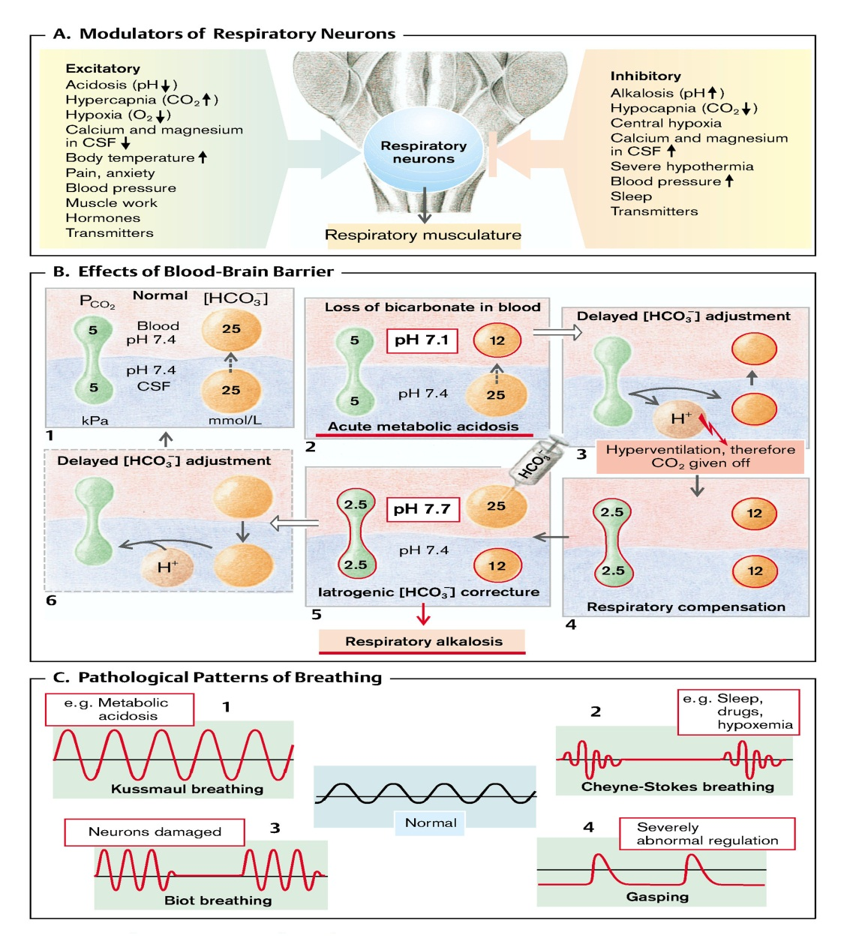
Fig.3 Disturbances in pulmonary ventilation due to disturbances in central breathing regulation
(From S. Silbernagl and F. Lang; Color Atlas of Pathophysiology)

Dyspnea
Dyspnea represents changes of rhythm, amplitude and frequency of external breathing concomitantly with increased effort of respiratory muscles associated with a characteristic subjective feeling of lack of satisfaction from breathing process. In other words dyspnea is a subjective sensation or a person’s perception of difficulty in breathing that includes the perception of labored breathing and the reaction to that sensation. The terms dyspnea, breathlessness, and shortness of breath often are used interchangeably.
Dyspnea is observed in at least three major cardiopulmonary disease states: primary lung diseases such as pneumonia, asthma, and emphysema; heart disease that is characterized by pulmonary congestion; and neuromuscular disorders such as myasthenia gravis and muscular dystrophy that affect the respiratory muscles. Although dyspnea commonly is associated with respiratory disease, it also occurs during exercise, particularly in untrained persons. According to these there can be distinguished central dyspnea, pulmonary and extrapulmonary dyspnea.
Central dyspnea is due to changes in the excitability of respiratory center and interrelations between inspiratory and expiratory neurons. Pulmonary dyspnea is due to changes at the level of the lung parenchyma (fibrosis, inflammation, cancer) or airways (obstruction). Extrapulmonary dyspnea can be cardiac dyspnea related to insufficiency of cardiac output (heart failure, heart defects with right-left shift etc…) and extracardiac which is characteristic for any type of hypoxia (except the cardiac hypoxia), anemia, metabolic acidosis.
The cause of dyspnea is unknown. Three types of mechanisms have been proposed to explain the sensation:
1 - Stimulation of lung receptors; these receptors are stimulated by the contraction of bronchial smooth muscle, the stretch of the bronchial wall (stretch receptors), pulmonary congestion, and conditions that decrease lung compliance(juxtacapillary receptors or J receptors).
2 - Increased sensitivity to changes in ventilation perceived through central nervous system mechanisms; focuses on central nervous system mechanisms that transmit information to the cortex regarding respiratory muscle weakness or a discrepancy between the increased effort of breathing and inadequate respiratory muscle contraction. Chemoreceptors in the carotid bodies and medulla are activated by hypoxemia, acute hypercapnia, and acidemia. Stimulation of these receptors, as well as others that lead to an increase in ventilation, produce a sensation of air hunger.
3 - Stimulation of neural receptors in the muscle fibers of the intercostals and diaphragm and of receptors in the skeletal joints. Metaboreceptors, located in skeletal muscle, are believed to be activated by changes in the local biochemical milieu of the tissue active during exercise and, when stimulated, contribute to the breathing discomfort. These receptors, once stimulated, transmit signals that bring about an awareness of the breathing discrepancy.
Afferent information from the receptors throughout the respiratory system projects directly to the sensory cortex to contribute to primary qualitative sensory experiences and provide feedback on the action of the ventilatory pump. Afferents also project to the areas of the brain responsible for control of ventilation. The motor cortex, responding to input from the control centers, sends neural messages to the ventilatory muscles and a corollary discharge to the sensory cortex (feed-forward with respect to the instructions sent to the muscles). If the feed-forward and feedback messages do not match, an error signal is generated and the intensity of dyspnea increases
Like other subjective symptoms, such as fatigue and pain, dyspnea is difficult to quantify because it relies on a person’s perception of the problem. The most common method for measuring dyspnea is a retrospective determination of the level of daily activity at which a person experiences dyspnea. Several scales are available for this use. One of these uses four dimensions (dyspnea, fatigue, emotional function, breathing mastery) of dyspnea to evaluate disability. The visual analog scale may be used to assess breathing difficulty that occurs with a given activity, such as walking a certain distance. The visual analog scale consists of a line (often 10 cm in length) with descriptors such as “easy to breathe” on one end and “very difficult to breathe” on the other. The person being assessed selects a point on the scale that describes his or her perceived dyspnea. It also can be used to assess dyspnea over time. The treatment of dyspnea depends on the cause. For example, persons with impaired respiratory function may require oxygen therapy, and those with pulmonary edema may require measures to improve heart function. Methods to decrease anxiety, breathing retraining, and energy conservation measures may be used to decrease the subjective sensation of dyspnea.

Terms for various breathing activities
(From S. Silbernagl and F. Lang; Color Atlas of Pathophysiology)
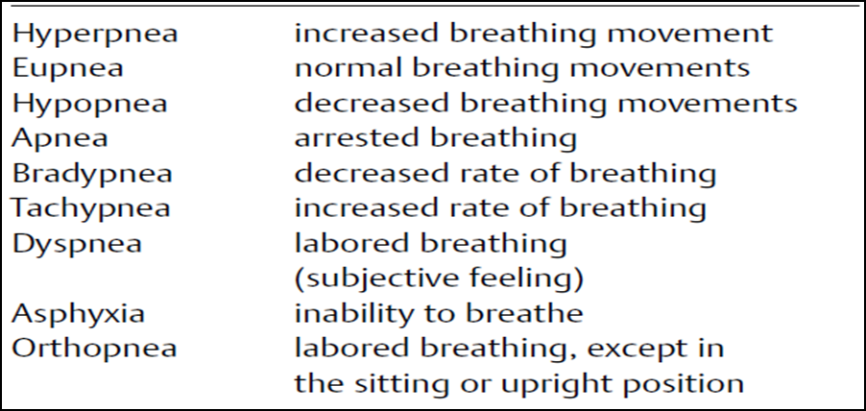

DISTURBANCES IN LUNG PERFUSION
Pulmonary perfusion. The term perfusion is used to describe the flow of blood through the pulmonary capillary bed. The primary function of the pulmonary circulation is to move deoxygenated blood through the gas exchange portion of the lung. The pulmonary circulation serves several important functions in addition to gas exchange. It filters all the blood that moves from the right to the left side of the circulation, removes most of the thromboemboli that might form, and serves as a reservoir of blood for the left side of the heart.
The gas exchange function of the lungs requires a continuousflow of blood through the respiratory portion of the lungs. Deoxygenated blood enters the lung through the pulmonary artery, which has its origin in the right side of the heart and enters the lung at the hilus, along with the primary bronchus. The pulmonary arteries branch in a manner similar to that of the airways. The small pulmonary arteries accompany the bronchi as they move down the lobules and branch to supply the capillary network that surrounds the alveoli. The oxygenated capillary blood is collected in the small pulmonary veins of the lobules, and then it moves to the larger veins to be collected in the four large pulmonary veins that empty into the left atrium.
The pulmonary blood vessels are thinner, are more compliant, and offer less resistance to flow than those in the systemic circulation, and the pressures in the pulmonary system are much lower (e.g., 22/8 mm Hg versus 120/70 mm Hg). The low pressure and low resistance of the pulmonary circulation accommodate the delivery of varying amounts of blood from the systemic circulation without producing signs and symptoms of congestion. The volume in the pulmonary circulation is approximately 500 mL, with approximately 100 mL of this volume located in the pulmonary capillary bed. When the input of blood from the right heart and output of blood to the left heart are equal, pulmonary blood flow remains constant. Small differences between input and output can result in large changes in pulmonary volume if the differences continue for many heartbeats. The movement of blood through the pulmonary capillary bed requires that the mean pulmonary arterial pressure be greater than the mean pulmonary venous pressure. Pulmonary venous pressure increases in left-sided heart failure, allowing blood to accumulate in the pulmonary capillary bed and cause pulmonary edema.
Distribution of blood flow.As with ventilation, the distribution of pulmonary blood flow is affected by body position and gravity. In the upright position, the distance of the upper apices of the lung above the level of the heart may exceed the perfusion capabilities of the mean pulmonary arterial pressure (approximately 12 mm Hg); therefore, blood flow in the upper part of the lungs is less than that in the base or bottom part of the lungs. In the supine position, the lungs and the heart are at the same level, and blood flow to the apices and base of the lungs becomes more uniform. In this position, however, blood flow to the posterior or dependent portions (e.g., bottom of the lung when lying on the side) exceeds flow in the anterior or nondependent portions of the lungs.

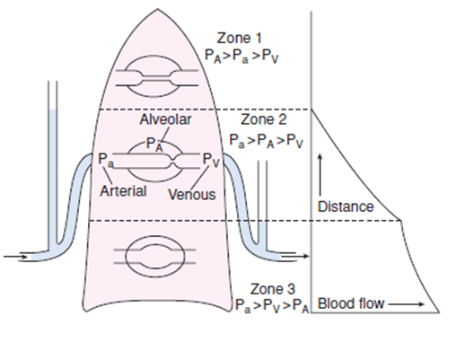
The uneven distribution of blood flow in the lung results from different pressures affecting
the capillaries, which are affected by body position and gravity.
(From C. Porth and G. Matfin; Pathophysiology. Concepts of altered health states).

Hypoxia-induced vasoconstriction (. The blood vessels in the pulmonary circulation undergo marked vasoconstriction when they are exposed to hypoxia. When alveolar oxygen levels drop below 60 mm Hg, marked vasoconstriction may occur, and at very low oxygen levels, the local flow may be almost abolished. In regional hypoxia, as occurs with a localized airway obstruction (e.g., atelectasis), vasoconstriction is localized to a specific region of the lung. In this situation, vasoconstrictionhas the effect of directing blood flow away from the hypoxic regions of the lungs. Generalized hypoxia causes vasoconstriction throughout all of the vessels of the lung. Generalized vasoconstriction occurs when the partial pressure of oxygen is decreased at high altitudes, or it can occur in persons with chronic hypoxia caused by lung disease. The vasoconstriction that accompanies prolonged hypoxia can lead to pulmonary hypertension and increased workload on the right heart. A low blood pH also produces vasoconstriction, especially when alveolar hypoxia is present (e.g., during circulatory shock).
Shunt. Shunt refers to blood that moves from the right to the left side of the circulation without being oxygenated. As with dead air space, there are two types of shunts: physiologic and anatomic. In an anatomic shunt, blood moves from the venous to the arterial side of the circulation without moving through the lungs. In a physiologic shunt, there is mismatching of ventilation and perfusion within the lung, resulting in insufficient ventilation to provide the oxygen needed to oxygenate the blood flowing through the alveolar capillaries. Physiologic shunting of blood usually results from destructive lung disease that impairs ventilation or from heart failure that interferes with movement of blood through sections of the lungs.

Lung perfusion is increased, for example, during physical work. It can be reduced by heart or circulatory failure, or by constriction or occlusion of pulmonary vessels. A moderate increase in lung perfusion while ventilation remains unchanged increases O₂ uptake virtually in proportion to the amount of blood flow. Even though the alveolar O₂ partial pressure falls slightly because of the increased O₂ uptake from the alveoli into the blood, this has little influence on O₂ saturation in the blood. It is only when the alveolar partial pressure of O₂ falls into the steep part of the O₂ dissociation curve that a decrease of alveolar O₂ partial pressure significantly affects O₂ uptake into blood. At those O₂ partial pressures a further increase in lung perfusion only slightly increases O₂ uptake. Furthermore, at very high lung perfusion flow, the contact time in the alveoli is not sufficient to guarantee that partial O₂ pressure in blood approaches that in the alveoli. If lung perfusion is reduced, O₂ uptake is proportionally decreased.
CO₂ removal from blood is dependent on lung perfusion to a lesser extent than O₂ uptake. In case of reduced lung perfusion (but constant ventilation and venous CO₂ concentration) the CO₂ partial pressure in the alveoli falls and thus favors the removal of CO₂ from the blood. This, in turn, attenuates the effect of the reduction in perfusion. At raised lung perfusion an increase of alveolar CO₂ concentration prevents a proportional rise in CO₂ release (Fig.4).

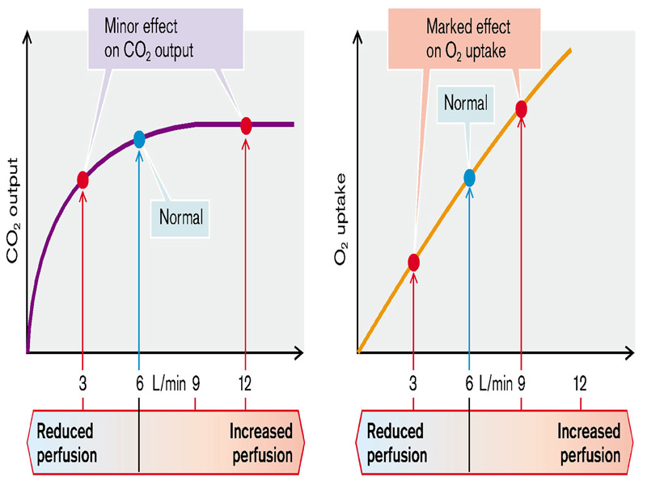
Fig.4 CO₂ release and O₂ uptake at different perfusion levels
(From S. Silbernagl and F. Lang; Color Atlas of Pathophysiology)

Pulmonary embolism
Pulmonary embolism develops when a blood-borne substance lodges in a branch of the pulmonary artery and obstructs the flow. The embolism may consist of a thrombus, air that has accidentally been injected during intravenous infusion, fat that has been mobilized from the bone marrow after a fracture or from a traumatized fat depot, or amniotic fluid that has entered the maternal circulation after rupture of the membranes at the time of delivery. In the United States, 50,000 to 100,000 deaths occur each year as the result of pulmonary emboli. The overall mortality rate for pulmonary embolism continues to be high—15% to 17.5%.
Almost all pulmonary emboli arise from deep vein thrombosis in the lower extremities. The presence of thrombosis in the deep veins of the legs or pelvis often is unsuspected until embolism occurs. The effects of emboli on the pulmonary circulation are related to mechanical obstruction of the pulmonary circulation and neurohumoral reflexes causing vasoconstriction. Obstruction of pulmonary blood flow causes reflex bronchoconstriction in the affected area of the lung, wasted ventilation and impaired gas exchange, and loss of alveolar surfactant.Pulmonary hypertension and right heart failure may develop when there is massive vasoconstriction because of a large embolus. Although small areas of infarction may occur, frank pulmonary infarction is uncommon. Persons at risk for developing DVT also are at risk for developing thromboemboli. Among the physiologic factors that contribute to venous thrombosis are venous stasis, venous endothelial injury, and hypercoagulability states. Venous stasis and venous endothelial injury can result from prolonged bed rest, trauma, surgery, childbirth, fractures of the hip and femur, myocardial infarction and congestive heart failure, and spinal cord injury. Persons undergoing orthopedic surgery and gynecologic cancer surgery are at particular risk, as are bedridden patients in an intensive care unit. Cancer cells can produce thrombin and synthesize procoagulation factors, increasing the risk for thromboembolism. Use of oral contraceptives, pregnancy, and hormone replacement therapy are thought toincrease the resistance to endogenous anticoagulants.
The risk for pulmonary embolism among users of oral contraceptives is approximately three times the risk in nonusers. Women who smoke are at particular risk.
The manifestations of pulmonary embolism depend on the size and location of the obstruction. Chest pain, dyspnea, and increased respiratory rate are the most frequent signs and symptoms of pulmonary embolism. Pulmonary infarction often causes pleuritic pain that changes with respiration; it is more severe on inspiration and less severe on expiration. Moderate hypoxemia without carbon dioxide retention occurs as a result of impaired gas exchange. Small emboli that become lodged in the peripheral branches of the pulmonary artery may exert little effect and go unrecognized. However, repeated small emboli gradually reduce the size of the pulmonary capillary bed, resulting in pulmonary hypertension. Moderate-sized emboli often present with breathlessness accompanied by pleuritic pain, apprehension, slight fever, and cough productive of blood-streaked sputum. Tachycardia often is detected, and the breathing pattern is rapid and shallow. Patients with massive emboli usually present with sudden collapse, crushing substernal chest pain, shock, and sometimes loss of consciousness. The pulse is rapid and weak, the blood pressure is low, the neck veins are distended, and the skin is cyanotic and diaphoretic. Massive pulmonary emboli often are fatal.

DISTURBANCES IN LUNG DIFFUSION
Pulmonary diffusion. Diffusion occurs in the respiratory portions of the lung and refers to the movement of gases across the alveolar–capillary membrane. Gas diffusion in the lung can be described by the Fick law of diffusion. The Fick law states that the volume of a gas (V.gas) diffusing across the membrane per unit time is directly proportional to the difference in the pressure of the gas (P₁ - P₂), the surface area (SA) of the membrane, and the diffusion coefficient (D) of the gas, and is inversely proportional to the thickness (T) of the membrane.
Several factors influence the diffusion of gases in the lung. The administration of high concentrations of oxygen increases the difference in partial pressure between the two sides of the membrane and increases the diffusion of the gas. Diseases that destroy lung tissue (i.e., surface area for diffusion) or increase the thickness of the alveolar–capillary membrane adversely influence the diffusing capacity of the lungs. The removal of one lung, for example, reduces the diffusing capacity by one half. The thickness of the alveolar–capillary membrane and the distance for diffusion are increased in persons with pulmonary edema or pneumonia. The characteristics of the gas and its molecular weight and solubility constitute the diffusion coefficient and determine how rapidly the gas diffuses through the respiratory membranes. For example, carbon dioxide diffuses 20 times more rapidly than oxygen because of its greater solubility in the respiratory membranes.
The diffusing capacity provides a measure of the rate of gas transfer in the lungs per partial pressure gradient. Because the initial alveolar–capillary difference for oxygen cannot be measured, carbon monoxide is used to determine the diffusing capacity. Carbon monoxide has several advantages: (1) its uptake is not limited by diffusion or blood flow, (2) there is essentially no carbon monoxide in venous blood, and (3) its affinity for hemoglobin is 210 times that of oxygen, ensuring that its partial pressure will remain essentially zero in the pulmonary capillary. The most common technique for making this measurement is the single-breath test. This test involves the inhalation of a single breath of dilute carbon monoxide (CO), followed by a breath-hold of 10 seconds. The diffusing capacity can be calculated using the lung volume and the percentage of CO in the alveoli at the beginning and end of the 10-second breath-hold.

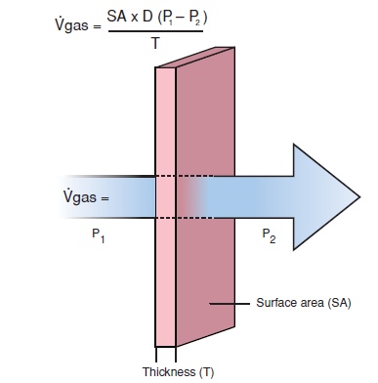
Fick laws of diffusion state that the diffusion of a gas (V. gas) across a sheet of tissue is directly
related to the surface area (A) of the tissue, the diffusion constant (D) for the gas, and the partial pressure difference (P₁ - P₂) on either side of the tissue, and is inversely proportional to the thickness (T) of the tissue.
(From C. Porth and G. Matfin; Pathophysiology. Concepts of altered health states).

O₂ has to diffuse from the alveoli to hemoglobin in the erythrocytes, and CO₂ from the erythrocytes into the alveoli. The amount of gas (M) that diffuses across the diffusion barrier between alveoli and blood per unit time is proportional to the diffusion area (F) and the difference in partial pressure between alveolar gas (P_{A}) and blood (P_{blood}), and inversely proportional to the length of the diffusion pathway (d):

M = K × F (PA – P_{blood})/d.

Krogh’s diffusion coefficient K is about 20 times greater for CO₂ than for O₂. The diffusion capacity D (= K × F/d) is about 230 mL × min^{–1} × kPa–1 (1.75 L × min^{–1} × mmHg^{–1}) in a healthy person.
A diffusion abnormality exists when the ratio of diffusion capacity to lung perfusion (or cardiac output) is reduced. The diffusion capacity may be reduced by increased distance. When a pulmonary edema occurs, raised intravascular pressure means plasma water is exuded into the interstitial pulmonary tissue or into the alveoli, and thus increases the diffusion distance. Inflammation causes a widening of the space between alveoli and blood capillaries as a result of edema and the formation of connective tissue. In interstitial lung fibrosis, the connective tissue forces alveoli and blood capillaries apart. It is the distance between hemoglobin and alveolar gas which matters. Thus, the distance can also be slightly increased by vessel dilation (inflammation) or anemia. A diminished diffusion capacity may also be caused by a reduction of the diffusion area, as after unilateral lung resection, loss of alveolar septa (pulmonary emphysema), or in loss of alveoli in pneumonia, pulmonary tuberculosis, or pulmonary fibrosis. The diffusion area can also be reduced by alveolar collapse (atelectasis, pulmonary edema, or pulmonary infarction). Diffusion abnormalities become obvious when cardiac output is large, blood flows rapidly through the lungs, and the contact time of blood in the alveoli is thus quite brief. In effect, diminution of the diffusion area (e.g., after unilateral lung resection) also means a shorter contact time in the remaining lung tissue, because the same amount of blood will now pass through a reduced amount of lung tissue per unit of time. An increased O₂ demand during physical exercise forces an increase in cardiac output and can thus reveal a diffusion abnormality (Fig.5).
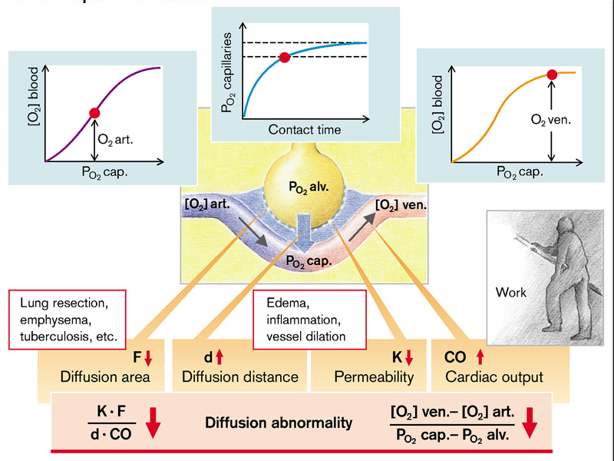

Fig.5 Development of diffusion abnormalities
(From S. Silbernagl and F. Lang; Color Atlas of Pathophysiology)

Abnormal diffusion primarily affects O₂ transport (Fig.6). In order for the same amount of gas to diffuse per time, the O₂ gradient must be twenty times greater than the CO₂ gradient. Should the diffusion capacity in an alveolus be diminished while ventilation remains constant, O₂ partial pressure will fall in the blood leaving the alveolus. If all alveoli are similarly affected, O₂ partial pressure will fall in the pulmonary venous (and thus systemic arterial) blood. If O₂ consumption remains constant, O₂ partial pressure will necessarily be lower also in deoxygenated (systemic venous) blood. For this reason patients with a diffusion abnormality get blue lips on physical exertion (central cyanosis). The primary effects of abnormal diffusion on CO₂ transport and acid–base metabolism are much less marked. Hypoxemia stimulates the peripheral chemoreceptors, and the resulting increase in ventilation can produce hypocapnia. However, the hypoxemia due to abnormal diffusion can only be slightly improved by hyperventilation. In the example given, doubling of the alveolar ventilation at unchanged O₂ consumption increases alveolar O₂ partial pressure by only 4 kPa to 17 kPa (40 mmHg to 75 mmHg), but the increased O₂ gradient does not normalize the O₂ saturation of the blood. At the same time, respiratory alkalosis develops, despite the abnormal diffusion, because of the increased CO₂ removal. Hypoxemia due to abnormal diffusion can be neutralized with O₂-enriched inspiratory air. The degree of hypoxemia can be lessened by decreasing O₂ consumption.

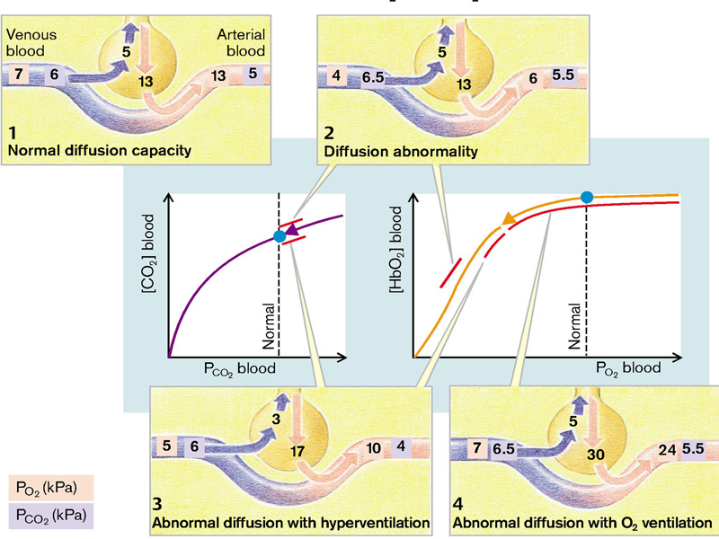

Fig. 6 Abnormal diffusion: concentrations of CO₂ and HbO₂ in blood
(From S. Silbernagl and F. Lang; Color Atlas of Pathophysiology)

DISTURBANCES IN LUNG DISTRIBUTION
Distribution of ventilation. The distribution of ventilation between the base (bottom) and apex (top) of the lung varies with body position and reflects the effects of gravity on intrapleural pressure and lung compliance. Compliance reflects the change in volume that occurs with a change in intrapleural pressure. It is less in fully expanded alveoli, which have difficulty accommodating more air, and greater in alveoli that are less inflated and can more easily expand to accommodate more air. In the seated or standing position, gravity exerts a downward pull on the lung, causing intrapleural pressure at the apex of the lung to become more negative. As a result, the alveoli at the apex of the lung are more fully expanded and less compliant than those at the base of the lung. The same holds true for lung expansion in the dependent portions of the lung in the supine or lateral position. In the supine position, ventilation in the lowermost (posterior) parts of the lung exceeds that in the uppermost (anterior) parts. In the lateral position (i.e., lying on the side), the dependent lung is better ventilated.
The distribution of ventilation also is affected by lung volumes. During full inspiration (high lung volumes) in the seated or standing position, the airways are pulled open and air moves into the more compliant portions of the lower lung. At low lung volumes, the opposite occurs. At functional residual capacity, the intrapleural pressure at the base of the lung exceeds airway pressure, compressing the airways so that ventilation is greatly reduced. In contrast, the airways in the apex of the lung remain open, and this area of the lung is well ventilated.
Even at low lung volumes, some air remains in the alveoli of the lower portion of the lungs, preventing their collapse. According to the law of Laplace, the pressure needed to overcome the tension in the wall of a sphere or an elastic tube is inversely related to its radius; therefore, the small airways close first, trapping some air in the alveoli. This trapping of air may be increased in older persons and persons with chronic lung disease (emphysema) owing to a loss in the elastic recoil properties of the lungs. In these persons, airway closure occurs at the end of normal instead of low lung volumes, trapping larger amounts of air with a resultant increase in the residual lung volume.
Dead air space. Dead space refers to the air that must be moved with each breath but does not participate in gas exchange. The movement of air through dead space contributes to the work of breathing but not to gas exchange. There are two types of dead space: that contained in the conducting airways, called the anatomic dead space, and that contained in the respiratory portion of the lung, called the alveolar dead space. The volume of the anatomic airway dead space ( air in the nose, pharynx, trachea, and bronchi) is fixed at approximately 150 to 200 mL, depending on body size. The creation of a tracheostomy (surgical opening in the trachea) decreases anatomic dead space ventilation because air does not have to move through the nasal and oral airways. Alveolar dead space, normally about 5 to 10 mL, constitutes alveolar air that does not participate in gas exchange. When alveoli are ventilated but deprived of blood flow, they do not contribute to gas exchange and thereby constitute alveolar dead space. The physiologic dead space includes both the anatomic dead space and the alveolar dead air space. In persons with normal respiratory function, physiologic dead space is about the same as anatomic dead space. Only in lung disease does physiologic dead space increase. Alveolar ventilation is equal to the minute ventilation minus the physiologic dead space ventilation.
Mismatching of ventilation and perfusion. The gas exchange properties of the lung depend on matching ventilation and perfusion, ensuring that equal amounts of air and blood are entering the respiratory portion of the lungs. Both dead air space and shunt produce a mismatching of ventilation and perfusion. With shunt (depicted on the left), there is perfusion without ventilation, resulting in a low ventilation–perfusion ratio. It occurs in conditions such as atelectasis in which there is airway obstruction. With dead air space (depicted on the right), there is ventilation without perfusion, resulting in a high ventilation–perfusion ratio. It occurs with conditions such as pulmonary embolism, which impairs blood flow to a part of the lung. The arterial blood leaving the pulmonary circulation reflects mixing of blood from normally ventilated and perfused areas of the lung as well as areas that are not ventilated (dead air space) or perfused (shunt). Many of the conditions that cause mismatching of ventilation and perfusion involve both dead air space and shunt. In chronic obstructive lung disease, for example, there may be impaired ventilation in one area of the lung and impaired perfusion in another area.

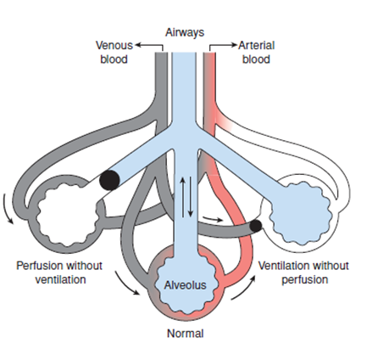

Matching of ventilation and perfusion. (Center) Normal matching of ventilation and perfusion; (left) perfusion without ventilation (i.e., shunt); (right) ventilation without perfusion (i.e., dead air space).
(From C. Porth and G. Matfin; Pathophysiology. Concepts of altered health states).

The concentration of O₂ and CO₂ in an alveolar space and the related capillary are dependent on the ratio of ventilation (VA) to perfusion (Q). In the ideal case this relationship (VA/Q) and thus the O₂ and CO₂ concentration is identical in all alveoli. Pulmonary vessels contract in hypoxia and thus normally guarantee extensive adaptation of perfusion to ventilation of individual alveoli. In an upright position ventilation and perfusion in the basal lung segments are greater than in the apical ones. Perfusion is more strongly affected and VA/Q is thus normally slightly higher apically than basally.
The term “abnormal distribution” describes the condition when the ratio of ventilation to perfusion in individual alveoli deviates to a functionally significant extent from that in the whole lung. In principle there are two possibilities (Fig.7):
- Impaired perfusion of individual alveoli in relation to perfusion occurs in vascular occlusion, for example, in pulmonary embolism. In addition, capillaries can be separated from their related alveoli by proliferating connective tissue, as is the case in pulmonary fibrosis. Lastly, capillary supply to the alveoli may also fade away if the alveolar septa are destroyed, as is the case in pulmonary emphysema. The impaired perfusion of ventilated alveoli increases the functional dead space, because the air in these alveoli no longer takes part in the gaseous exchange (alveolar dead space). This condition can be compensated by deeper breathing. If a large proportion of alveoli are not perfused, the diffusion area also decreases, and this can no longer be compensated by deeper breathing.
- In impaired ventilation of perfused alveoli the blood is no longer adequately saturated with O₂ and rid of CO₂ (alveolar shunt). In an extreme case a functional arteriovenous shunt develops. In obstructive lung disease, such as asthma and chronic bronchitis, some of the bronchi are narrowed and preclude normal ventilation of their alveoli. Ventilation of individual bronchi (or bronchioles) can also be by occlusion through tumor. The up and therefore ventilation of parts of the lung can be prevented by local scarring such as pleural thickening. Diaphragmatic paralysis has the same effect by preventing expansion of basal lung segments. Functional arteriovenous shunts can also occur in pulmonary fibrosis.

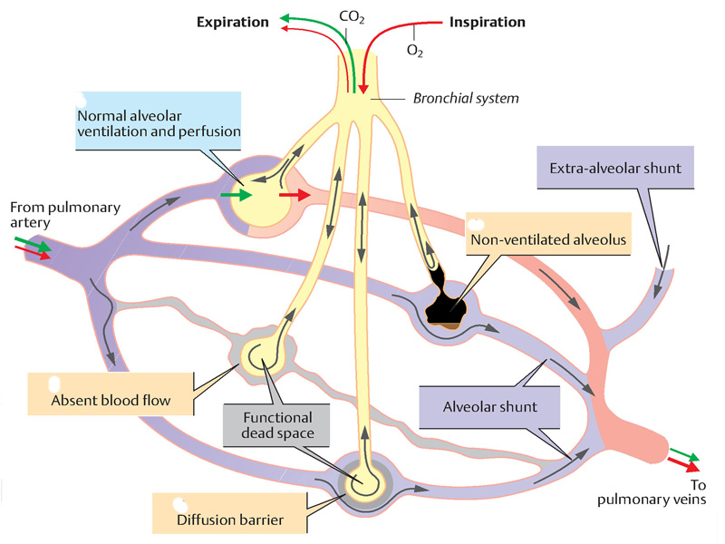

Fig.7 Abnormal distribution in the lungs: alveolar shunt and alveolar dead space
(From C. Porth and G. Matfin; Pathophysiology. Concepts of altered health states).

Perfusion of inadequately ventilated alveoli leads to an admixture of nonarterialized blood with pulmonary venous blood. This results in hypoxemia, which cannot be compensated by hyperventilation of “intact” alveoli (this is because O₂ uptake by the blood that passes along ventilated alveoli can be increased only minimally by hyperventilation). On the other hand, hypercapnia hardly ever occurs because the reduced CO₂ release from underventilated alveoli can be well compensated by increased release into hyperventilated alveoli. On the contrary, the hypoxemia frequently leads to excess hyperventilation, and the development of hypocapnia and respiratory alkalosis. If considerable venous admixture occurs, the arterial hypoxemia cannot be stopped even by breathing pure O₂ (Fig.8).

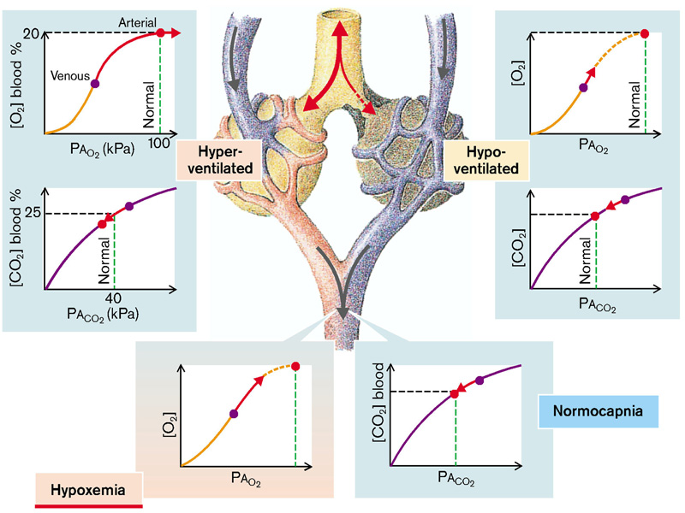

Fig. 8 Effects of abnormal lung distribution on O₂ uptake and CO₂ release
(From S. Silbernagl and F. Lang; Color Atlas of Pathophysiology)

Obstructive versus restrictive pulmonary diseases
Based on pulmonary function tests, chronic non-infectious diffuse pulmonary diseases can be classified in one of two categories:
(1) Obstructive diseases (or airway diseases), characterized by an increase in resistance to airflow due to partial or complete obstruction at any level, from the trachea and larger bronchi to the terminal and respiratory bronchioles. In individuals with diffuse obstructive disorders, pulmonary function tests show decreased maximal airflow rates during forced expiration, usually measured by forced expiratory volume at 1 second. They are distinguished by distinct anatomic lesions and hence different mechanisms for airflow obstruction. As discussed below, such neat distinctions are not always possible.
(2) Restrictive diseases, characterized by reduced expansion of lung parenchyma and/or thorax with decreased total lung capacity. Restrictive diseases are identified by a reduced total lung capacity, and an expiratory flow rate that is normal or reduced proportionately. Restrictive defects occur in two general conditions:
(1) Chest wall disorders (neuromuscular diseases such as poliomyelitis, severe obesity, kyphoscoliosis), pleural diseases like pneumothorax, hydrothorax, etc…- so called extraparenchymatous restriction;
(2) Chronic interstitial and infiltrative diseases, such as pneumoconioses and interstitial fibrosis of unknown etiology – intraparenchymatous restriction.

PATHOPHYSIOLOGY OF RESTRICTIVE LUNG DISEASE

Lung compliance. Lung compliance refers to the ease with which the lungs can be inflated. Compliance can be appreciated by comparing the ease of blowing up a balloon that has been previously blown up with a new balloon that is stiff and noncompliant. Specifically, lung compliance is a measure of the change in lung volume that occurs with a change in intrapulmonary pressure. The normal compliance of both lungs in the average adult is approximately 200 mL/cm H₂O. This means that every time the intrapulmonary pressure increases by 1 cm/H₂O, the lung volume expands by 200 mL. It would take more pressure to move the same amount of air into a noncompliant lung.
Lung compliance is determined by the elastic properties of the lung, its water content, and surface tension. It also depends on the compliance of the thoracic or chest cage. It is diminished by conditions that reduce the natural elasticity of the lung, increase the surface tension in the alveoli, or impair the flexibility of the thoracic cage. Lung tissue is made up of elastin and collagen fibers. The elastin fibers are easily stretched and increase the ease of lung inflation, whereas the collagen fibers resist stretching and make lung inflation more difficult. In lung diseases such as interstitial lung disease and pulmonary fibrosis, the lungs become stiff and noncompliant as the elastin fibers are replaced with the collagen fibers of scar tissue. Pulmonary congestion and edema produce a reversible decrease in pulmonary compliance by increasing the water content of the lung.
Elastic recoil describes the ability of the elastic components of the lung to recoil to their original position after having been stretched. Overstretching lung tissues, as occurs with emphysema, causes the elastic components of the lung to lose their recoil, making the lung more compliant and easier to inflate but more difficult to deflate because of its inability to recoil.
Surface tension. An important factor in lung compliance is the surface tension in the alveoli. The alveoli are lined with a thin film of liquid, and it is at the interface between this liquid film and the alveolar air that surface tension develops. This is because the forces that hold the liquid molecules together are stronger than those that hold the air molecules together. In the alveoli, excess surface tension causes the liquid film to contract, making lung inflation more difficult. The units of surface tension are those of force per unit length. The relationship between the pressure within a sphere such as an alveolus and the tension in the wall can be described using the law of Laplace (pressure =2 × surface tension/radius). If the surface tension were equal throughout the lungs, the alveoli with the smallest radii would have the greatest pressure, and this would cause them to empty into the larger alveoli. The reason this does not occur is because of special surface tension-lowering molecules, called surfactant, that line the inner surface of the alveoli.
Pulmonary surfactant is a complex mixture of phospholipids, neutral lipids, and proteins that are synthesized in the previously discussed type II alveolar cells. Substances that are termed surfactants consist of two parts, with opposing properties that are irreversibly bound to each other. One part is polar and seeks aqueous fluid or hydrophilic (water-attracting) surfaces; the other is non-polar and seeks oil, air, or hydrophobic (water-repelling) surfaces. Pulmonary surfactant forms a monolayer with its hydrophilic surface binding to liquid film on the surface of the alveoli and its hydrophobic surface facing outward toward the gases in the alveolar air. It is this monolayer that interrupts the surface tension that develops at the air–liquid interface in the alveoli.
Pulmonary surfactant, particularly SP-B, exerts several important effects on lung inflation: it lowers the surface tension and it increases lung compliance and ease of lung inflation. Without surfactant, lung inflation would be extremely difficult. In addition, it helps to keep the alveoli dry and prevent pulmonary edema. This is because water is pulled out of the pulmonary capillaries into the alveoli when increased surface tension causes the alveoli to contract.
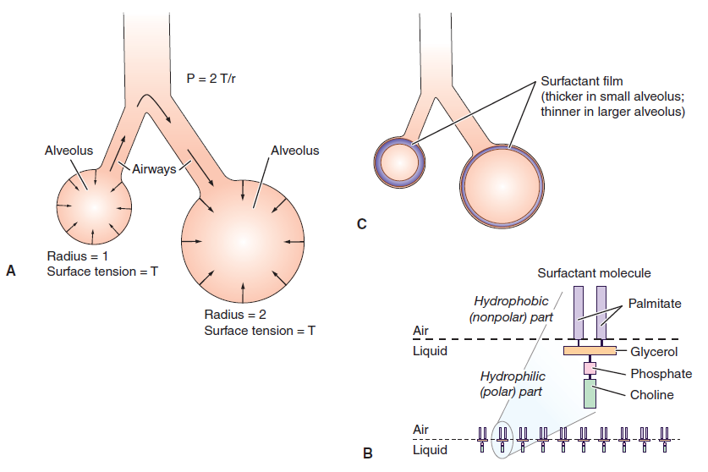

(A) The effect of the surface tension (forces generated at the fluid–air interface) and radius on the pressure and movement of gases in the alveolar structures. According tothe law of Laplace (P = 2 T/r, P =pressure, T =tension, r =radius), the pressure generated within the sphere is inversely proportional to the radius. Air moves from the alveolus with asmall radius and higher pressure to the alveolus with the largerradius and lower pressure. (B) The surfactant molecules with their hydrophilic heads (that attach to the fluid lining of the alveolus) and their hydrophobic tails (that are oriented toward the air interface. (C) The surfactant molecules form a monolayer (shaded in blue) that disrupts the intermolecular forces and lowers the surface tension more in the smaller alveolus with its higher concentration of surfactant than in the larger alveolus with its lower concentration of surfactant
(From C. Porth and G. Matfin; Pathophysiology. Concepts of altered health states).

Surfactant also stabilizes the inflation of alveoli by changing its density in relation to alveolar size, with surfactant molecules becoming more tightly compressed in small alveoli with their higher surface tension and less compressed in larger alveoli with their lower surface tension. At low lung volumes, when the molecules are tightly compressed, some surfactant is squeezed out of the surface to form micelles. On expansion, the surfactant in these micelles is used to spread a new film on the alveolar surface lining. In surgical and bed-ridden patients, shallow and quiet breathing often impairs the spreading of surfactant. Encouraging these patients to cough and deep breathe enhances the spreading of surfactant, allowing for a more even distribution of ventilation and prevention of atelectasis.
The type II alveolar cells that produce surfactant do not begin to mature until the 26th to 27th week of gestation; consequently, many premature infants have difficulty producing sufficient amounts of surfactant. This can lead to alveolar collapse and severe respiratory distress. This condition, called infant respiratory distress syndrome, is the single most common cause of respiratory disease in premature infants. Recombinant forms of surfactant are now available for use in treatment of the disorder. The synthesis of surfactant can also be impaired in the adult. This usually occurs as the result of severe injury or infection and can contribute to the development of a condition called the acute respiratory distress syndrome.

Restrictive lung disease is a term given to an anatomical or functional loss of gaseous exchange area. An anatomical loss occurs after removal (resection) or displacement (by a tumor) of lung tissue. Atelectasis may also lead to a decrease in diffusion area. A functional decrease in exchange area occurs if plasma water is exuded into alveoli, for example, in pulmonary edema or in inflammation (increased vascular permeability in pneumonia). In pulmonary fibrosis proliferating connective tissue displaces intact pulmonary parenchyma (decrease in diffusion area), infiltrates between capillaries and alveoli (increase in distance), and prevents the normal expansion of the lung (impairment of alveolar air exchange). Pulmonary fibrosis can be caused by inflammatory reaction against connective tissue (so-called collagen disease) or by inhalation of dust which contains silicate or asbestos. Sometimes no cause is found (idiopathic pulmonary fibrosis [Hamman– Rich syndrome]). Local or generalized impairment of lung expansion can also occur in thoracic deformities, diaphragmatic paralysis, or adhesion of both pleural layers (as a result of inflammation [pleural fibrosis]).Restrictive lung diseases because of reduced lung compliance are named intraparenchymatous restriction. When restriction is due to disorders at the level of thepleura, thoracic cage, respiratory muscles – extraparenchymatous restriction (Fig.9)
Restrictive pulmonary disease causes a fall in compliance (C), vital capacity (VC), functional residual capacity (FRC), and diffusion capacity. The latter leads to diffusion abnormality and thus to hypoxemia (S_{O2} = oxygen saturation of blood). Maximum breathing capacity (V_{max}) and forced expiration volume in 1 second (FEV₁) are usually reduced, but relative forced expiration volume (normally 80% of VC) is generally normal. To inspire a certain volume, greater negative pressure than normal is required in the pleural space (P_{pl}) and more energy thus has to be expended during breathing (increased work of breathing; V = ventilation flow). Reduction of the vascular bed by removing lung tissue or by compressing blood vessels increases vascular resistance. Greater pressure is required to pump the blood through the pulmonary vascular bed, pressure which must be generated by the right heart. The consequence is a raised load on the right ventricle (cor pulmonale) (Fig.9)

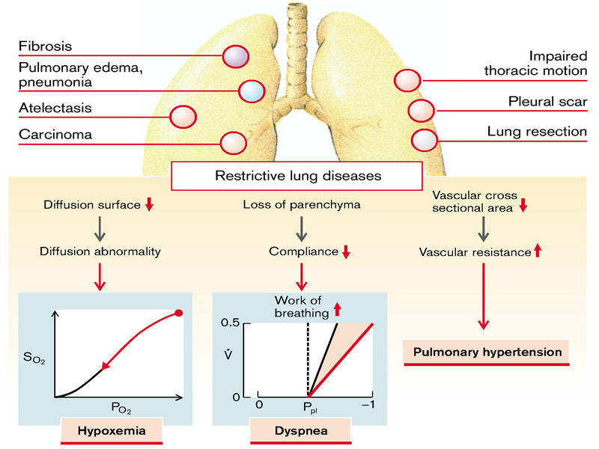

Fig.9 Causes and effects of restrictive lung diseases
(From S. Silbernagl and F. Lang; Color Atlas of Pathophysiology)

Intraparenchymatous restriction

Atelectasis (Collapse)
Atelectasis refers either to incomplete expansion of the lungs (neonatal atelectasis) or to the collapse of previously inflated lung, producing areas of relatively airless pulmonary parenchyma. Acquired atelectasis, encountered principally in adults, may be divided into resorption (or obstruction), compression, and contraction atelectasis (Fig.10).

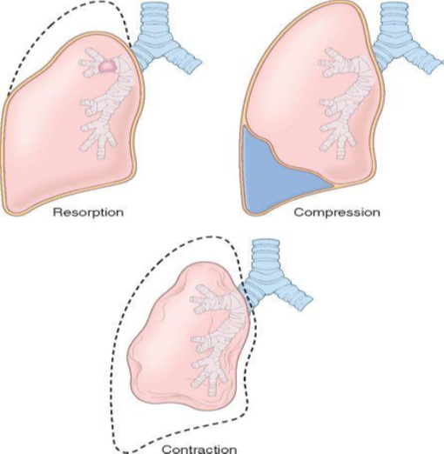

Fig.10 Various forms of acquired atelectasis. Dashed lines indicate normal lung volume.
(From Robbins-Cotran; Pathologic basis of disease)

Resorption atelectasis is the consequence of complete obstruction of an airway, which in time leads to resorption of the oxygen trapped in the dependent alveoli, without impairment of blood flow through the affected alveolar walls. Since lung volume is diminished, the mediastinum shifts toward the atelectatic lung. Resorption atelectasis is caused principally by excessive secretions (e.g., mucus plugs) or exudates within smaller bronchi and is therefore most often found in bronchial asthma, chronic bronchitis, bronchiectasis, postoperative states, aspiration of foreign bodies and, rarely, in bronchial neoplasms.
Mechanisms of resorption atelectasis. If the supplying airway is completely occluded, alveoli collapse (atelectasis). Normally more O₂ is taken up in tissue than CO₂ is released, so that there is a greater decrease in O₂ partial pressure than increase in CO₂ partial. The blood therefore takes more O₂ from the alveoli than it adds CO₂, resulting in a decrease of the alveolar volume. As a consequence N₂ in the alveoli is concentrated and, following its gradient, also diffuses into the blood. Eventually, the entire alveolar air is reabsorbed. The process is delayed by a fall in alveolar O₂ concentration and subsequent vascular contraction (hypoxic vasoconstriction). Ventilation with O₂ can favor the development of atelectases, because O₂ uptake is increased by the high alveolar O₂ partial pressure and there is no constriction of the supplying vessels (Fig.11).

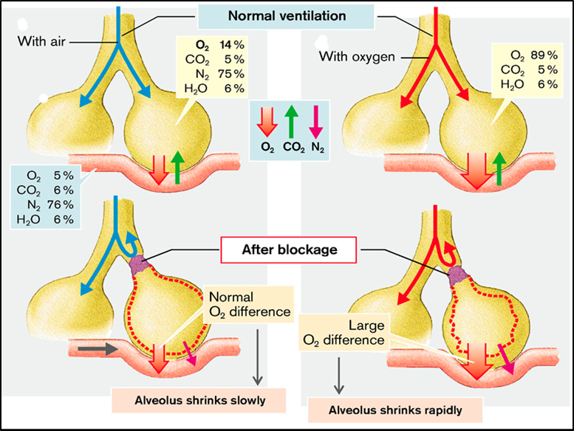

Fig.11 Development of resorption atelectasis
(From S. Silbernagl and F. Lang; Color Atlas of Pathophysiology)

Compression atelectasis results whenever the pleural cavity is partially or completely filled by fluid exudate, tumor, blood, or air (the last-mentioned constituting pneumothorax) or, with tension pneumothorax, when air pressure impinges on and threatens the function of the lung and mediastinum, especially the major vessels. With compressive atelectasis, the mediastinum shifts away from the affected lung.
Contraction atelectasis occurs when local or generalized fibrotic changes in the lung or pleura prevent full expansion.
Significant atelectasis reduces oxygenation and predisposes to infection. Because the collapsed lung parenchyma can be re-expanded, atelectasis is a reversible disorder (except that caused by contraction).

Pulmonary edema
In pulmonary capillaries, as in systemic capillaries, filtration is determined by the effective filtration pressure, the difference between the hydrostatic and oncotic pressure gradients. An increase in effective filtration pressure in the pulmonary vessels leads to pulmonary congestion, filtration of plasma water into the interstitial space results in interstitial pulmonary edema, and the passage of plasma water into alveoli causes alveolar pulmonary edema (Fig.12).
Mechanisms. A rise in hydrostatic pressure in the pulmonary capillaries occurs when the left ventricle’s forward pumping action is inadequate (cardiogenic or hemodynamic pulmonary edema). Causes are reduced myocardial power or excess demand on it (heart failure, mitral valve stenosis or regurgitation). The resulting increase in left atrial pressure is transmitted backward into the pulmonary vessels. The development of pulmonary edema is facilitated by abnormal lymphatic drainage. Normally, an excess of filtered fluid is removed via the lymphatics. However, the capacity of the pulmonary lymphatic system is low even under physiological conditions. If right heart failure occurs together with left heart failure, the systemic venous pressure rises and thus also the pressure at the point of drainage of the lymphatic vessels into the veins at the venous angle, so impairing lymphatic drainage.
The oncotic pressure in the capillaries is reduced by hypoproteinemia, favoring the development of pulmonary edema. Hypoproteinemia is usually the result of hyperhydration (relative), for example, an inappropriately high supply of fluids to patients with reduced renal excretion (due to renal failure). A reduction in plasma protein formation in the liver (liver failure) or loss of plasma proteins, for example, via the kidneys (nephrotic syndrome), also decreases plasma protein concentration.
Finally, increased capillary permeability can result in pulmonary edema. Increased permeability of the capillary wall for proteins reduces the oncotic pressure gradient and thus increases the effective filtration pressure. Capillary permeability is increased by, for example, inhalation of corrosive gases or prolonged inspiration of pure O_{2,} in shock, trauma, radiation, near-downing, effects of some drugs and toxins, transfusion.
Effects of pulmonary congestion are reduced pulmonary perfusion, and thus impaired maximal O₂ uptake. The distension of the congested vessels prevents enlargement of the alveoli and decreases lung compliance. In addition, the bronchi are narrowed by the distended vessels and resistance to breathing increases, discernable through diminution of the maximal breathing capacity and of FEV₁.
In interstitial pulmonary edema the interstitial space between capillary and alveolus is increased. As a result, diffusion is disturbed with impairment mainly of O₂ uptake. If, due to physical activity, O₂ consumption rises, O₂ concentration in blood falls (hypoxemia, cyanosis).
Any further pressure increase and damage to the alveolar wall causes the passage of filtrate into the alveolar space. The fluid-filled alveoli are no longer involved in breathing (gaseous exchange) and a functional veno-arterial (pulmonary arterial to pulmonary venous) shunt occurs along with a decrease in O₂ in the systemic arterial blood (central cyanosis). Fluid enters the airways and thus also increases airway resistance. Increased filtration of fluid into the pleural space (pleural effusion) also impairs breathing.
Pulmonary edemas force the patient to breathe in the upright position (orthopnea). On sitting or standing up after being recumbent (orthostasis) venous return from the lower part of the body falls (even more in the fully upright position), and thus right atrial pressure and the right cardiac output decrease. Less blood flows through the lungs, causing a fall in hydrostatic pressure in the pulmonary capillaries at the same time that pulmonary venous flow from the upper parts of the lung is increased. Moreover, the decrease of central venous pressure facilitates lymphatic drainage from the lung. As a result, pulmonary congestion as well as interstitial and alveolar edemas regress.

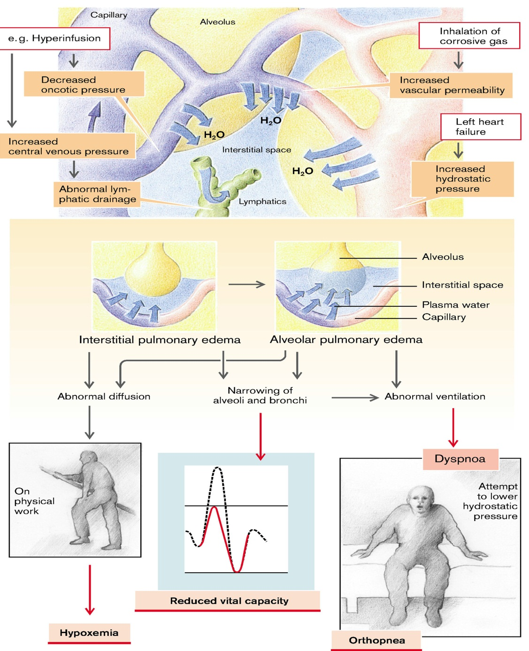

Fig.12 Mechanisms and manifestations of pulmonary edema
(From S. Silbernagl and F. Lang; Color Atlas of Pathophysiology)

Pulmonary fibrosis

The term idiopathic pulmonary fibrosis (IPF) refers to a clinicopathologic syndrome with characteristic radiologic, pathologic, and clinical features. In Europe the term cryptogenic fibrosing alveolitis is more popular.
Pathogenesis.While the causative agent(s) of IPF remain unknown, our concepts of pathogenesis have evolved over the past several years.The earlier view was that IPF is initiated by an unidentified insult that gives rise to chronic inflammation resulting in fibrosis (Fig.13). A key cell is the alveolar macrophage which is activated as well as neutrophils which migrate in the pulmonary tissue. These inflammatory cells release oxidants and proteases which lead to injury of type I pneumocytes. Cytokines which are released from activated macrophages (IL-1; IL-4; TNF, INF) as well as growth factors (TGF-α and β; FGF, PDGF) are responsible for development of fibroblastic foci within the lung tissue, where fibroblast are activated and converted to myofibroblasts which initiate production of collagen fibers.
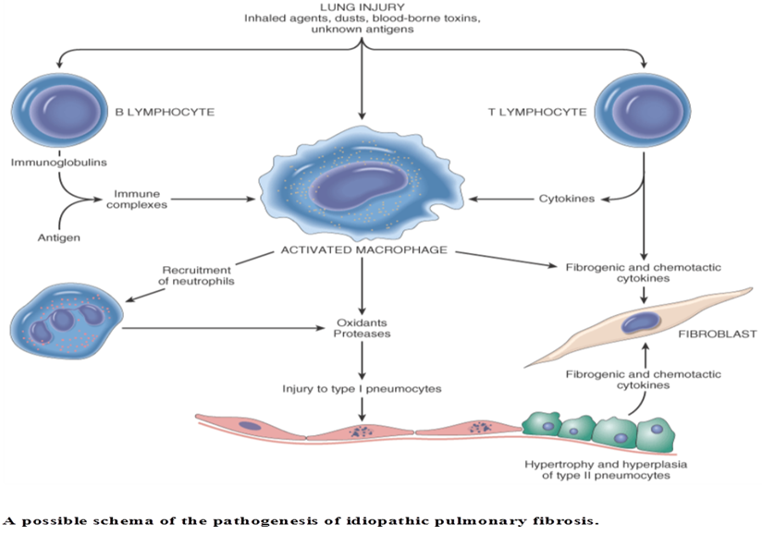

Fig.13. Role of chronic inflammation in development of pulmonary fibrosis
(From Robbins-Cottran; Pathological basis of diseases)

The new pathogenic concept is that IPF is caused by repeated cycles of epithelial activation/injury by some unidentified agent. There is inflammation and induction of Th2 type T cell response characterized by the presence of eosinophils, mast cells, IL-4 and IL-13 in the lesions. But the significance of this inflammatory response is unknown. Abnormal epithelial repair at these sites gives rise to exuberant fibroblastic/myofibroblastic proliferation, leading to the fibroblastic foci that are so characteristic of IPF. The circuits that drive such aberrant epithelial repair are not fully understood, but all evidence points to TGF-β1 as the driver of the process. TGF-β1 is known to be fibrogenic and is released from injured type I alveolar epithelial cells. It favors the transformation of fibroblasts into myofibroblasts and deposition of collagen and other extracellular matrix molecules (Fig.14).
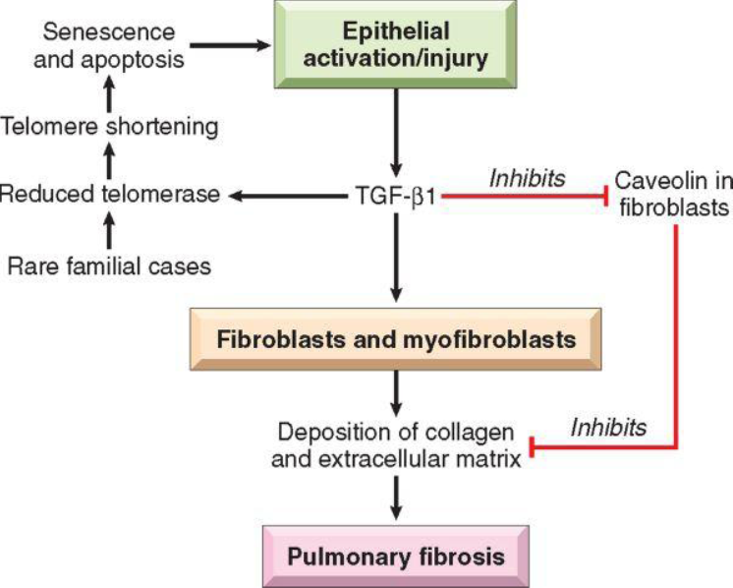

Fig.14 Schematic representation of current understanding of the pathogenesis of idiopathic pulmonary fibrosis.(From Robbins-Cotran; Pathological basis of diseases)
The concept that there is an intrinsic abnormality of tissue repair in IPF is supported by the finding that some patients with familial pulmonary fibrosis have mutations that shorten telomeres. Recall that telomeres control cell replications. Interestingly, TGF-β1 negatively regulates telomerase activity, thus facilitating epithelial cell apoptosis and the cycle of death and repair. Another molecule regulated by TGF-β1 is caveolin-1, the predominant structural protein of caveolae, flask-shaped invaginations of the plasma membrane present in many terminally differentiated cells. Caveolin-1 acts as an endogenous inhibitor of pulmonary fibrosis by limiting TGF-β1induced production of extracellular matrix and restoring alveolar epithelial repair processes. Caveolin-1 is decreased in epithelial cells and fibroblasts of IPF patients, and over-expression of caveolin-1 in a mouse model limits fibrosis. Such down-regulation may be mediated by the ability of TGF-β1 to attenuate the expression of caveolin-1 in fibroblasts. Thus, it seems that TGF-β1 has its fingerprints on multiple pathways that regulate pulmonary fibrosis. Therapeutics directed toward neutralizing TGF-β1, enhancing telomerase activity or delaying telomere shortening, or augmenting caveolin-1 may lead to novel treatments for IPF in the future.

Acute lung injury and acute respiratory distress syndrome (diffuse alveolar damage)

Acute lung injury (ALI) (also called non-cardiogenic pulmonary edema) is characterized by the abrupt onset of significant hypoxemia and diffuse pulmonary infiltrates in the absence of cardiac failure. Acute respiratory distress syndrome (ARDS) refers to severe ALI. ARDS and ALI both have inflammation-associated increase in pulmonary vascular permeability, and epithelial and endothelial cell death. The histologic manifestation of these diseases is diffuse alveolar damage (DAD). Most cases of ALI are associated with an underlying etiology such as sepsis. In the absence of any etiologic association, such cases are called acute interstitial pneumonia (AIP).
ALI is a well-recognized complication of diverse conditions, including both direct injuries to the lungs and systemic disorders. In many cases, a combination of predisposing conditions is responsible (e.g., shock, oxygen therapy, and sepsis). Non-pulmonary organ dysfunction may also be present in severe cases.
Pathogenesis.The alveolar capillary membrane is formed by two separate barriers: the microvascular endothelium andthe alveolar epithelium. In ARDS the integrity of this barrier is compromised by either endothelial or epithelial injury or, more commonly, both. Markers of endothelial injury and activation such as endothelin and von Willebrand factor can be detected at high levels in the serum of patients with ARDS. Evidence of epithelial injury in the form of swelling, vacuolization, bleb formation, and frank necrosis is also noted early in the course of acute lung injury. The acute consequences of damage to the alveolar capillary membrane include increased vascular permeability and alveolar flooding, loss of diffusion capacity, and widespread surfactant abnormalities caused by damage to type II pneumocytes. Endothelial injury also triggers the formation of microthrombi that add the insult of ischemic injury. Hyaline membranes so characteristic of ALI/ARDS result from inspissation of protein rich edema fluid that entraps debris of dead alveolar epithelial cells (Fig.15).
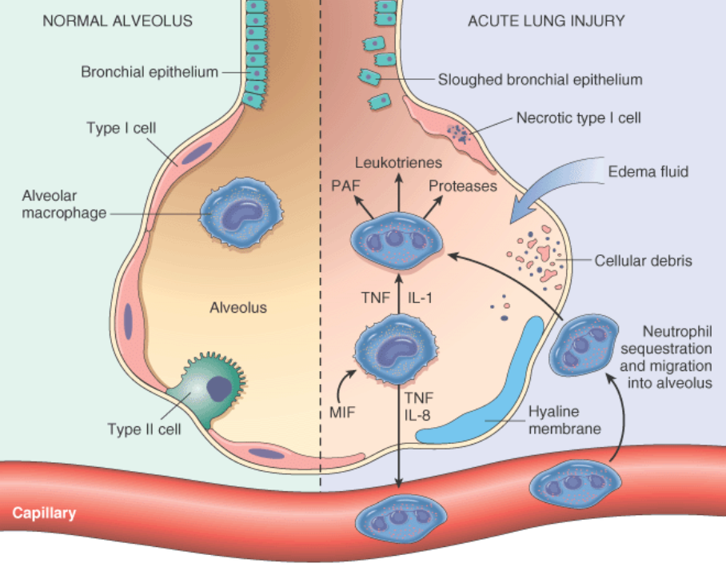

Fig.15 The normal alveolus (left side) compared with the injured alveolus in the early phase of acute lung injury and acute respiratory distress syndrome.
Pro-inflammatory cytokines such as interleukin 8 (IL-8), interleukin 1 (IL-1), and tumor necrosis factor (TNF) (released bymacrophages), cause neutrophils to adhere to pulmonary capillaries and extravasate into the alveolar space, where they undergo activation. Activated neutrophils release a variety of factors, such as leukotrienes, oxidants, proteases, and platelet-activating factor (PAF), whichcontribute to local tissue damage, accumulation of edema fluid in the airspaces, surfactant inactivation, and hyaline membrane formation.Macrophage migration inhibitory factor (MIF) released into the local milieu sustains the ongoing pro-inflammatory response. Subsequently, therelease of macrophage-derived fibrogenic cytokines such as transforming growth factor β (TGF-β) and platelet-derived growth factor (PDGF)stimulate fibroblast growth and collagen deposition associated with the healing phase of injury.
(From Robbins-Cotran; Pathological basis of diseases)
Although the cellular and molecular basis of acute lung injury and ARDS remains an area of active investigation, it appears that in ARDS, lung injury is caused by an imbalance of pro-inflammatory and anti-inflammatory mediators. The most proximate signals leading to uncontrolled activation of the acute inflammatory response are not yet understood. However, nuclear factor κB (NF-κB), a transcription factor whose activation itself is tightly regulated under normal conditions, has emerged as a likely candidate shifting the balance in favor of a pro-inflammatory state. As early as 30 minutes after an acute insult, there is increased synthesis of interleukin-8 (IL-8), a potent neutrophil chemotactic and activating agent, by pulmonary macrophages. Release of this and similar compounds, such as IL-1 and tumor necrosis factor (TNF), leads to endothelial activation, and pulmonary microvascular sequestration and activation of neutrophils. Neutrophils are thought to have an important role in the pathogenesis of ARDS. Histologic examination of lungs early in the disease process shows increased numbers of neutrophils within the vascular space, the interstitium, and the alveoli. How neutrophils are sequestered in the lung is not entirely clear. There are two possible mechanisms. Firstly, neutrophils that are activated by cytokines like IL-8 and TNF upregulate the expression of adhesion molecules that allow them to bind to their ligands on activated endothelial cells. Secondly, activated neutrophils become stiff and less deformable and thus get trapped in the narrow capillary beds of the lung. Activated neutrophils release a variety of products (e.g., oxidants, proteases, platelet-activating factor, and leukotrienes) that cause damage to the alveolar epithelium and fuel the inflammatory cascade. Combined assault on the endothelium and epithelium perpetuate vascular leakiness and loss of surfactant that render the alveolar unit unable to expand. It should be noted that the destructive forces unleashed by neutrophils can be counteracted by an array of endogenous anti-proteases, antioxidants, and anti-inflammatory cytokines (e.g., IL-10) that are upregulated by pro-inflammatory cytokines.
Dysregulation of the coagulation system is also a feature of ARDS. Levels of tissue factor are increased and those of the anticoagulant, protein C, are decreased in the plasma and bronchoalveolar lavage fluid. The coagulation pathway itself is a powerful pro-inflammatory signal. Thrombin, for example, promotes adhesion of neutrophils to endothelium. In the end, it is the balance between the destructive and protective factors that determines the degree of tissue injury and clinical severity of ALI/ARDS.
Resolution of ARDS requires resorption of the exudate, removal of dead cells, and their replacement by new endothelium and alveolar epithelial cells. Removal of exudates and tissue debris is accomplished by macrophages as in any other form of tissue injury. Epithelial cells are recovered by an initial proliferation of surviving type II pneumocytes that line the denuded basement membrane. The recently discovered bronchoalveolar stem cells may also participate. Type II cells then give rise to type I cells that constitute the majority of alveolar epithelium. Endothelial restoration occurs both by migration from uninjured capillaries and marrow-derived endothelial progenitor cells; the latter can be detected in the circulation during recovery from ARDS.

Extraparenchymatous restrictive lung disease
Pleural effusion
Pleural effusion refers to an abnormal collection of fluid in the pleural cavity. The fluid may be a transudate, exudate, purulent drainage (empyema), chyle, or blood. Normally, only a thin layer (<10 to 20 mL) of serous fluid separates the visceral and parietal layers of the pleural cavity. Like fluid developing in other transcellular spaces in the body, pleural effusion occurs when the rate of fluid formation exceeds the rate of its removal. Five mechanisms have been linked to the abnormal collection of fluid in the pleural cavity:
(1) increased capillary pressure, as in congestive heart failure;
(2) increased capillary permeability, which occurs with inflammatory conditions;
(3) decreased colloidal osmotic pressure, such as the hypoalbuminemia occurring with liver disease and nephrosis;
(4) increased negative intrapleural pressure, which develops with atelectasis;
(5) impaired lymphatic drainage of the pleural space, which results from obstructive processes such as mediastinal carcinoma.
A transudate consists of serous fluid. The accumulation of a serous transudate in the pleural cavity often is referred to as hydrothorax. The condition may be unilateral or bilateral. The most common cause of hydrothorax is congestive heart failure. Other causes are renal failure, nephrosis, liver failure, and malignancy.
An exudate is a pleural fluid having one or more of the following characteristics:
- a pleural fluid protein to serum protein ratio greater than 0.5;
- a pleural fluid lactate dehydrogenase (LDH) to serum LDH ratio greater than 0.6;
- pleural fluid LDH greater than two thirds the upper limit of normal serum LDH.
- Sometimes, there is characteristic presence of inflammatory cells.
LDH is an enzyme that is released from inflamed and injured pleural tissue. Because measurements of LDH are easily obtained from a sample of pleural fluid, it is a useful marker for diagnosis of exudative pleural disorders. Conditions that produce exudative pleural effusions are infections, pulmonary infarction, malignancies, rheumatoid arthritis, and lupus erythematosus.
Empyema refers to pus in the pleural cavity. It is caused by direct infection of the pleural space from an adjacent bacterial pneumonia, rupture of a lung abscess into the pleural space, invasion from a subdiaphragmatic infection, or infection associated with trauma.
Chylothorax is the effusion of lymph in the thoracic cavity. Chyle, a milky fluid containing chylomicrons, is found in the lymph fluid originating in the gastrointestinal tract. The thoracic duct transports chyle to the central circulation. Chylothorax also results from trauma, inflammation, or malignant infiltration. It is the most common cause of pleural effusion in the fetus and neonate, resulting from congenital malformation of the thoracic duct or lymph channels. Chylothorax also can occur as a complication of intrathoracic surgical procedures and use of the great veins for total parenteral nutrition and hemodynamic monitoring.
Hemothorax is the presence of blood in the thoracic cavity. Bleeding may arise from chest injury, a complication of chest surgery, malignancies, or rupture of a great vessel such as an aortic aneurysm. Hemothorax may be classified as minimal, moderate, or large. A minimal hemothorax involves the presence of 300 to 500 mL of blood in the pleural space. Small amounts of blood usually are absorbed from the pleural space, and a minimal hemothorax usually clears in 10 to 14 days without complication. A moderate hemothorax (500 to 1000 mL of blood) fills approximately one third of the pleural space and may produce signs of lung compression and loss of intravascular volume. It requires immediate drainage and replacement of intravascular fluids. A large hemothorax fills one half or more of one side of the chest; it indicates the presence of 1000 mL or more of blood in the thorax and usually is caused by bleeding from a high-pressure vessel such as an intercostal or mammary artery. It requires immediate drainage and, if the bleeding continues, surgery to control the bleeding. One of the complications of untreated moderate or large hemothorax is fibrothorax—the fusion of the pleural surfaces by fibrin, hyalin, and connective tissue - and in some cases, calcification of the fibrous tissue, which restricts lung expansion.
Manifestations. The manifestations of pleural effusion vary with the cause. Hemothorax may be accompanied by signs of blood loss, and empyema by fever and other signs of inflammation. Fluid in the pleural cavity acts as a space-occupying mass; it causes a decrease in lung expansion on the affected side that is proportional to the amount of fluid collected. The effusion may cause a mediastinal shift toward the contralateral side of the chest with a decrease in lung volume on that side. Characteristic signs of pleural effusion are dullness or flatness to percussion and diminished breath sounds. Dyspnea, the most common symptom, occurs when fluid compresses the lung, resulting in decreased ventilation. Pleuritic pain usually occurs only when inflammationis present, although constant discomfort may be felt with large effusions. Mild hypoxemia may occur and usually is corrected with supplemental oxygen.

Pneumothorax is also an extraparenchymatous restrictive lung disease. Normally, the pleural cavity is free of air and contains only a thin layer of fluid. Pneumothorax refers to air or gas in the pleural cavities and may be spontaneous, traumatic, or therapeutic. Spontaneous pneumothorax may complicate any form of pulmonary disease that causes rupture of an alveolus. An abscess cavity that communicates either directly with the pleural space or with the lung interstitial tissue may also lead to the escape of air. In the latter circumstance the air may dissect through the lung substance or back through the mediastinum (interstitial emphysema), eventually entering the pleural cavity. Pneumothorax is most commonly associated with emphysema, asthma, and tuberculosis. Traumatic pneumothorax is usually caused by some perforating injury to the chest wall, but sometimes the trauma pierces the lung and thus provides two avenues for the accumulation of air within the pleural spaces. Resorption of the pleural space air occurs slowly in spontaneous and traumatic pneumothorax, provided that the original communication seals itself. Of the various forms of pneumothorax, the one that attracts greatest clinical attention is so-called spontaneous idiopathic pneumothorax. This entity is encountered in relatively young people, seems to be due to rupture of small, peripheral, usually apical subpleural blebs, and usually subsides spontaneously as the air is resorbed. Recurrent attacks are common and can be quite disabling.
Tension pneumothorax occurs when the intrapleural pressure exceeds atmospheric pressure. It is a life-threatening condition and occurs when injury to the chest or respiratory structures permits air to enter but not leave the pleural space. This results in a rapid increase in pressure in the chest with compression atelectasis of the unaffected lung, a shift in the mediastinum to the opposite side of the chest, and compression of the vena cava with impairment of venous return to the heart. Although tension pneumothorax can develop in persons with spontaneous pneumothorax, it is seen most often in persons with traumatic pneumothorax. It also may result from mechanical ventilation.
The manifestations of pneumothorax depend on its size and the integrity of the underlying lung. In spontaneous pneumothorax, manifestations of the disorder include development of ipsilateral chest pain in an otherwise healthy person. There is an almost immediate increase in respiratory rate, often accompanied by dyspnea that occurs as a result of the activation of receptors that monitor lung volume. Heart rate is increased. Asymmetry of the chest may occur because of the air trapped in the pleural cavity on the affected side.
If there is an open connection between the pleural space and outside air (thoracic injury) or the alveoli (torn alveolar wall due to overdistension), air enters and the ipsilateral lung collapses. Breathing is also impaired in the other lung, because the pleural pressure on the healthy side falls on inspiration and as a result the mediastinum is displaced to the healthy side. On expiration the pressure rises and the mediastinum moves toward the collapsed side. This mediastinal flutter reduces the breathing excursion of the healthy lung. If a valve-like mechanism develops on the injured side, allowing air into the pleural space but not out of it, tension pneumothorax develops. It is especially the burst alveoli that often act like valves: the collapsed lung expands on inspiration, allowing air to enter the pleural space through the damaged alveolus, but when lung and alveolus collapse during expiration the escape of air is prevented. The mediastinum is massively displaced by the increasing pressure toward the healthy side and breathing correspondingly impaired. The increase in intrathoracic pressure also reduces the venous return and thus right ventricular filling, as a consequence of which cardiac output falls (Fig.16).

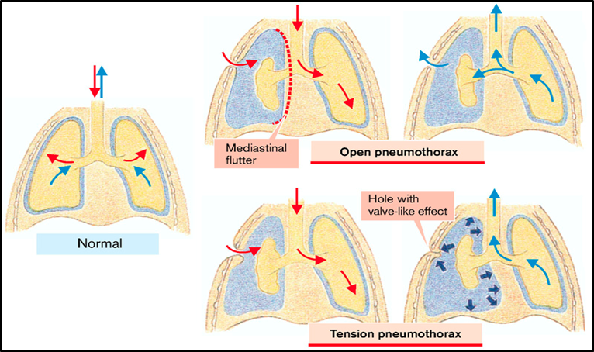
Fig.16 Pneumothorax
(From S. Silbernagl and F. Lang; Color Atlas of Pathophysiology)

Hypoxemia usually develops immediately after a large pneumothorax, followed by vasoconstriction of the blood vessels in the affected lung, causing the blood flow to shift to the unaffected lung. In persons with primary spontaneous pneumothorax, this mechanism usually returns oxygen saturation to normal within 24 hours. Hypoxemia usually is more serious in persons with underlying lung disease in whom secondary spontaneous pneumothorax develops. In these persons, the hypoxemia caused by the partial or total loss of lung function can be life threatening.

Obstructive lung disease
Airflow during breathing. The volume of air that moves into and out of the gas exchange portion of the lungs is directly related to the pressure difference between the lungs and the atmosphere and inversely related to the resistance that the air encounters as it moves through the conducting airways.
Airway resistance. Airway resistance is the ratio of the pressure driving inspiration or expiration to airflow. The French physician Jean Leonard Marie Poiseuille first described the pressure-flow characteristics of laminar flow in a straight circular tube, a correlation that has become known as Poiseuille law. According to Poiseuille law, the resistance to flow is inversely related to the fourth power of the radius (R = 1/r⁴). If the radius is reduced by one half, the resistance increases 16-fold (2× 2 ×2 ×2 =16).
Airway resistance differs in large (e.g., trachea and bronchi), medium-sized (e.g., segmental), and small (e.g., bronchioles) airways. Therefore, the total airway resistance is equal to the sum of the resistances in these three types of airways. The site of most of the resistance along the bronchial tree is in the large bronchi, with the smallest airways contributing very little to the total airway resistance. This is because most of these airways are arranged in parallel and their resistances are added as reciprocals (i.e., total combined resistance = 1/R + 1/R, etc.). While the resistance of each individual bronchiole may be relatively high, their great number results in a large total cross-sectional area, causing their total combined airway resistance to be low. Many airway diseases, such as emphysema and chronic bronchitis, begin in the small airways. Early detection of these diseases is often difficult because a considerable amount of damage must be present before the usual diagnostic measurements of airway resistance can detect them.
Airway resistance is greatly affected by lung volumes, being less during inspiration than during expiration. This is because elastic-type fibers connect the outside of the airways to the surrounding lung tissues. As a result, these airways are pulled open as the lungs expand during inspiration, and they become narrower as the lungs deflate during expiration. This is one of the reasons why persons with conditions that increase airway resistance, such as bronchial asthma, usually have less difficulty during inspiration than during expiration.

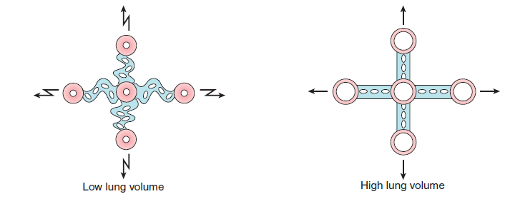

Interaction of tissue forces on airways during low and high lung volumes.
At low lung volumes, the tissueforces promote folding or collapsing and place less tension onthe airways, which become smaller; during high lung volumes,the tissue forces stretch and pull the airways open
(From C. Porth and G. Matfin; Pathophysiology. Concepts of altered health states).

Airway resistance is also affected by the bronchial smooth muscle tone that controls airway diameter. The smooth muscles in the airway, from the trachea down to the terminal bronchioles, are under autonomic nervous system control. As discussed earlier in the chapter, stimulation of the parasympathetic nervous system causes bronchial constriction as well as increased mucous secretion, whereas sympathetic stimulation has the opposite effect.
Laminar and turbulent airflow. Depending on the velocity and pattern of flow, airflow can be laminar or turbulent. Both laminar and turbulent flow causes resistance to air movement in the airways. Laminar, or streamlined airflow occurs at low flow rates in which the air stream is parallel to the sides of the airway. With laminar flow, the air at the periphery must overcome the resistance to flow, and as a result, the air in the center of the airway moves faster. In the bronchial tree with its many branches, laminar airflow probably occurs only in the very small airways, where the velocity of flow is low. Because the small airways contribute little resistance to airflow, they constitute a silent zone (to be discussed). Turbulent airflow is disorganized flow in which the molecules of the gas move laterally, collide with one another, and change their velocities. Whether turbulence develops depends on the radius of the airways, the interaction of the gas molecules, and the velocity of airflow. It is most likely to occur when the radius of the airways is large and the velocity of flow is high. Turbulent flow occurs regularly in the trachea. Turbulence of airflow accounts for the respiratory sounds that are heard during chest auscultation (i.e., listening to chest sounds using a stethoscope).
Airway compression during forced expiration. Airway resistance does not change much during normal quiet breathing; however, it is significantly increased during forced expiration, such as in vigorous exercise. The marked changes that occur during forced expiration are the result of airway compression. Airflow through the collapsible airways in the lungs depends on the distending airway (intrapulmonary) pressures that hold the airways open and the external (intrapleural or intrathoracic) pressures that surround and compress the airways. The difference between these two pressures (intrathoracic pressure minus airway pressure) is called the transpulmonary pressure. For airflow to occur, the distending pressure inside the airways must be greater than the compressing pressure outside the airways. During forced expiration, the transpulmonary pressure is decreased because of a disproportionate increase in the intrathoracic pressure compared with airway pressure. The resistance that air encounters as it moves out of the lungs causes a further drop in airway pressure. If this drop in airway pressure is sufficiently great, the surrounding intrathoracic pressure will compress the collapsible airways (i.e., those that lack cartilaginous support), causing airflow to be interrupted and air to be trapped in the terminal airways.
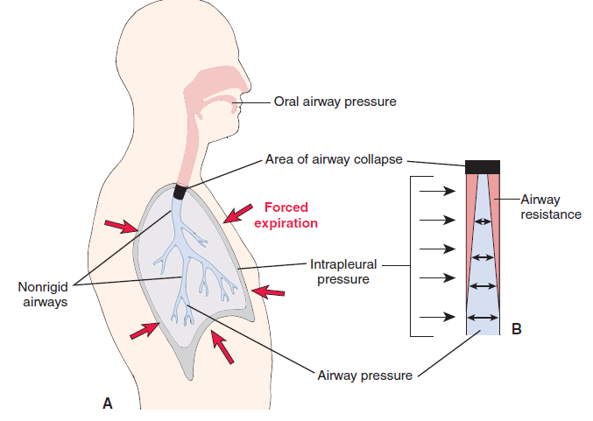
Mechanism that limits maximal expiratory flow rate.
(A) Airway patency and airflow in the non-rigid airways of the lungs rely on a trans-pulmonary pressure gradient inwhich airway pressure is greater thanintrapleural pressure. (B) Airway resistancenormally produces a drop inairway pressure as air moves out of thelungs. The increased intrapleural pressurethat occurs with forced expiration produces airway collapse in the non-rigid airways at the point where intrapleuralpressure exceeds airway pressure.
(From C. Porth and G. Matfin; Pathophysiology. Concepts of altered health states).

Although this type of airway compression usually is seen only during forced expiration such as occurs with vigorous exercise in persons with normal respiratory function, it may occur during normal breathing in persons with lung diseases. For example, in conditions that increase airway resistance, such as asthma or chronic obstructive lung disease, the pressure drop along the smaller airways is magnified, and an increase in intra-airway pressure is needed to maintain airway patency. Measures such as pursed-lip breathing increase airway pressure and improve expiratory flow rates in persons with obstructive lung diseases. This is also the rationale for using positive end-expiratory pressure in persons who are being mechanically ventilated. Infants who are having trouble breathing often grunt to increase their expiratory airway pressures and keep their airways open.

In order to reach the alveoli air must pass through the respiratory tract or airways which present a resistance to the flow. This resistance is determined by the lumen in the tract. In particular the narrow lumen of the bronchioles can be further narrowed by mucus and the contraction of the bronchial musculature. Mucus is secreted in order to trap pathogens and dirt particles. It is transported toward the mouth by the cilia of the lining epithelium and then swallowed. As the cilia cannot propel very sticky mucus, an electrolyte solution is usually secreted that lifts the mucus from the cilia, so that mucus moves toward the mouth on a thin fluid layer. The lumen can be narrowed by the action of the bronchial muscles, which increases the likelihood of pathogens being caught in the mucus. The disadvantage, however, is that narrowing raises flow resistance. Obstructive lung diseases are characterized by an increased flow resistance.
Intrathoracic increase in resistance is usually due to a narrowing or obstruction of the bronchi, by either external compression, contraction of bronchial muscles, thickening of the lining mucus layer, or obstruction of the lumen by mucus. Most of these changes are the result of asthma or chronic bronchitis. In asthma there is an allergy to inhaled antigens (e.g., pollen). These antigens cause an inflammation of the bronchial mucosa leading to the release of histamine and leukotrienes (called slow reacting substances in anaphylaxis [SRSA]). The bronchial muscles contract and mucus secretion as well as vessel permeability (mucosal edema) are increased under the influence of these mediators. In addition to the inhaled antigens, microorganisms in the mucosa may also act as antigens (infectious-allergic asthma). Here there is no clearcut distinction between asthma and bronchitis. Obstructive lung disease can also be the result of cystic fibrosis (CF). As the result of an autosomal recessive genetic defect of the CF transmembrane regulator (CFTR) there is decreased secretion and hyperreabsorption of fluid, and mucus can no longer be cleared from the airways. The result is obstructive lung disease. The lung’s reduced ability to retract (flaccid lung) can also lead to obstructive lung disease, because reduced elastic recoil (increased compliance) of the lung requires an increase in pressure during expiration, resulting in compression of the intrathoracic airways.
Extrathoracic increase in resistance occurs, for example, in paralysis of the vocal chords, edema of the glottis, and external tracheal compression (e.g., by tumor or goitre). In tracheomalacia the tracheal wall is softened and collapses on inspiration. The effect of obstructive lung disease is reduced ventilation. If extrathoracic obstruction occurs, it is mainly inspiration that is affected (inspiratory stridor), because during expiration the pressure rise in the prestenotic lumen widens the narrowed portion. Intrathoracic obstruction mainly impairs expiration, because the falling intrathoracic pressure during inspiration widens the airways. The ratio of the duration of expiration to that of inspiration is increased. Obstructed expiration distends the alveolar ductules (centrilobular emphysema), lung recoil decreases (compliance increases), and the midposition of breathing is shifted toward inspiration (barrel chest). This raises the functional residual capacity. Greater intrathoracic pressure is necessary for expiration because compliance and resistance are increased. This causes compression of the bronchioles so that the airway pressure increases further. While the effort required to overcome the elastic lung resistance is normal or actually decreased, the effort required to overcome the viscous lung resistance and thus the total effort of breathing is greatly increased. The obstruction reduces maximum breathing capacity (V_{max}) and FEV₁, and the differing ventilation of various alveoli results in abnormal distribution. The hypoxia of underventilated alveoli leads to vasoconstriction, increased pulmonary vascular resistance, pulmonary hypertension, and an increased right ventricular load (cor pulmonale) (Fig.17).

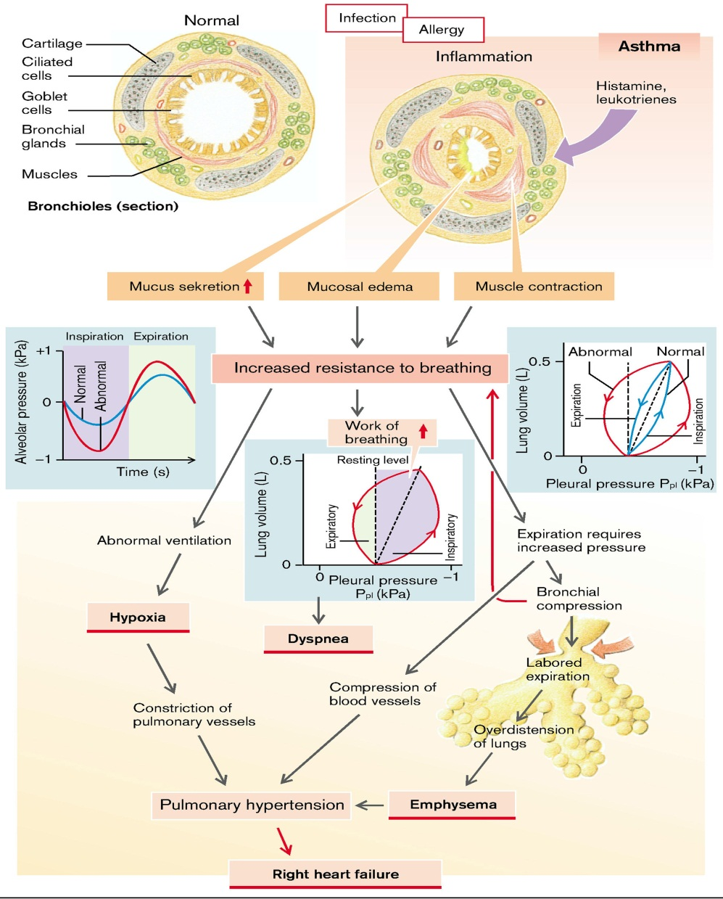

Fig.17 Pathogenesis of obstructive lung disease (overview)
(From S. Silbernagl and F. Lang; Color Atlas of Pathophysiology)

Emphysema and chronic bronchitis are often clinically grouped together and referred to as chronic obstructive pulmonary disease (COPD), since many patients have overlapping features of damage at both the acinar level (emphysema) and bronchial level (bronchitis), almost certainly because one extrinsic trigger cigarette smokingis common to both. In addition, small-airway disease, a variant of chronic bronchiolitis, is now known to contribute to obstruction both in emphysema and chronic bronchitis. While asthma is distinguished from chronic bronchitis and emphysema by the presence of reversible bronchospasm, some patients with otherwise typical asthma also develop an irreversible component. Conversely, some patients with otherwise typical COPD have a reversible component. It is clinically common to label such patients as having COPD/asthma. In a recent study the overlap between these three disorders was found to be substantial. In most patients, COPD is the result of long-term heavy cigarette smoking; about 10% of patients are nonsmokers. However, only a minority of smokers develop COPD, the reason for which is still unknown. Because of the increase in smoking, environmental pollutants, and other noxious exposures, the incidence of COPD has increased markedly in the last few decades and now ranks fourth in the United States as a cause of morbidity and mortality. Recognizing the overlap between various forms of COPD, each of the components and the features that characterize them in pure forms are discussed next, because it is essential to understand the pathophysiologic basis of different causes of airflow obstruction. While currently they are treated on the basis of symptoms, an understanding of pathogenesis may lead to therapies that target the mechanisms.
Pulmonary emphysema
Emphysema is a condition of the lung characterized by irreversible enlargement of the airspaces distal to the terminal bronchiole, accompanied by destruction of their walls without obvious fibrosis.
Emphysema is classified according to its anatomic distribution within the lobule. Recall that the lobule is a cluster of acini, the terminal respiratory units. Although the term emphysema is sometimes loosely applied to diverse conditions, there are four major types: (1) centriacinar, (2) panacinar, (3) paraseptal, and (4) irregular (Fig.18). Of these, only the first two cause clinically significant airflow obstruction. Centriacinar emphysema is far more common than the panacinar form, constituting more than 95% of cases.

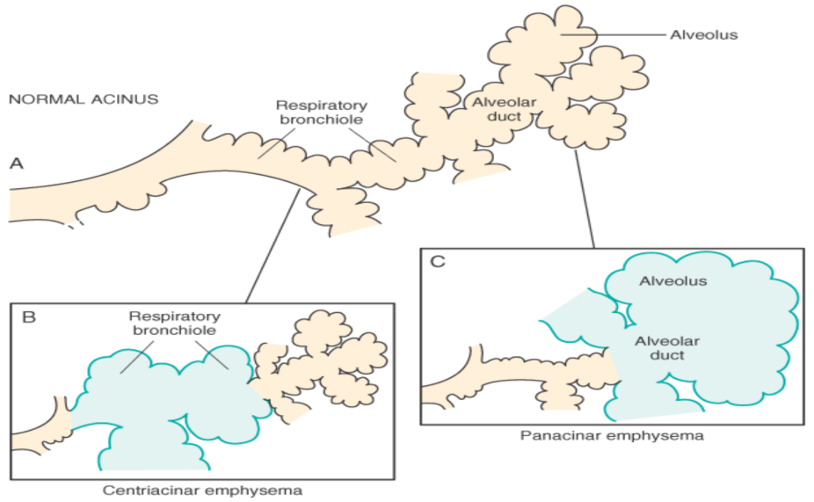
Fig. 18 Major patterns of emphysema.
A, Normal structure within the acinus. B, Centriacinar emphysema with dilation that initially
affects the respiratory bronchioles. C, Panacinar emphysema with initial distention of the alveolus and alveolar duct. (From Robbins-Cotran; Pathological basis of diseases)
Centriacinar (centrilobular) emphysema . In this type of emphysema the central or proximal parts of the acini, formed by respiratory bronchioles, are affected, whereas distal alveoli are spared. Thus, both emphysematous and normal airspaces exist within the same acinus and lobule. The lesions are more common and usually more severe in the upper lobes, particularly in the apical segments. The walls of the emphysematous spaces often contain large amounts of black pigment. Inflammation around bronchi and bronchioles is common. In severe centriacinar emphysema, the distal acinus may also be involved, and differentiation from panacinar emphysema becomes difficult. Centriacinar emphysema occurs predominantly in heavy smokers, often in association with chronic bronchitis.
Panacinar (panlobular) emphysema. In this type, the acini are uniformly enlarged from the level of the respiratory bronchiole to the terminal blind alveoli. The prefix pan refers to the entire acinus but not to the entire lung. In contrast to centriacinar emphysema, panacinar emphysema tends to occur more commonly in the lower zones and in the anterior margins of the lung, and it is usually most severe at the bases. This type of emphysema is associated with α₁-antitrypsin (α₁-AT) deficiency.
Distal acinar (paraseptal) emphysema. In this type, the proximal portion of the acinus is normal, and the distal part is predominantly involved.The emphysema is more striking adjacent to the pleura, along the lobular connective tissue septa, and at the margins of the lobules. It occurs adjacent to areas of fibrosis, scarring, or atelectasis and is usually more severe in the upper half of the lungs. The characteristic findings are of multiple, continuous, enlarged airspaces from less than 0.5 cm to more than 2.0 cm in diameter, sometimes forming cyst-like structures. This type of emphysema probably underlies many of the cases of spontaneous pneumothorax in young adults.
Airspace enlargement with fibrosis (Irregular emphysema). Irregular emphysema, so named because the acinus is irregularly involved, is almost invariably associated with scarring. Thus, it may be the most common form of emphysema, because careful search of most lungs at autopsy shows one or more scars from a healed inflammatory process. In most instances, these foci of irregular emphysema are asymptomatic and clinically insignificant.
Pathogenesis. Emphysema is characterized by mild chronic inflammation throughout the airways, parenchyma, and pulmonary vasculature. Macrophages, CD8+ and CD4+ T lymphocytes, and neutrophils are increased in various parts of the lung. Activated inflammatory cells release a variety of mediators, including leukotriene B₄, IL-8, TNF, and others, that are capable of damaging lung structures or sustaining neutrophilic inflammation. Although details of the genesis of the two common forms of emphysema centriacinar and panacinar remain unsettled, the most plausible hypothesis to account for the destruction of alveolar walls is the protease-antiprotease mechanism, aided and abetted by imbalance of oxidants and antioxidants.
The protease-antiprotease imbalance hypothesis is based on the observation that patients with a genetic deficiency of the antiprotease α₁-antitrypsin have a markedly enhanced tendency to develop pulmonary emphysema, which is compounded by smoking ( Fig. 19). About 1% of all patients with emphysema have this defect. α₁-antitrypsin, normally present in serum, tissue fluids, and macrophages, is a major inhibitor of proteases (particularly elastase) secreted by neutrophils during inflammation. α₁-antitrypsin is encoded by codominantly expressed genes on the proteinase inhibitor (Pi) locus on chromosome 14. The Pi locus is extremely polymorphic, with many different alleles. Most common is the normal (M) allele and the corresponding phenotype. Approximately 0.012% of the US population is homozygous for the Z allele, associated with markedly decreased serum levels of α₁antitrypsin. More than 80% of these individuals develop symptomatic panacinar emphysema, which occurs at an earlier age and with greater severity if the individual smokes. The following sequence is postulated:
1. Neutrophils (the principal source of cellular proteases) are normally sequestered in peripheral capillaries, including those in the lung, and a few gain access to the alveolar spaces.
2. Any stimulus that increases either the number of leukocytes (neutrophils and macrophages) in the lung or the release of their protease-containing granules increases proteolytic activity.
3. With low levels of serum α₁-antitrypsin, elastic tissue destruction is unchecked and emphysema results.
Thus, emphysema is seen to result from the destructive effect of high protease activity in subjects with low anti-protease activity. The protease-antiprotease imbalance hypothesis also helps explain the effect of cigarette smoking in the development of emphysema, particularly the centriacinar form in subjects with normal amounts of α₁-antitrypsin:
• In smokers, neutrophils and macrophages accumulate in alveoli. The mechanism of inflammation is not entirely clear, but possibly involves the direct chemoattractant effects of nicotine as well as the effects of reactive oxygen species contained in smoke. These activate the transcription factor NF-κB, which switches on genes that encode TNF and chemokines, including IL-8. These, in turn, attract and activate neutrophils.
• Accumulated neutrophils are activated and release their granules, rich in a variety of cellular proteases (neutrophil elastase, proteinase 3, and cathepsin G), resulting in tissue damage.
• Smoking also enhances elastase activity in macrophages; macrophage elastase is not inhibited by α₁-antitrypsin) and, indeed, can proteolytically digest this antiprotease. There is increasing evidence that in addition to elastase, matrix metalloproteinases derived from macrophages and neutrophils have a role in tissue destruction. In addition, smoking has a seminal role in perpetuating the oxidant-antioxidant imbalance in the pathogenesis of emphysema. Normally, the lung contains a healthy complement of antioxidants (superoxide dismutase, glutathione) that keep oxidative damage to a minimum. Tobacco smoke contains abundant reactive oxygen species (free radicals), which deplete these antioxidant mechanisms, thereby inciting tissue damage. Activated neutrophils also add to the pool of reactive oxygen species in the alveoli. A secondary consequence of oxidative injury is inactivation of native antiproteases, resulting in functional α₁-antitrypsin deficiency even in patients without enzyme deficiency (Fig.19).

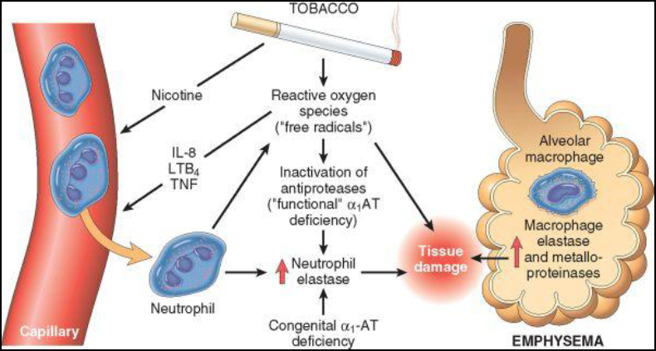
Fig.19 Pathogenesis of emphysema
Excessive protease activity and reactive oxygen species are additive in their effects and contributeto tissue damage. α₁-antitrypsin (α₁-AT) deficiency can be either congenital or functional as a result of oxidative inactivation. IL-8, interleukin 8; LTB₄, leukotriene B₄; TNF, tumor necrosis factor.
(From Robbins-Cotran; Pathological basis of diseases)
In emphysema the loss of alveolar walls leads to a diminished diffusion area; the loss of pulmonary capillaries to an increase in functional dead space as well as increased pulmonary artery pressure and vascular resistance with the development of cor pulmonale. In centrilobular, but not panlobular, emphysema a distribution abnormality develops, too, because of differing resistances in different bronchioles. The abnormal distribution results in hypoxemia. Patients with centrilobular emphysema due to obstructive lung disease are called “blue bloaters”. In contrast, patients with panlobular emphysema at rest are called “pink puffers”, because enlargement of the functional dead space forces them to breathe more deeply. It is only when diffusion capacity is greatly reduced or oxygen consumption is increased (e.g., during physical work) that diffusion abnormality will result in hypoxemia (Fig.20).
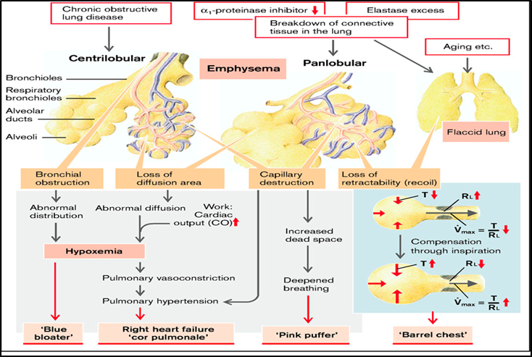

Fig.20 Mechanisms of emphysema
(From S. Silbernagl and F. Lang; Color Atlas of Pathophysiology)

When considering the effects of pulmonary emphysema, the consequences of reduced elastic recoil are important. In the end the lung’s elastic recoil generates the positive pressure in the alveoli in comparison to ambient air necessary for normal expiration. Although positive pressure in the alveoli can also be produced by external compression, i.e., by contraction of the expiratory muscles, this will also compress the bronchioles and thus bring about a massive increase in flow resistance. Maximal expiratory flow rate (V_{max}) is thus a function of the ratio between elastic recoil (K) and resistance (RL). Reduced elastic recoil can thus have the same effect as obstructive lung disease. Elastic recoil can be raised by increasing the inspiratory volume, eventually leading to a shift in the resting position toward inspiration (barrel chest). If tidal volume remains constant, both the functional residual capacity and the residual volume are increased, sometimes also the dead space. However, vital capacity is diminished because of the reduced expiratory volume (Fig.21).

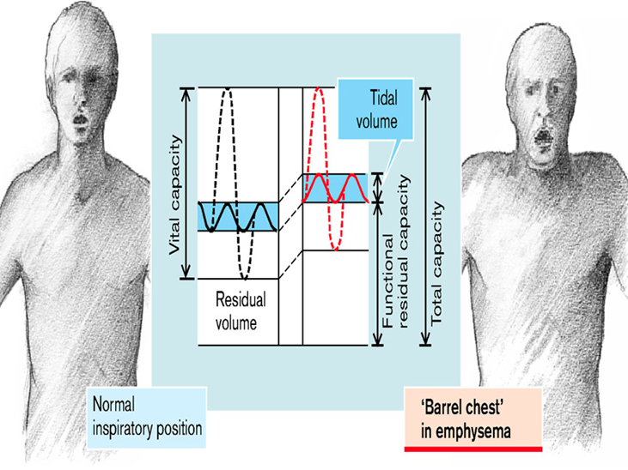
Fig. 21 Development of barrel chest in emphysema

.(From S. Silbernagl and F. Lang; Color Atlas of Pathophysiology)

Until recently loss of elastic recoil was considered to be the sole mechanism of airflow obstruction in emphysema. However, careful studies in young smokers who died in accidents have revealed that inflammation of small airways, defined as bronchioles less than 2 mm in diameter, occurs early in the evolution of emphysema. Several changes are seen:
1. Goblet cell metaplasia with mucus plugging of the lumen
2. Inflammatory infiltration of the walls with neutrophils, macrophages, B cells (sometimes forming follicles), CD₄ and CD₈+ T cells
3. Thickening of the bronchiolar wall due to smooth muscle hypertrophy and peribronchial fibrosis.
Together these changes narrow the bronchiolar lumen and contribute to airway obstruction.

Bronchial asthma
Asthma is a chronic inflammatory disorder of the airways that causes recurrent episodes of wheezing, breathlessness, chest tightness, and cough, particularly at night and/or in the early morning. These symptoms are usually associated with widespread but variable bronchoconstriction and airflow limitation that is at least partly reversible, either spontaneously or with treatment. The hallmarks of the disease are: increased airway responsiveness to a variety of stimuli, resulting in episodic bronchoconstriction; inflammation of the bronchial walls; and increased mucus secretion. Some of thestimuli that trigger attacks in patients would have little or no effect in subjects with normal airways.
Many cells play a role in the inflammatory response, in particular lymphocytes, eosinophils, mast cells, macrophages, neutrophils, and epithelial cells.[27] Individuals with asthma experience attacks of varying severity of dyspnea, coughing, and wheezing due to sudden episodes of bronchospasm. Rarely, a state of unremitting attacks, called status asthmaticus, proves fatal; usually, such patients have had a long history of asthma. Between the attacks, patients may be virtually asymptomatic. There has been a significant increase in the incidence of asthma in theWestern world in the past four decades.
Asthma may be categorized into atopic (evidence of allergen sensitization, often in a patient with a history of allergic rhinitis, eczema) and non-atopic (without evidence of allergen sensitization). In either type, episodes of bronchospasm can be triggered by diverse mechanisms, such as respiratory infections (especially viral infections), environmental exposure to irritants (e.g., smoke, fumes), cold air, stress, and exercise. Recent studies have suggested that the recognition of subphenotypes of asthma based on the pattern of airway inflammation may also be useful. There is emerging evidence for differing patterns of airway inflammation: eosinophilic, neutrophilic, mixed inflammatory, and pauci-granulocytic asthma.
These subgroups may differ in their etiology, immunopathology, and response to treatment. Asthma may also be classified according to the agents or events that trigger bronchoconstriction. These include seasonal, exercise-induced, drug-induced (e.g., aspirin), and occupational asthma, and asthmatic bronchitis in smokers.
Atopic asthma. This most common type of asthma is a classic example of type I IgE-mediated hypersensitivity reaction, discussed in detail in allergic reactions. The disease usually begins in childhood and is triggered by environmental allergens, such as dusts, pollens, roach or animal dander, and foods. A positive family history of asthma is common, and a skin test with the offending antigen in these patients results in an immediate wheal-and-flare reaction. Atopic asthma may also be diagnosed based on evidence of allergen sensitization by serum radio-allergo-sorbent tests (called RAST), which identify the presence of IgE specific for a panel of allergens.
Non-atopic asthma. The second group of individuals with asthma does not have evidence of allergen sensitization, and skin test results are usually negative. A positive family history of asthma is less common in these patients. Respiratory infections due to viruses (e.g., rhinovirus, parainfluenza virus) are common triggers in nonatopic asthma. In these patients hyperirritability of the bronchial tree probably underlies their asthma. It is thought that virus-induced inflammation of the respiratory mucosa lowers the threshold of the subepithelial vagal receptors to irritants. Inhaled air pollutants, such as sulfur dioxide, ozone, andnitrogen dioxide, may also contribute to the chronic airway inflammation and hyperreactivity that are present in some cases.
Drug-induced asthma. Several pharmacologic agents provoke asthma.
Aspirin-sensitive asthma is an un common yet fascinating type, occurring in individuals with recurrent rhinitis and nasal polyps. These individuals are exquisitely sensitive to small doses of aspirin as well as other nonsteroidal anti-inflammatory medications, and they experience not only asthmatic attacks but also urticaria. It is probable that aspirin triggers asthma in these patients by inhibiting the cyclooxygenase pathway of arachidonic acid metabolism without affecting the lipoxygenase route, thus tipping the balance toward elaboration of the bronchoconstrictor leukotrienes.
Occupational asthma. This form of asthma is stimulated by fumes (epoxy resins, plastics), organic and chemical dusts (wood, cotton, platinum), gases (toluene), and other chemicals (formaldehyde, penicillin products). Minute quantities of chemicals are required to induce the attack, which usually occurs after repeated exposure.The underlying mechanisms vary according to stimulus and include type I reactions, direct liberation of bronchoconstrictor substances, and hypersensitivity responses of unknown origin.
Pathogenesis.The major etiologic factors in atopic asthma are a genetic predisposition to type I hypersensitivity (atopic) and exposure to environmental triggers that remain poorly defined. It is postulated that inheritance of susceptibility genes makes individuals prone to develop strong TH₂ reactions against environmental antigens (allergens) that are ignored or elicit harmless responses in most individuals. In the airways the scene for the reaction is set by initial sensitization to inhaled allergens, which stimulate induction of TH₂ cells. TH₂ cells secrete cytokines that promote allergic inflammation and stimulate B cells to produce IgE and other antibodies. These cytokines include IL-4, which stimulates the production of IgE; IL-5, which activates locally recruited eosinophils; and IL-13, which stimulates mucus secretion from bronchial submucosal glands and also promotes IgE production by B cells. As in other allergic reactions, IgE coats submucosal mast cells, and repeat exposure to the allergen triggers the mast cells to release granule contents and produce cytokines and other mediators,which collectively induce the early-phase (immediate hypersensitivity) reaction and the late-phase reaction. The early reaction is dominated by bronchoconstriction, increased mucus production, andvariable degrees of vasodilation with increased vascular permeability. Bronchoconstriction is triggeredby direct stimulation of subepithelial vagal (parasympathetic) receptors through both central and localreflexes (including those mediated by unmyelinated sensory C fibers).

Fig. 22 A and B, Comparison of a normal bronchus with that in a person with asthma.
Note the accumulation of mucus in the bronchial lumen resulting from an increase in the number of mucus-secreting goblet cells in the mucosa and hypertrophy of submucosal glands. In addition, there is intense chronic inflammation due to recruitment of eosinophils, macrophages, and other inflammatory cells. Basement membrane underlying the mucosal epithelium is thickened, and there is hypertrophy and hyperplasia of smooth muscle cells. C, Inhaled allergens (antigen) elicit a TH2-dominated response favoring IgE production and eosinophil recruitment (priming or sensitization). D, On reexposure to antigen (Ag), the immediate reaction is triggered by Ag-induced cross-linking of IgE bound to IgE receptors on mast cells. These cells release preformed mediators. Collectively, either directly or via neuronal reflexes, the mediators induce bronchospasm, increased vascular permeability, and mucus production, and recruit additional mediator-releasing cells from the blood. E, The arrival of recruited leukocytes (neutrophils, eosinophils, and basophils; lymphocytes and monocytes) signals the initiation of the late phase of asthma and a fresh round of mediator release from leukocytes, endothelium, and epithelial cells. Factors, particularly from eosinophils (e.g., major basic protein, eosinophil cationic protein), also cause damage to the epithelium. GM-CSF, granulocyte-macrophage colony-stimulating factor. (From Robbins-Cotran; Pathological basis of diseases)

The late-phase reaction consists largely of inflammation with recruitment of leukocytes, notably eosinophils, neutrophils, and more T cells. Leukocyte recruitment is stimulated by chemokines produced by mast cells, epithelial cells and T cells, and by other cytokines. Epithelial cells are known to produce a large variety of cytokines in response to infectious agents, drugs, and gases as well as to inflammatory mediators. This second wave of mediators stimulates the late reaction. For example, eotaxin, produced by airway epithelial cells, is a potent chemoattractant and activator of eosinophils.The major basic protein of eosinophils, in turn, causes epithelial damage and more airway constriction. Many mediators have been implicated in the asthmatic response, but the relative importance of each putative mediator in actual human asthma has been difficult to establish. It is thus clear that multiple mediators contribute to the acute asthmatic response. Moreover, the composition of this mediator soup might differ among different individuals or types of asthma. The appreciation of the importance of inflammatory cells and mediators in asthma has led to greater emphasis on anti-inflammatory drugs, such as corticosteroids, in the treatment of asthma.
Over time, repeated bouts of allergen exposure and immune reactions result in structural changes in the bronchial wall, referred to as airway remodeling. These changes include hypertrophy and hyperplasia of bronchial smooth muscle, epithelial injury, increased airway vascularity, increased subepithelial mucus gland hypertrophy/hyperplasia, and deposition of subepithelial collagen. The complex interactions between the immune system, airway epithelium, and mesenchymal tissues in the airways are poorly understood. Infections with common respiratory pathogens, such as respiratory syncytial virus and influenza, can exacerbate the chronic changes and cause serious worsening of the clinical manifestations of the disease.
Although infections are often triggers for asthma, paradoxically, some infections may be protective. Epidemiologic studies first suggested that the incidence of asthma was greater in populations not exposed to microbes than in those living in an environment with abundant microbes, and this relationship may explain the increasing incidence of asthma in developed countries.These findings have led to the hygiene hypothesis, which states that eradication of infections may promote allergic and other harmful immune responses. Despite a fascination with this idea, there is no plausible explanation for the inverse relationship between infections and asthma.
Asphyxia
Asphyxia represents acute respiratory failure characterised by disorders in O₂ uptake (hypoxemia) and CO₂ release (hypercapnia). Usually it is linked with obstruction of upper airways (larynx, trachea, main bronchi) by foreign bodies, blood, teeth etc… Asphyxia has several characteristic stages. First there is inspiratory dyspnea characterized by deep and accelerated breathing (hyperpnea) with prevalence of inspiration. Thereafter it will be progress to expiratory dyspnea with progressive reduction in respiratory rate but with preservation of maximal amplitude of breathing with prevalence of expiration. In the third stage of asphyxia concomitantly with reduced respiratory rate there will be also reduced amplitude of breathing movements (hypopnea); this stage usually leads to terminal pause (respiratory arrest). Respiratory arrest is followed by a short recovery of breathing (gasping or agonal breathing). Finally there will be complete respiratory arrest with clinical death of the patient.

RESPIRATORY FAILURE

Respiratory failure is a condition in which the lungs fail to oxygenate the blood adequately and prevent carbon dioxide retention. Symptoms and signs of acute respiratory failure are whose of underlying disease combined with signs of hypoxemia and hypercapnia/hypoxemia. Respiratory failure is manifested by varying degrees of hypoxemia and hypercapnia. There is no absolute definition of the levels of PaO₂ and PaCO₂ that indicate respiratory failure. As a general rule, respiratory failure refers to a PaO₂ level of 50 mm Hg or less and a PaCO₂ level greater than 50 mmHg. These values are not reliable when dealing with persons who have chronic lung disease because many of these persons are alert and functioning with blood gas levels outside this range.
It is not a specific disease, but rather is the result of a number of conditions that impair ventilation, compromise the matching of ventilation and perfusion, or disrupt blood flow in the lung. These conditions include impaired ventilation caused by impaired function of the respiratory center, airway obstruction, weakness and paralysis of the respiratory muscles, chest wall deformities, and disease of the airways and lungs. It may occur in previously healthy persons as the result of acute disease or trauma involving the respiratory system, or it may develop in the course of a chronic neuromuscular or respiratory disease.
The common result of respiratory failure is hypoxemia and hypercapnia. The term hypoxia refers to a reduction in oxygen supply to the tissues; hypoxemia, to a low level of oxygen in the arterial blood (PaO₂<60); and hypercapnia (sometimes referred to as hypercarbia), to excess carbon dioxide in the arterial blood (PaCO₂>46). Hypoxia and hypercapnia can manifest as acute and chronic conditions, and hypoxia may exist without hypercapnia, or the two conditions may coexist.
Various types of respiratory failure are associated with different degrees of hypoxemia or hypercapnia. For example, pure hypoventilation, as occurs in conditions such as drug overdose, favors retention of CO₂. Severe ventilation-perfusion mismatching with alveolar ventilation that is inadequate to maintain arterial PaO₂ levels results in hypoxemia that is more severe in relation to the hypercapnia than occurs with pure hypoventilation. This pattern of respiratory failure is seen most commonly in persons with advanced COPD. In this situation, the breathing of high concentrations of oxygen increases both the PaO₂ and the PaCO₂. Persons with interstitial lung disease may develop severe hypoxemia but not hypercapnia because of increased ventilation. In persons with ARDS, the degree of hypoxemia is usually severe, whereas the arterial PaCO₂ is low because of the greater diffusing capacity of carbon dioxide. In this case, administration of oxygen can produce an increase in PaO₂ without producing an increase in PaCO₂.

Causes of respiratory failure

- Impaired Ventilation (hypercapnic-hypoxemic respiratory failure)

- Upper airway obstruction - Drug overdose
- Infection (e.g., epiglottitis) - Muscular dystrophy
- Spinal cord injury - Weakness or paralysis of respiratory muscles
- Foreign body - Laryngospasm
- Brain injury - Chest wall injury

- Impaired Matching of Ventilation and Perfusion
- Chronic obstructive pulmonary disease
- Restrictive lung disease
- Severe pneumonia
- Atelectasis

- Impaired Diffusion
- Pulmonary edema
- Acute respiratory distress syndrome

Hypoxemic respiratory failure (Type I respiratory failure)
- Due to ventilation-perfusion mismatching
The mismatching of ventilation and perfusion occurs when areas of the lung are ventilated but not perfused or when areas are perfused but not ventilated. Usually, the hypoxemia seen in situations of ventilation-perfusion mismatching is more severe in relation to hypercapnia than that seen in hypoventilation. Severe mismatching of ventilation and perfusion often is seen in persons with advanced COPD. These disorders contribute to the retention of carbon dioxide by reducing the effective alveolar ventilation, even when total ventilation is maintained. This occurs because a region of the lung is not perfused and gas exchange cannot take place or because an area of the lung is not being ventilated. Maintaining a high ventilation rate effectively prevents hypercapnia but also increases the work of breathing.
The hypoxemia associated with ventilation-perfusion disorders often is exaggerated by conditions such as hypoventilation and decreased cardiac output. For example, sedation can cause hypoventilation in persons with severe COPD, resulting in further impairment of ventilation. Likewise, a decrease in cardiac output because of myocardial infarction can exaggerate the ventilation-perfusion impairment in a person with mild pulmonary edema.
The beneficial effect of oxygen administration on PO₂ levels in ventilation-perfusion disorders depends on the degree of mismatching that is present. Because oxygen administration increases the diffusion gradient in ventilated portions of the lung, it usually is effective in raising arterial PO2 levels. However, it may also decrease the respiratory drive and produce an increase in PCO2.
- Due to impaired diffusion
Diffusion impairment describes a condition in which gas exchange between the alveoli and the red blood cells is impeded because of an increase in the distance for diffusion or a decrease in the permeability of the alveolar capillary membrane to movement of gases. It most commonly occurs in conditions such as interstitial lung disease, ARDS, pulmonary edema, and pneumonia. Hypoxemia resulting from impaired diffusion can be partially or completely corrected by the administration of high concentrations of oxygen. In this case, the high concentration of oxygen serves to overcome the resistance to diffusion by establishing a large alveolar-to-capillary diffusion gradient. The elimination of carbon dioxide, which has a diffusion capacity about 20 times that of oxygen, is generally unaffected by diffusion abnormalities.

Hypercapnic respiratory failure (Type II respiratory failure or ventilatory failure)
Hypoventilation occurs when the volume of “fresh” air moving into and out of the lung is significantly reduced. Hypoventilation is commonly caused by conditions outside the lung such as depression of the respiratory center (e.g., drug overdose), diseases of the nerves supplying the respiratory muscles (e.g., Guillain-Barré syndrome), disorders of the respiratory muscles (e.g., muscular dystrophy), or thoracic cage disorders (e.g., severe scoliosis or crushed chest).Hypoventilation has two important effects on arterial blood gases. First, it almost always causes an increase in PaCO₂. The rise in PaCO₂ is directly related to the level of ventilation. Reducing the ventilation by one half causes a doubling of the PaCO₂. Thus, the PaCO₂ level is a good diagnostic measure for hypoventilation. Second, hypoxemia that is caused by hypoventilation can be readily abolished by increasing the oxygen content of the inspired air. In fact, pure hypoventilation does not cause large decreases in PaO₂. The PaO₂ falls by approximately 1mmHg for every 1 mmHg rise in PaCO₂. Hypoventilation sufficient to double the PaCO₂ from 40 to 80 mm Hg decreases the PaO₂ from 100 to 60 mmHg.
Hypercapnia affects a number of body functions, including renal function, neural function, cardiovascular function, and acid-base balance. Elevated levels of PaCO₂ produce a decrease in pH and respiratory acidosis. The body normally compensates for an increase in PaCO₂ by increasing renal bicarbonate retention. As long as the pH is in an acceptable range, the main complications of hypercapnia are those resulting from the accompanying hypoxia. Because the body adapts to chronic increases in blood levels of carbon dioxide, persons with chronic hypercapnia may not have symptoms until the PaCO₂ becomes markedly elevated. Carbon dioxide has a direct vasodilating effect on many blood vessels and a sedative effect on the nervous system. Raised levels of PaCO₂ greatly increase cerebral blood flow, causing headache, increased cerebral spinal fluid pressure, and sometimes papilledema. There is headache due to dilation of the cerebral vessels; the conjunctivae are hyperemic; and the skin is warm and flushed. Hypercapnia has nervous system effects similar to those of an anesthetic - hence the term carbon dioxide narcosis. There is progressive somnolence, disorientation, and, if the condition is untreated, coma. Mild to moderate increases in blood pressure are common. Air hunger and rapid breathing occur when alveolar P_{A}CO₂ levels rise to approximately 60 to 75 mm Hg; as PaCO₂ levels reach 80 to 100 mm Hg, the person becomes lethargic and sometimes semicomatose. Anesthesia and death can result when PaCO₂ levels reach 100 to 150 mm Hg.

